DAILY ONLINE ACTIVITIES SUMMARY

Date: |  | 05-06-2020 |  |  |  |  | Name: | Niharika G V
Sem & Sec |  | 8th A |  |  |  |  | USN: | 4AL16CS059
 |  |  |  | Online Test Summary
Subject |  |  | BDA
Max. Marks |  |  | 30 |  |  | Score |  | 14
 |  |  |  | Certification Course Summary
Course |  | Learn Ethical Hacking in 2020 : Beginner to Advanced
Certificate Provider |  |  |  | Udemy |  | Duration |  |  | 30 Hrs
 |  |  |  | Coding Challenges

Problem Statement: prob1- To find the LCM of TWO numbers.

Status: Solved

Uploaded the report in Github | Yes
If yes Repository name
 | Coading_event
Uploaded the report in slack | Yes

Online Test Details: (Attach the snapshot and briefly write the report for the same)

Certification Course Details: (Attach the snapshot and briefly write the report for the same)

Coding Challenges Details: (Attach the snapshot and briefly write the report for the same)

- Online test Details:
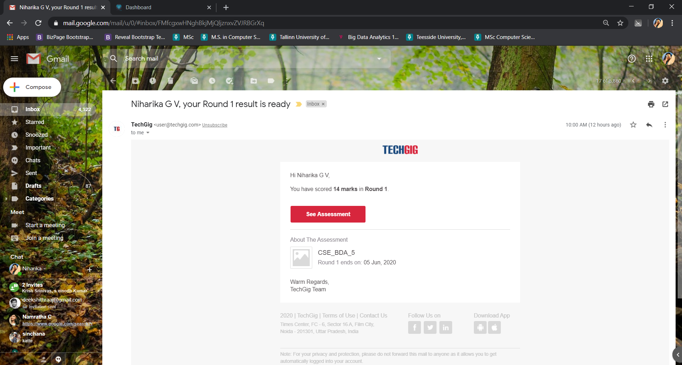

- Certification Course Details
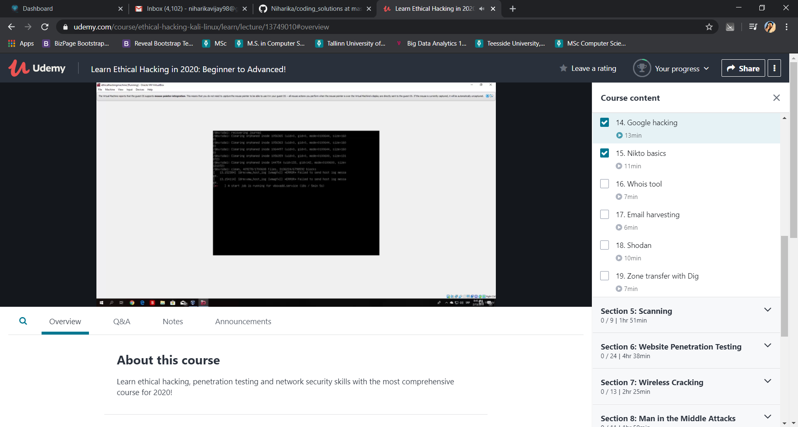

2) Coding Challenges:

1. To find LCM of two number

Pgrm1:

def compute_lcm(x, y):

if x > y:
greater = x
else:
greater = y

while(True):
if((greater % x == 0) and (greater % y == 0)):
lcm = greater
break
greater += 1

return lcm

num1 = 54
num2 = 24

print("The L.C.M. is", compute_lcm(num1, num2))

