DAILY ONLINE ACTIVITIES SUMMARY

Date: |  | 11-06-2020 |  |  |  |  | Name: | Niharika G V
Sem & Sec |  | 8thSem, A sec |  |  |  |  | USN: | 4AL16CS059
 |  |  |  | Online Test Summary
Subject |  |  | SMS
Max. Marks |  |  | 60 |  |  | Score |  | 60
 |  |  |  | Certification Course Summary
Course |  | Introduction to Information Security
Certificate Provider |  |  |  | Great learning |  | Duration |  |  | 6 Hrs
 |  |  |  | academy
 |  |  |  | Coding Challenges

Problem Statement: prob1- To find SUM OF DIGIT of given number

Status: Solved

Uploaded the report in Github | Yes
If yes Repository name | Daily_progress
Uploaded the report in slack | Yes

- Online test details
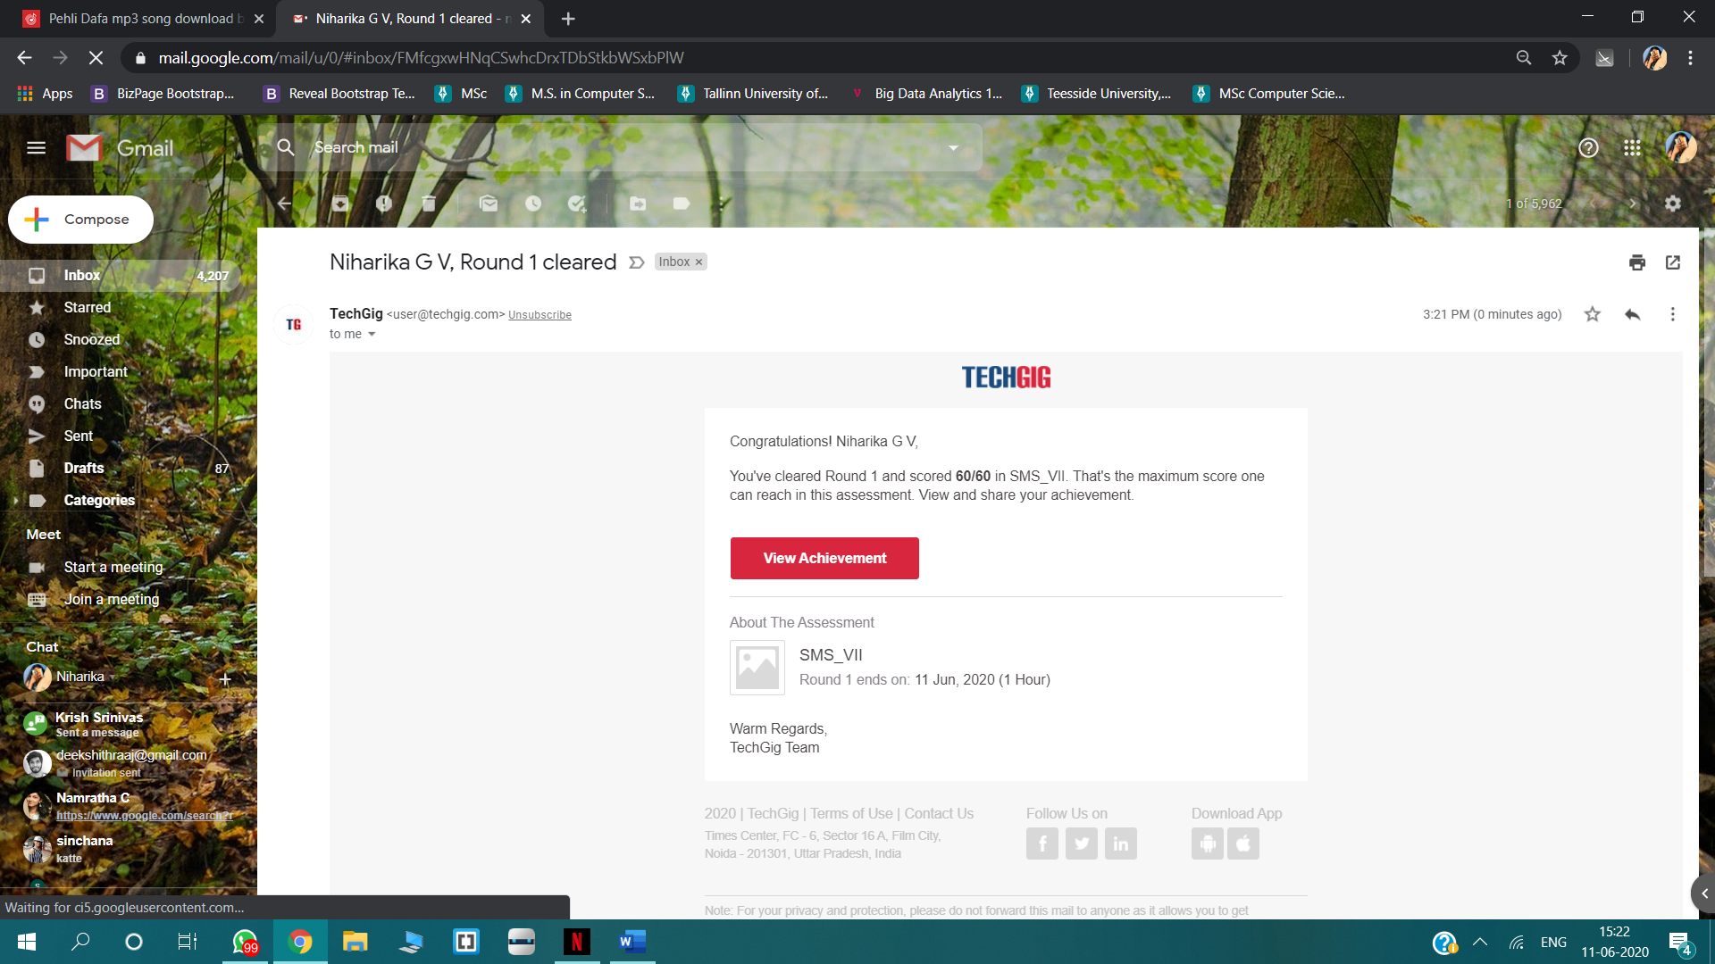

- Certification Course Details
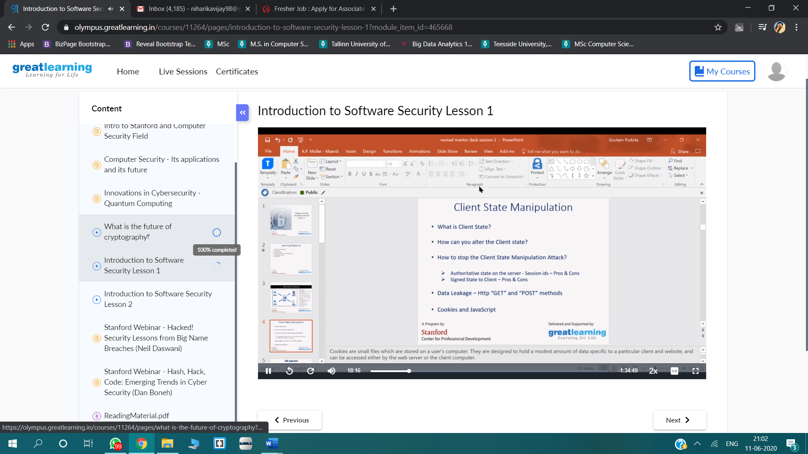

- Coding Challenges:

1. To find sum of digit of given number

Pgrm1:

n=int(input("Enter a number:"))
tot=0
while(n>0):
dig=n%10
tot=tot+dig
n=n//10
print("The total sum of digits is:",tot)

