DAILY ONLINE ACTIVITIES SUMMARY

Date: |  | 09-06-2020 |  |  |  |  | Name: | Niharika G V
Sem & Sec |  | 8th, A |  |  |  |  | USN: | 4AL16CS062
 |  |  |  | Online Test Summary
Subject |  |  | BDA
Max. Marks |  |  | 30 |  |  | Score |  | 18
 |  |  |  | Certification Course Summary
Course |  | Introduction to Hadoop
Certificate Provider |  |  |  | Great learner |  | Duration |  |  | 6 Hrs
 |  |  |  | academy
 |  |  |  | Coding Challenges

Problem Statement: prob1- To find the factorial of given number

Status: Solved

Uploaded the report in Github | Yes
If yes Repository name
 | Coading_event
Uploaded the report in slack | Yes

Online Test Details: (Attach the snapshot and briefly write the report for the same)

Certification Course Details: (Attach the snapshot and briefly write the report for the same)

Coding Challenges Details: (Attach the snapshot and briefly write the report for the same)

- Online Test Deails

- Certification Course Details
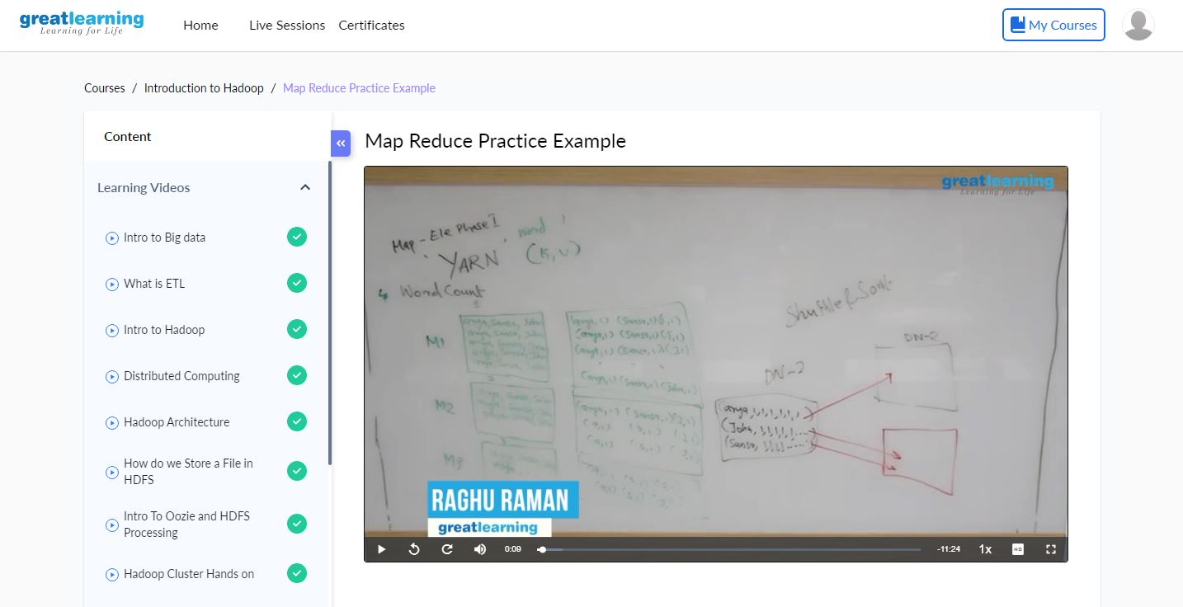

Introduction to Hadoop :
Hadoop is an Apache open source framework written in java that allows distributed processing of large datasets across clusters of computers using simple programming models. The Hadoop framework application works in an environment that provides distributed storage and computation across clusters of computers. Hadoop is designed to scale up from single server to thousands of machines, each offering local computation and storage.

.

How Does Hadoop Work?
It is quite expensive to build bigger servers with heavy configurations that handle large scale processing, but as an alternative, you can tie together many commodity computers with single-CPU, as a single functional distributed system and practically, the clustered machines can read the dataset in parallel and provide a much higher throughput. Moreover, it is cheaper than one high-end server. So this is the first motivational factor behind using Hadoop that it runs across clustered and low-cost machines.
Hadoop runs code across a cluster of computers. This process includes the following core tasks that Hadoop performs −
- Data is initially divided into directories and files. Files are divided into uniform sized blocks of 128M and 64M (preferably 128M).
- These files are then distributed across various cluster nodes for further processing.
- HDFS, being on top of the local file system, supervises the processing.
- Blocks are replicated for handling hardware failure.
- Checking that the code was executed successfully.
- Performing the sort that takes place between the map and reduce stages.
- Sending the sorted data to a certain computer.
- Writing the debugging logs for each job.

2) Coding Challenges:

1. To find the factorial of given number

Pgrm1:

num = 7

factorial = 1

if num < 0:
print("Sorry, factorial does not exist for negative numbers")
elif num == 0:
print("The factorial of 0 is 1")
else:
for i in range(1,num + 1):
factorial = factorial*i
print("The factorial of",num,"is",factorial)

