DAILY ONLINE ACTIVITIES SUMMARY

Date: |  | 30-06-2020 |  |  |  |  | Name: | Niharika G V
Sem & Sec |  | 8th,A |  |  |  |  | USN: | 4AL16CS059
 |  |  |  | Online Test Summary
Subject |  |  | NA
Max. Marks |  |  | NA |  |  | Score |  |  | NA
 |  |  |  | Certification Course Summary
Course |  | Introduction to cyber security
Certificate Provider |  |  |  | Great learner |  | Duration |  |  | 5.5 Hrs
 |  |  |  | academy
 |  |  |  | Coding Challenges

Problem Statement: prob1-Program to find given number is perfect number or not

Status: Solved

Uploaded the report in Github | Yes
If yes Repository name
 | Daily_progress
Uploaded the report in slack | Yes

Online Test Details: (Attach the snapshot and briefly write the report for the same)

Certification Course Details: (Attach the snapshot and briefly write the report for the same)

Coding Challenges Details: (Attach the snapshot and briefly write the report for the same)

- Certification Course Details
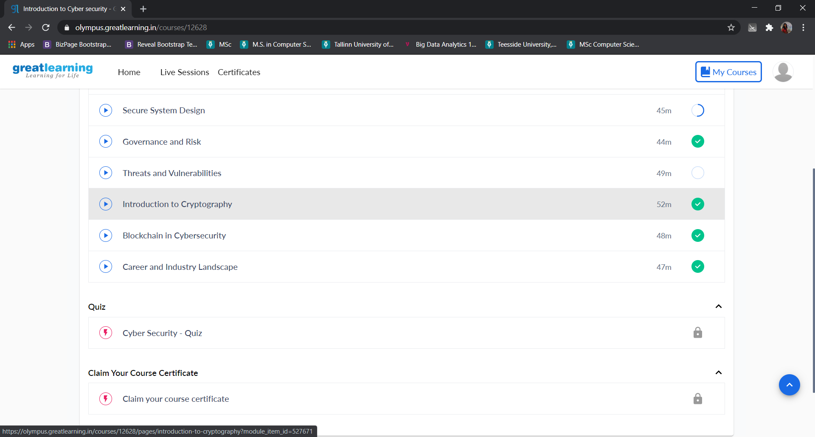

2) Coding Challenges:

1. Program to find given number is perfect number or not
Pgrm1:

n = int(input("Enter any number: "))
sum1 = 0
for i in range(1, n):
if(n % i == 0):
sum1 = sum1 + i
if (sum1 == n):
print("The number is a Perfect number!")
else:
print("The number is not a Perfect number!")

