**DAILY ONLINE ACTIVITIES SUMMARY**

|  |  |  |  |  |  |  |  |
| --- | --- | --- | --- | --- | --- | --- | --- |
| **Date:** | **08/06/2020** | | | | **Name:** | **Niharika G V** | |
| **Sem & Sec** | **8th sem, A sec** | | | | **USN:** | **4AL16CS059** | |
| **Online Test Summary** | | | | | | | |
| **Subject** | | **SMS** | | | | | |
| **Max. Marks** | | **60** | | **Score** | | **60** | |
| **Certification Course Summary** | | | | | | | |
| **Course** | **Introduction to Amazon Elastic Compute Cloud (EC2)** | | | | | | |
| **Certificate Provider** | | | **Aws training and certification** | **Duration** | | | **10mins** |
| **Coding Challenges** | | | | | | | |
| **Problem Statement: 1) Function to print binary number using recursion** | | | | | | | |
| **Status: Completed** | | | | | | | |
| **Uploaded the report in Github** | | | | **Yes** | | | |
| **If yes Repository name** | | | | **DailyProgress** | | | |
| **Uploaded the report in slack** | | | | **Yes** | | | |

Online Test Details:



Certification Course Details:

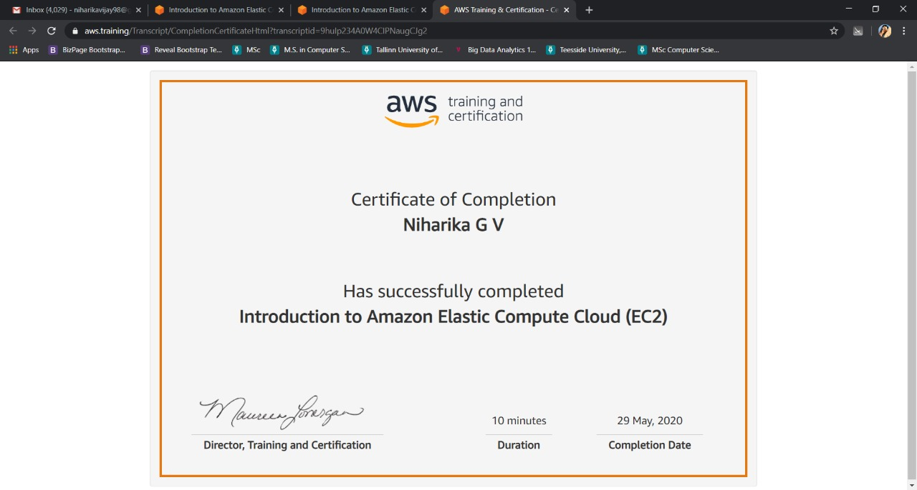

Coding Challenges Details:

1)

def convertToBinary(n):

if n > 1:

convertToBinary(n//2)

print(n % 2,end = '')

dec = 34

convertToBinary(dec)

print()