**DAILY ONLINE ACTIVITIES SUMMARY**

|  |  |  |  |  |  |  |  |
| --- | --- | --- | --- | --- | --- | --- | --- |
| **Date:** | **13-06-2020** | | | | **Name:** | **Niharika G V** | |
| **Sem & Sec** | **8th sem, A sec** | | | | **USN:** | **4AL16CS059** | |
| **Online Test Summary** | | | | | | | |
| **Subject** | | **IoT** | | | | | |
| **Max. Marks** | | **30** | | **Score** | | **26** | |
| **Certification Course Summary** | | | | | | | |
| **Course** | **Introduction toSoftware security** | | | | | | |
| **Certificate Provider** | | | **Aws training and certification** | **Duration** | | | **4Hr** |
| **Coding Challenges** | | | | | | | |
| **Problem Statement: 1)** Python program to display all the prime numbers within an interval | | | | | | | |
| **Status: Completed** | | | | | | | |
| **Uploaded the report in Github** | | | | **Yes** | | | |
| **If yes Repository name** | | | | **Daily Progress** | | | |
| **Uploaded the report in slack** | | | | **Yes** | | | |

Online Test Details:

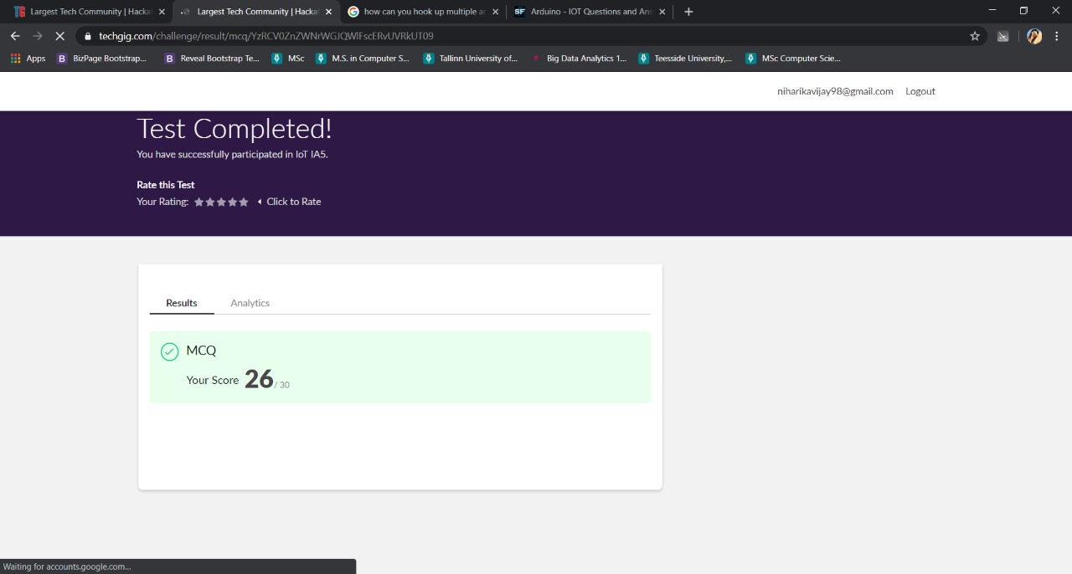

Certification Course Details:



Coding Challenges Details:

1)

lower = 100

upper = 200

print("Prime numbers between", lower, "and", upper, "are:")

for num in range(lower, upper + 1):

if num > 1:

for i in range(2, num):

if (num % i) == 0:

break

else:

print(num)