**DAILY ONLINE ACTIVITIES SUMMARY**

|  |  |  |  |  |  |  |  |
| --- | --- | --- | --- | --- | --- | --- | --- |
| **Date:** | **17-06-2020** | | | | **Name:** | **Niharika G V** | |
| **Sem & Sec** | **8th sem, A sec** | | | | **USN:** | **4AL16CS059** | |
| **Online Test Summary** | | | | | | | |
| **Subject** | | **NA** | | | | | |
| **Max. Marks** | |  | | **Score** | |  | |
| **Certification Course Summary** | | | | | | | |
| **Course** | **Introduction to Software security** | | | | | | |
| **Certificate Provider** | | | **Aws training and certification** | **Duration** | | | **4Hr** |
| **Coding Challenges** | | | | | | | |
| **Problem Statement: 1) To find the sum of a natural number** | | | | | | | |
| **Status: Completed** | | | | | | | |
| **Uploaded the report in Github** | | | | **Yes** | | | |
| **If yes Repository name** | | | | **Daily Progress** | | | |
| **Uploaded the report in slack** | | | | **Yes** | | | |

Online Test Details:

Certification Course Details:

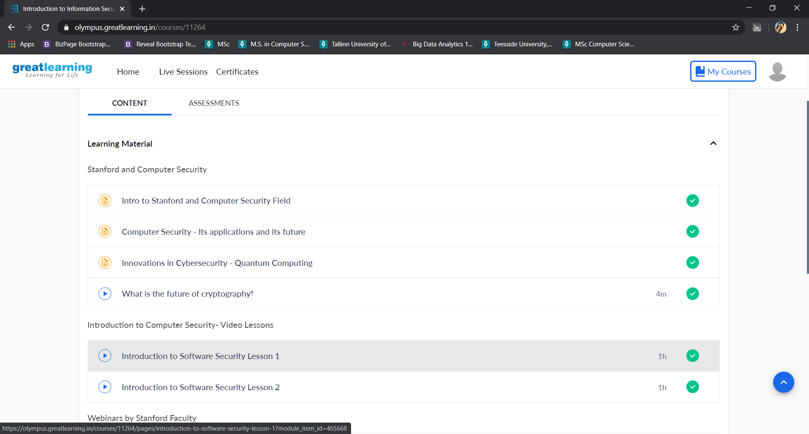

Coding Challenges Details:

def recur_sum(n):

if n <= 1:

return n

else:

return n + recur_sum(n-1)

# change this value for a different result

num = 16

if num < 0:

print("Enter a positive number")

else:

print("The,sum,is",recur_sum(num))