**DAILY ONLINE ACTIVITIES SUMMARY**

|  |  |  |  |  |  |  |  |
| --- | --- | --- | --- | --- | --- | --- | --- |
| **Date:** | **19-06-2020** | | | | **Name:** | **Niharika G V** | |
| **Sem & Sec** | **8th sem, A sec** | | | | **USN:** | **4AL16CS059** | |
| **Online Test Summary** | | | | | | | |
| **Subject** | | **BDA** | | | | | |
| **Max. Marks** | | **30** | | **Score** | | **24** | |
| **Certification Course Summary** | | | | | | | |
| **Course** | **Introduction to Cyber Security** | | | | | | |
| **Certificate Provider** | | | **Great Learning** | **Duration** | | | **5.5Hr** |
| **Coding Challenges** | | | | | | | |
| **Problem Statement: 1) Java Program to check if the String is Null in Java** | | | | | | | |
| **Status: Completed** | | | | | | | |
| **Uploaded the report in Github** | | | | **Yes** | | | |
| **If yes Repository name** | | | | **Daily Progress** | | | |
| **Uploaded the report in slack** | | | | **Yes** | | | |

Online Test Details:

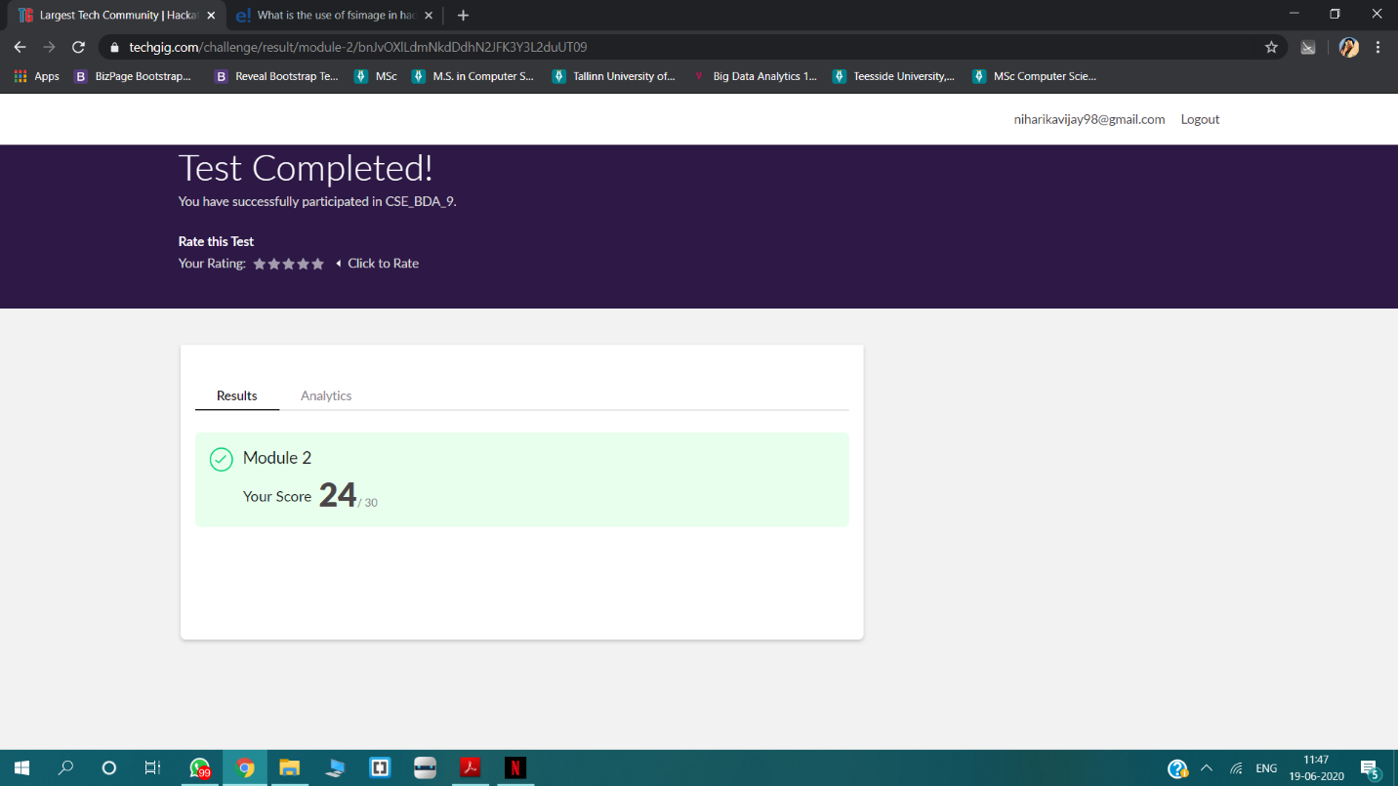

Certification Course Details:



Coding Challenges Details:

X = [[12,7,3],

[4 ,5,6],

[7 ,8,9]]

Y = [[5,8,1],

[6,7,3],

[4,5,9]]

result = [[0,0,0],

[0,0,0],

[0,0,0]]

# iterate through rows

for i in range(len(X)):

# iterate through columns

for j in range(len(X[0])):

result[i][j] = X[i][j] + Y[i][j]

for r in result:

print(r)