**DAILY ONLINE ACTIVITIES SUMMARY**

|  |  |  |  |  |  |  |  |
| --- | --- | --- | --- | --- | --- | --- | --- |
| **Date:** | **22-06-2020** | | | | **Name:** | **Niharika G V** | |
| **Sem & Sec** | **8th sem, A sec** | | | | **USN:** | **4AL16CS059** | |
| **Online Test Summary** | | | | | | | |
| **Subject** | | **SMS** | | | | | |
| **Max. Marks** | | **NA** | | **Score** | | **NA** | |
| **Certification Course Summary** | | | | | | | |
| **Course** | **Introduction to Cyber Security** | | | | | | |
| **Certificate Provider** | | | **Great Learning** | **Duration** | | | **5.5Hr** |
| **Coding Challenges** | | | | | | | |
| **Problem Statement: Concatenate 2 numbers** | | | | | | | |
| **Status: Completed** | | | | | | | |
| **Uploaded the report in Github** | | | | **Yes** | | | |
| **If yes Repository name** | | | | **Daily Progress** | | | |
| **Uploaded the report in slack** | | | | **Yes** | | | |

Online Test Details:

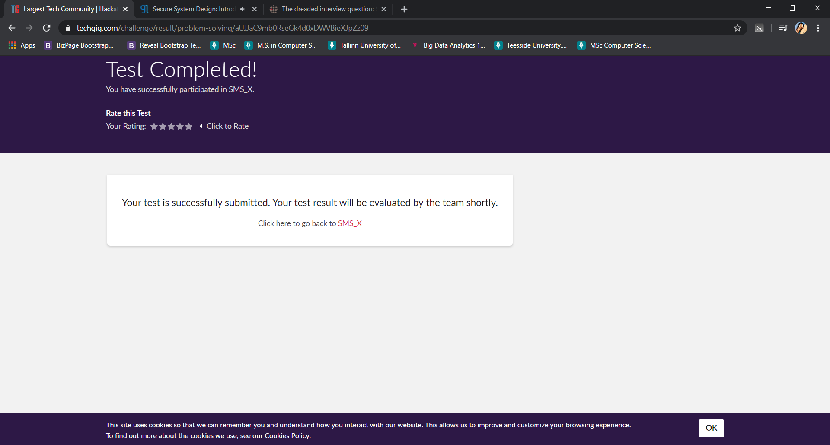

Certification Course Details:



Coding Challenges Details:

def numConcat(num1, num2):

digits = len(str(num2))

num1 = num1 * (10**digits)

num1 += num2

return num1

a = 100

b = 20

print(numConcat(a, b))