**DAILY ONLINE ACTIVITIES SUMMARY**

|  |  |  |  |  |  |  |  |
| --- | --- | --- | --- | --- | --- | --- | --- |
| **Date:** | **28-06-2020** | | | | **Name:** | **Niharika G V** | |
| **Sem & Sec** | **8th sem, A sec** | | | | **USN:** | **4AL16CS09** | |
| **Online Test Summary** | | | | | | | |
| **Subject** | | **No Test Conducted** | | | | | |
| **Max. Marks** | |  | | **Score** | |  | |
| **Certification Course Summary** | | | | | | | |
| **Course** | **Introduction to Cyber Security** | | | | | | |
| **Certificate Provider** | | | **Great Learning** | **Duration** | | | **5.5Hr** |
| **Coding Challenges** | | | | | | | |
| **Problem Statement:** Program to count digit | | | | | | | |
| **Status: Completed** | | | | | | | |
| **Uploaded the report in Github** | | | | **Yes** | | | |
| **If yes Repository name** | | | | **Daily Progress** | | | |
| **Uploaded the report in slack** | | | | **Yes** | | | |

Online Test Details: **No Test Conducted**

Certification Course Details:

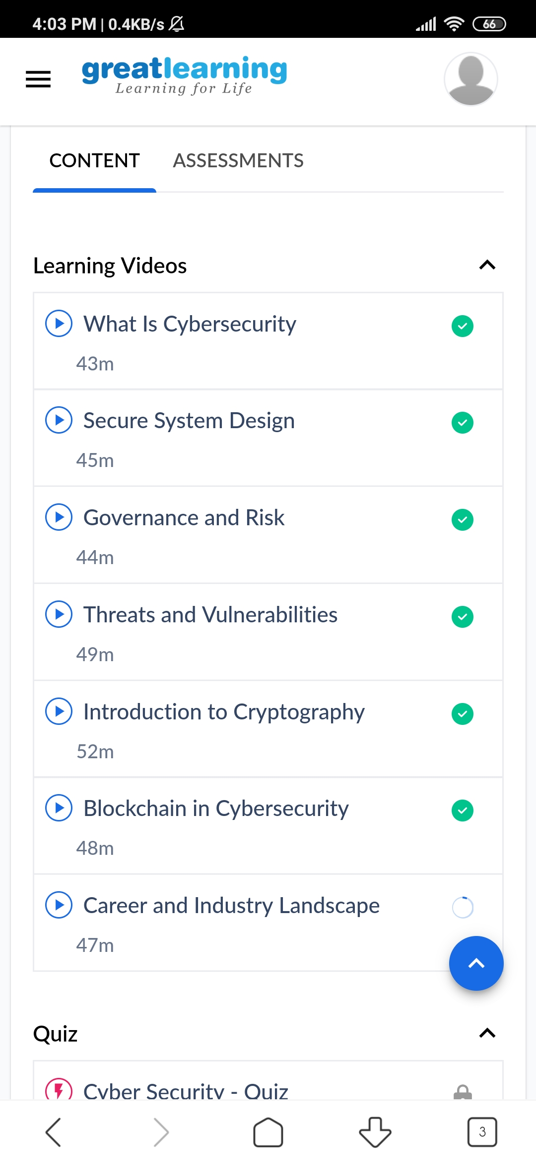

Coding Challenges Details:

n=int(input("Enter number:"))

count=0

while(n>0):

count=count+1

n=n//10

print("The number of digits in the number are:",count)