**DAILY ONLINE ACTIVITIES SUMMARY**

|  |  |  |  |  |  |  |  |  |
| --- | --- | --- | --- | --- | --- | --- | --- | --- |
| **Date:** | **11/7/2020** | | | | | **Name:** | **Nivedita** | |
| **Sem & Sec** | **4th sem /A** | | | | | **USN:** | **4al18cs053** | |
| **Online Test Summary** | | | | | | | | |
| **Subject** | | **---** | | | | | | |
| **Max. Marks** | | **--** | | **Score** | | | **--** | |
| **Certification Course Summary** | | | | | | | | |
| **Course** | **Python data structure** | | | | | | | |
| **Certificate Provider** | | | **Coursera for students** | | **Duration** | | | **9 weeks** |
| **Coding Challenges** | | | | | | | | |
| **Problem Statement:** **Write a Java program for Reversal algorithm for array rotation by 3** | | | | | | | | |
| **Status: done** | | | | | | | | |
| **Uploaded the report in Github** | | | | | **yes** | | | |
| **If yes Repository name** | | | | | [**https://github.com/nivi-nivedita/lockdown-coding-program/blob/master/java%20program%20(reverse%20algorithum).txt**](https://github.com/nivi-nivedita/lockdown-coding-program/blob/master/java%20program%20(reverse%20algorithum).txt) | | | |
| **Uploaded the report in slack** | | | | | **yes** | | | |

Certification Course Details: I continued the course and completed 3 week.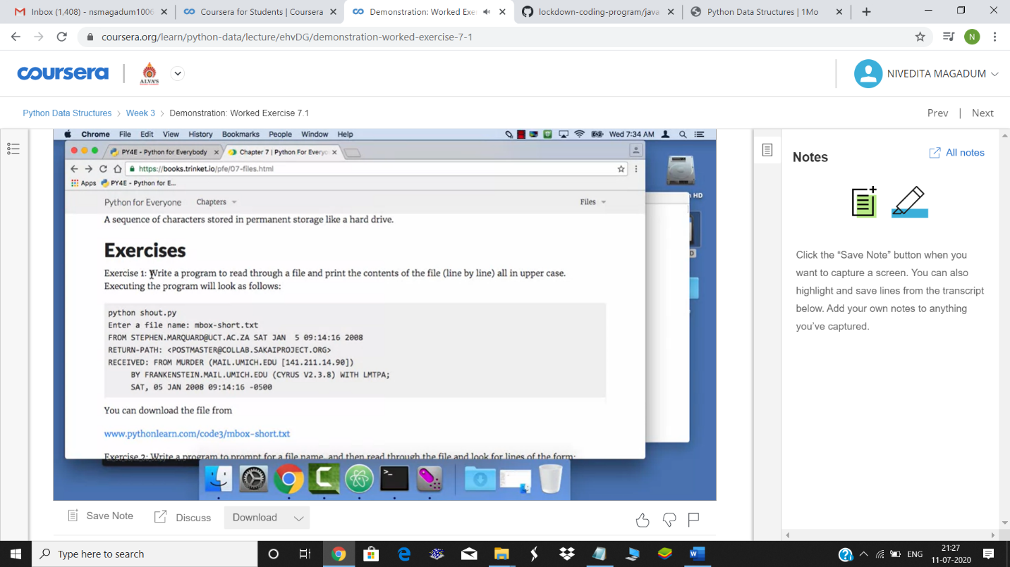

Coding Challenges Details: Write a Java program for Reversal algorithm for array rotation by 3.

