**DAILY ONLINE ACTIVITIES SUMMARY**

|  |  |  |  |  |  |  |  |  |
| --- | --- | --- | --- | --- | --- | --- | --- | --- |
| **Date:** | **14/07/2020** | | | | | **Name:** | **Nivedita** | |
| **Sem & Sec** | **4th sem /A** | | | | | **USN:** | **4al18cs053** | |
| **Online Test Summary** | | | | | | | | |
| **Subject** | | **------** | | | | | | |
| **Max. Marks** | | **---** | | **Score** | | |  | |
| **Certification Course Summary** | | | | | | | | |
| **Course** | **Python data structure** | | | | | | | |
| **Certificate Provider** | | | **coursera** | | **Duration** | | | **9 weeks** |
| **Coding Challenges** | | | | | | | | |
| **Problem Statement:** **Write a java program to check for balanced parenthesis** | | | | | | | | |
| **Status: done** | | | | | | | | |
| **Uploaded the report in Github** | | | | | **yes** | | | |
| **If yes Repository name** | | | | | [**https://github.com/nivi-nivedita/lockdown-coding-program**](https://github.com/nivi-nivedita/lockdown-coding-program) | | | |
| **Uploaded the report in slack** | | | | | **yes** | | | |

Certification Course Details: I continued course and completed 4th and continuing 5th .

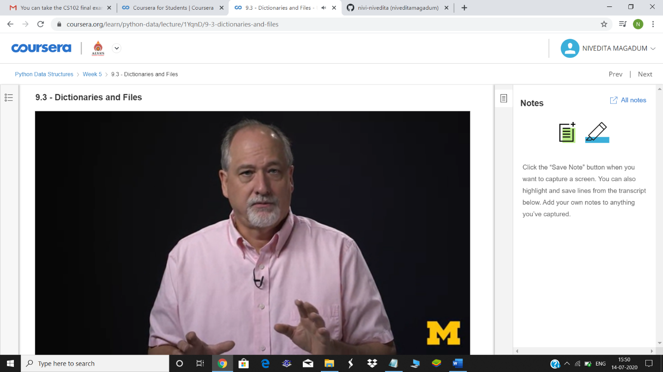

Contributions on MAY ,JUNE ,JULY till today:

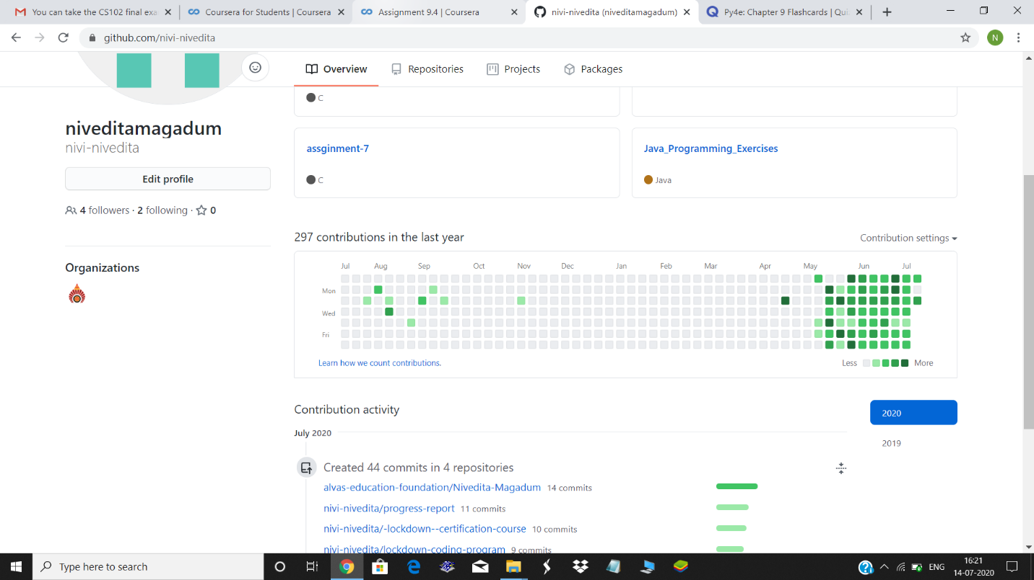

May contributions=113

June contributions=113

July contributions=50

Total=275

Coding Challenges Details: Write a java program to check for balanced parenthesis

