**DAILY ONLINE ACTIVITIES SUMMARY**

|  |  |  |  |  |  |  |  |  |
| --- | --- | --- | --- | --- | --- | --- | --- | --- |
| **Date:** | **18/06/2020** | | | | | **Name:** | **Nivedita** | |
| **Sem & Sec** | **4th sem /A** | | | | | **USN:** | **4al18cs053** | |
| **Online Test Summary** | | | | | | | | |
| **Subject** | | **---** | | | | | | |
| **Max. Marks** | | **--** | | **Score** | | | **----** | |
| **Certification Course Summary** | | | | | | | | |
| **Course** | **Introduction of iot** | | | | | | | |
| **Certificate Provider** | | | **Cisco provider** | | **Duration** | | | **20 hours** |
| **Coding Challenges** | | | | | | | | |
| **Problem Statement:** C**++ program to generate first N Magic Numbers** | | | | | | | | |
| **Status: done** | | | | | | | | |
| **Uploaded the report in Github** | | | | | **yes** | | | |
| **If yes Repository name** | | | | | **<https://github.com/nivi-nivedita/lockdown-coding-program/blob/master/c%2B%2B%20program%20(first%20n%20number).txt>** | | | |
| **Uploaded the report in slack** | | | | | **yes** | | | |

Certification Course Details: today I started new course enterprenuership and completed 2 modules enterd to 3rd module.

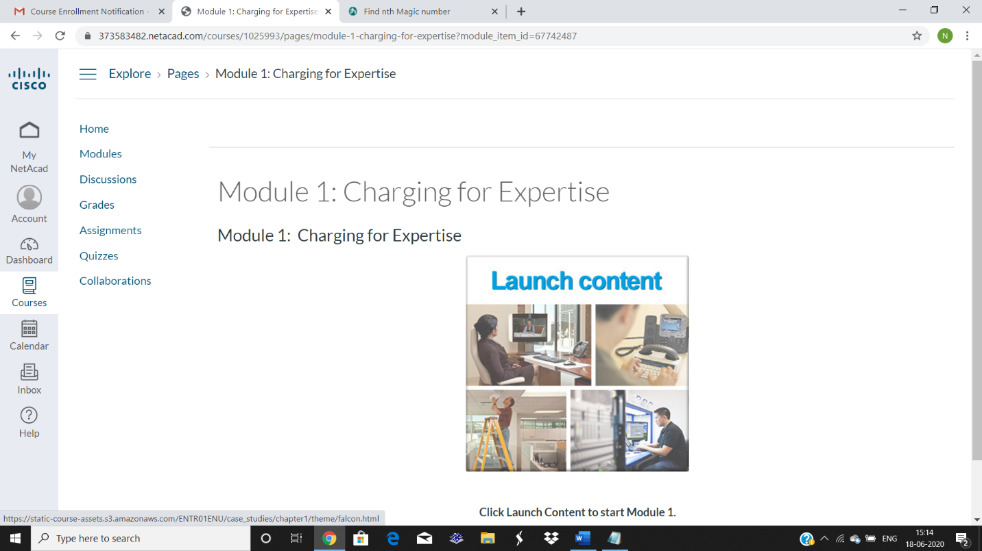

Coding Challenges Details: C++ program to generate first N Magic Numbers.

