**DAILY ONLINE ACTIVITIES SUMMARY**

|  |  |  |  |  |  |  |  |  |
| --- | --- | --- | --- | --- | --- | --- | --- | --- |
| **Date:** | **18/7/2020** | | | | | **Name:** | **Nivedita** | |
| **Sem & Sec** | **4th sem/ A-sec** | | | | | **USN:** | **4al18cs053** | |
| **Online Test Summary** | | | | | | | | |
| **Subject** | | **----** | | | | | | |
| **Max. Marks** | | **30** | | **Score** | | | **---** | |
| **Certification Course Summary** | | | | | | | | |
| **Course** | **Introduction to html5**  **Introduction to big data** | | | | | | | |
| **Certificate Provider** | | | **Coursera** | | **Duration** | | | **3 weeks**  **3weeks** |
| **Coding Challenges** | | | | | | | | |
| **Problem Statement:** **Reverse words in a given String in Python We are given a string and we need to reverse words of given string** | | | | | | | | |
| **Status:done** | | | | | | | | |
| **Uploaded the report in Github** | | | | | **yes** | | | |
| **If yes Repository name** | | | | | **<https://github.com/nivi-nivedita/lockdown-coding-program/blob/master/python%20program(reverse%20string).txt>** | | | |
| **Uploaded the report in slack** | | | | | **yes** | | | |

Certification Course Details: I continued same course and completed 1 week .

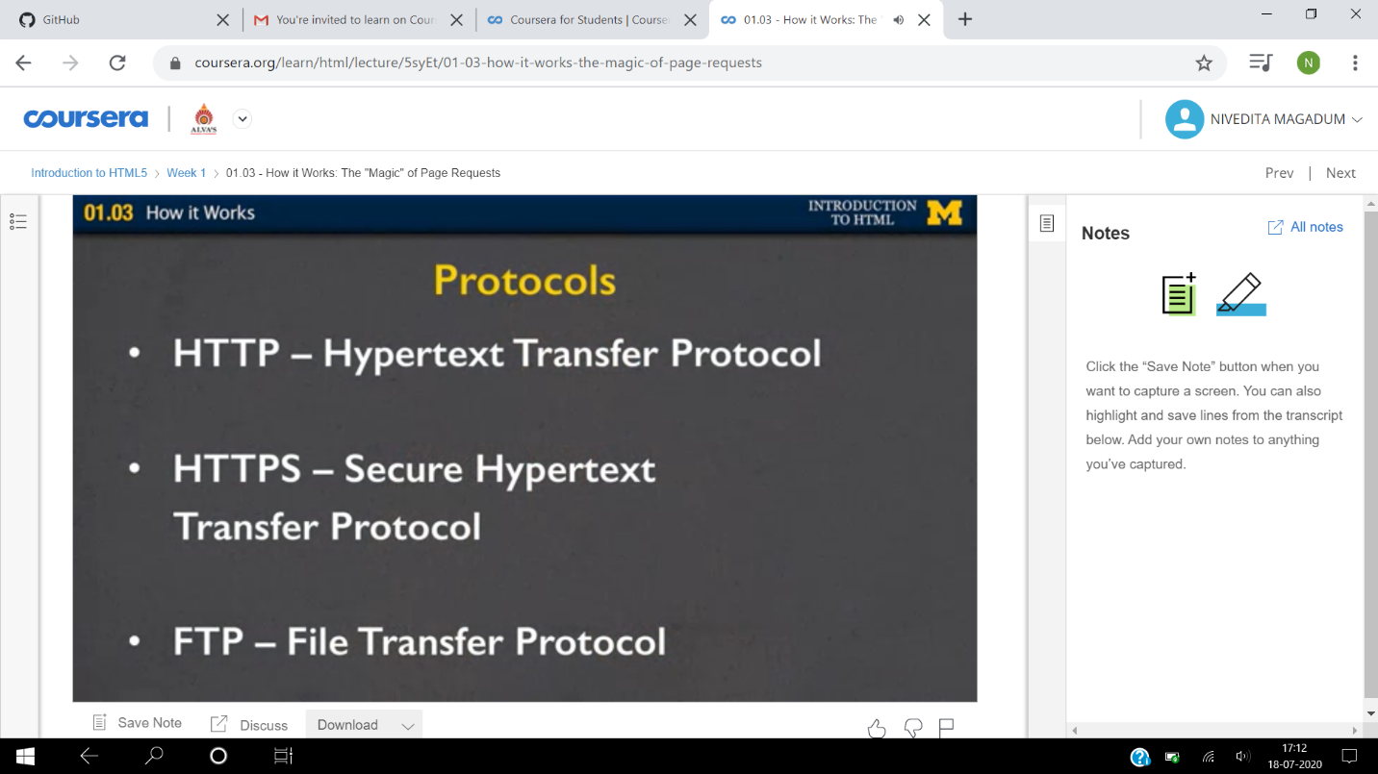

I started again a new course “big data”.

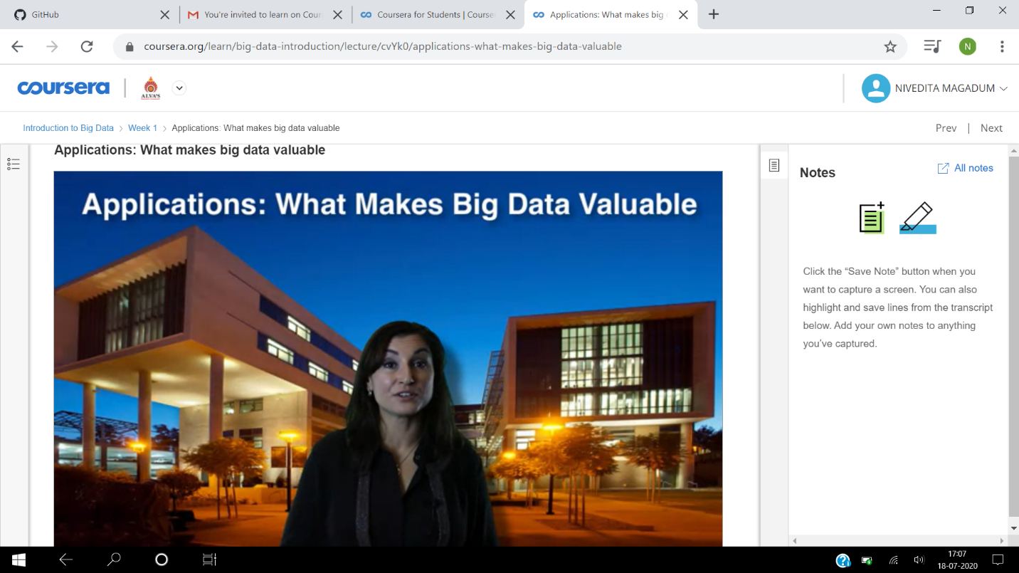

Coding Challenges Details: Reverse words in a given String in Python We are given a string and we need to reverse words of given string .

Executed and uploaded.

