**DAILY ONLINE ACTIVITIES SUMMARY**

|  |  |  |  |  |  |  |  |  |
| --- | --- | --- | --- | --- | --- | --- | --- | --- |
| **Date:** | **2/7/2020** | | | | | **Name:** | **Nivedita** | |
| **Sem & Sec** | **4th sem /A** | | | | | **USN:** | **4al18cs053** | |
| **Online Test Summary** | | | | | | | | |
| **Subject** | | **----** | | | | | | |
| **Max. Marks** | | **----** | | **Score** | | | **----** | |
| **Certification Course Summary** | | | | | | | | |
| **Course** | **IOS developer** | | | | | | | |
| **Certificate Provider** | | | **udemy** | | **Duration** | | | **49 hours** |
| **Coding Challenges** | | | | | | | | |
| **Problem Statement:** **Write a Java Program minimize the maximum difference between adjacent elements in an array** | | | | | | | | |
| **Status: done** | | | | | | | | |
| **Uploaded the report in Github** | | | | | **yes** | | | |
| **If yes Repository name** | | | | | **<https://github.com/nivi-nivedita/lockdown-coding-program>** | | | |
| **Uploaded the report in slack** | | | | | **yes** | | | |

Certification Course Details: course was so big I cant complete this course tomorrow I will start new course .

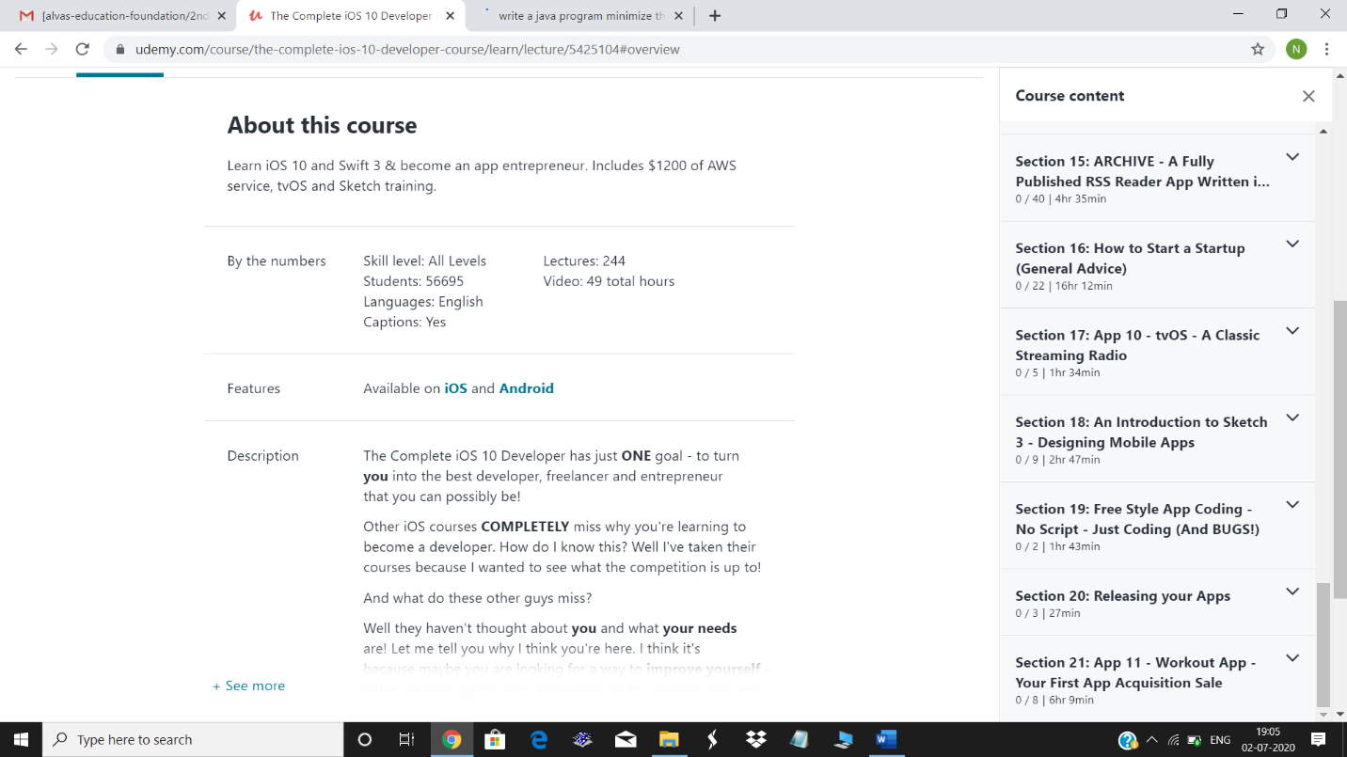

Coding Challenges Details: **Write a Java Program minimize the maximum difference between adjacent elements in an array .**



