**DAILY ONLINE ACTIVITIES SUMMARY**

|  |  |  |  |  |  |  |  |  |
| --- | --- | --- | --- | --- | --- | --- | --- | --- |
| **Date:** | **20/5/2020** | | | | | **Name:** | **Nivedita** | |
| **Sem & Sec** | **2nd year/4th sem/A-section** | | | | | **USN:** | **4al10cs053** | |
| **Online Test Summary** | | | | | | | | |
| **Subject** | | **----** | | | | | | |
| **Max. Marks** | | **30** | | **Score** | | |  | |
| **Certification Course Summary** | | | | | | | | |
| **Course** | **Introduction of html5**  **Introduction to big data** | | | | | | | |
| **Certificate Provider** | | | **Coursera** | | **Duration** | | | **3 weeks** |
| **Coding Challenges** | | | | | | | | |
| **Problem Statement1:** | | | | | | | | |
| **Status:** | | | | | | | | |
| **Uploaded the report in Github** | | | | |  | | | |
| **If yes Repository name** | | | | |  | | | |
| **Uploaded the report in slack** | | | | |  | | | |

Certification Course Details .:I continued course and completed 1 week.

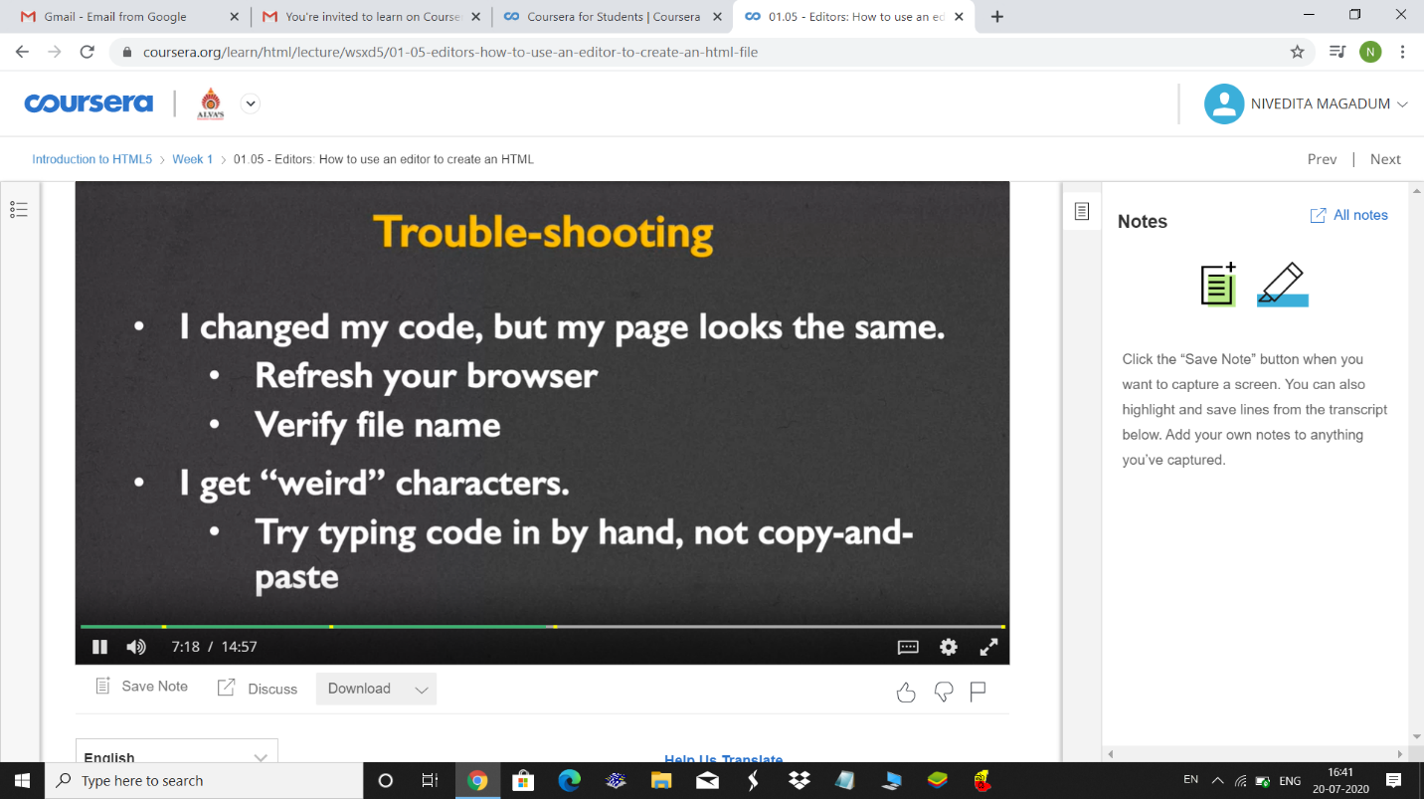

I continued same course which is big data and completed few concepts.



    
    
    
    
    
    
    
    
    