**DAILY ONLINE ACTIVITIES SUMMARY**

|  |  |  |  |  |  |  |  |  |
| --- | --- | --- | --- | --- | --- | --- | --- | --- |
| **Date:** | **22/06/2020** | | | | | **Name:** | **Nivedita** | |
| **Sem & Sec** | **4th sem /A** | | | | | **USN:** | **4al18cs053** | |
| **Online Test Summary** | | | | | | | | |
| **Subject** | | **------** | | | | | | |
| **Max. Marks** | | **-----** | | **Score** | | | **------** | |
| **Certification Course Summary** | | | | | | | | |
| **Course** | **Machine learning** | | | | | | | |
| **Certificate Provider** | | | **coursera** | | **Duration** | | | **11 weeks** |
| **Coding Challenges** | | | | | | | | |
| **Problem Statement:** **Write a Java Program for Modular Exponentiation** | | | | | | | | |
| **Status: done** | | | | | | | | |
| **Uploaded the report in Github** | | | | | **yes** | | | |
| **If yes Repository name** | | | | | [**https://github.com/nivi-nivedita/lockdown-coding-program/blob/master/java%20program(modular).txt**](https://github.com/nivi-nivedita/lockdown-coding-program/blob/master/java%20program(modular).txt) | | | |
| **Uploaded the report in slack** | | | | | **yes** | | | |

Certification Course Details: today I started new course in coursera “MACHINE LEARNING” of 11 weeks.

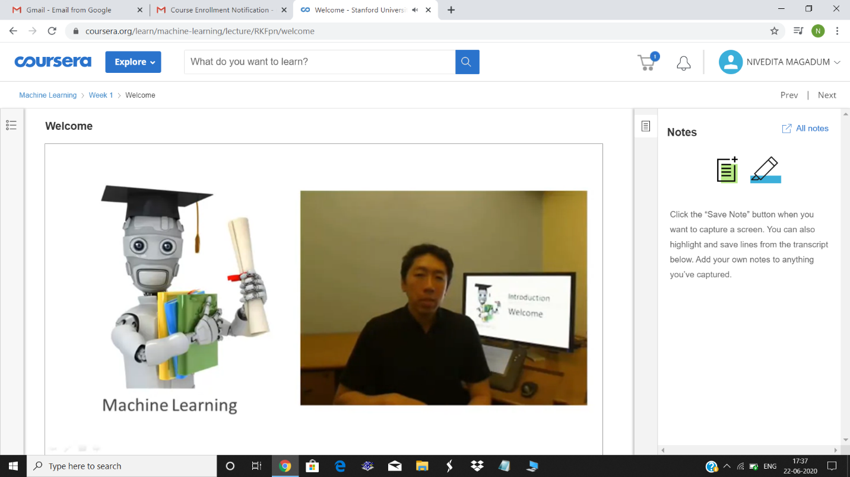

Coding Challenges Details: Write a Java Program for Modular Exponentiation.

Executed and uploaded.

