**DAILY ONLINE ACTIVITIES SUMMARY**

|  |  |  |  |  |  |  |  |  |
| --- | --- | --- | --- | --- | --- | --- | --- | --- |
| **Date:** | **23/06/2020** | | | | | **Name:** | **nivedita** | |
| **Sem & Sec** | **4th sem /A** | | | | | **USN:** | **4al18cs053** | |
| **Online Test Summary** | | | | | | | | |
| **Subject** | | **Webinar iot** | | | | | | |
| **Max. Marks** | | **15** | | **Score** | | | **10** | |
| **Certification Course Summary** | | | | | | | | |
| **Course** | **Machine learning** | | | | | | | |
| **Certificate Provider** | | | **coursera** | | **Duration** | | | **11 weeks** |
| **Coding Challenges** | | | | | | | | |
| **Problem Statement: Python Program to Split the array and add the first part to the end There is a given an array and split it from a specified position, and move the first part of array add to the end** | | | | | | | | |
| **Status: done** | | | | | | | | |
| **Uploaded the report in Github** | | | | | **yes** | | | |
| **If yes Repository name** | | | | | [**https://github.com/nivi-nivedita/lockdown-coding-program/blob/master/python%20program%20(spliting%20number).txt**](https://github.com/nivi-nivedita/lockdown-coding-program/blob/master/python%20program%20(spliting%20number).txt) | | | |
| **Uploaded the report in slack** | | | | | **yes** | | | |

Online Test Details: today online test at 4pm of 15 marks and on webinar IOT .(Sushanth sir)

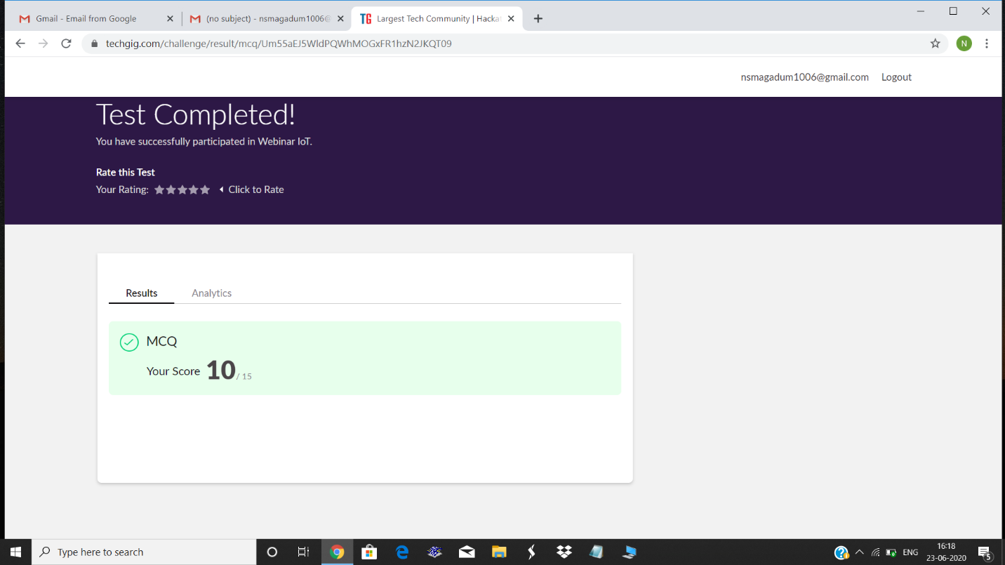

Certification Course Details: continued same course and finished

Week 2.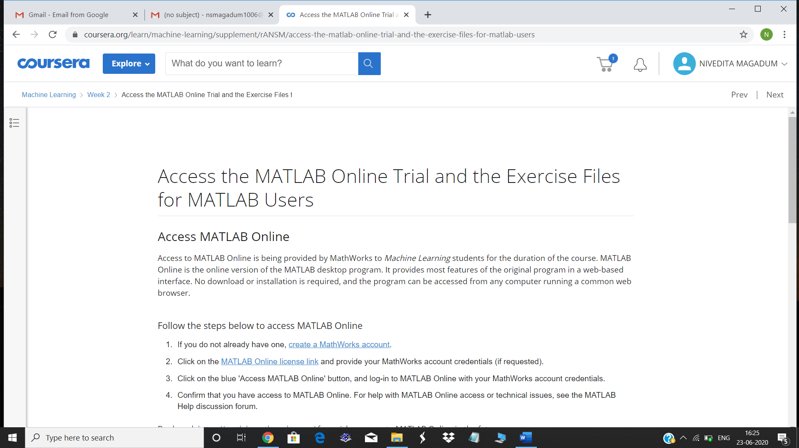

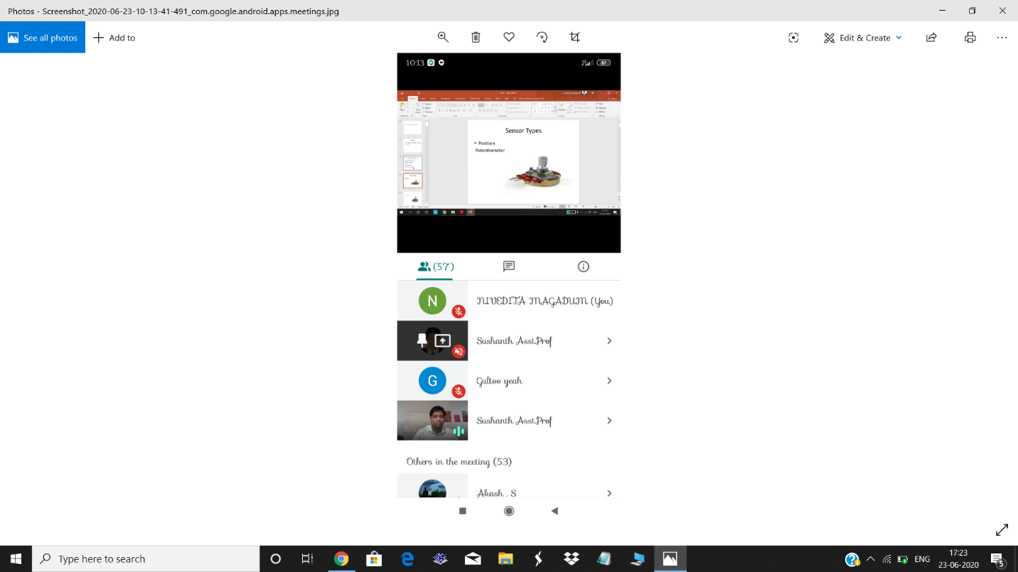

Coding Challenges Detail: Python Program to Split the array and add the first part to the end There is a given an array and split it from a specified position, and move the first part of array add to the end.