**DAILY ONLINE ACTIVITIES SUMMARY**

|  |  |  |  |  |  |  |  |  |
| --- | --- | --- | --- | --- | --- | --- | --- | --- |
| **Date:** | **29/06/2020** | | | | | **Name:** | **Nivedita** | |
| **Sem & Sec** | **4th sem/A** | | | | | **USN:** | **4al18cs053** | |
| **Online Test Summary** | | | | | | | | |
| **Subject** | | **-----** | | | | | | |
| **Max. Marks** | | **-----** | | **Score** | | | **-----** | |
| **Certification Course Summary** | | | | | | | | |
| **Course** | **IOS developer** | | | | | | | |
| **Certificate Provider** | | | **uudemy** | | **Duration** | | | **49 hours** |
| **Coding Challenges** | | | | | | | | |
| **Problem Statement:** **Given a list of numbers, write a Python program to count Even and Odd numbers in a List** | | | | | | | | |
| **Status: done** | | | | | | | | |
| **Uploaded the report in Github** | | | | | **yes** | | | |
| **If yes Repository name** | | | | | [**https://github.com/nivi-nivedita/lockdown-coding-program/blob/master/python%20program(even%20and%20odd).txt**](https://github.com/nivi-nivedita/lockdown-coding-program/blob/master/python%20program(even%20and%20odd).txt) | | | |
| **Uploaded the report in slack** | | | | | **yes** | | | |

Certification Course Details: i continued same course and completed

4th section.

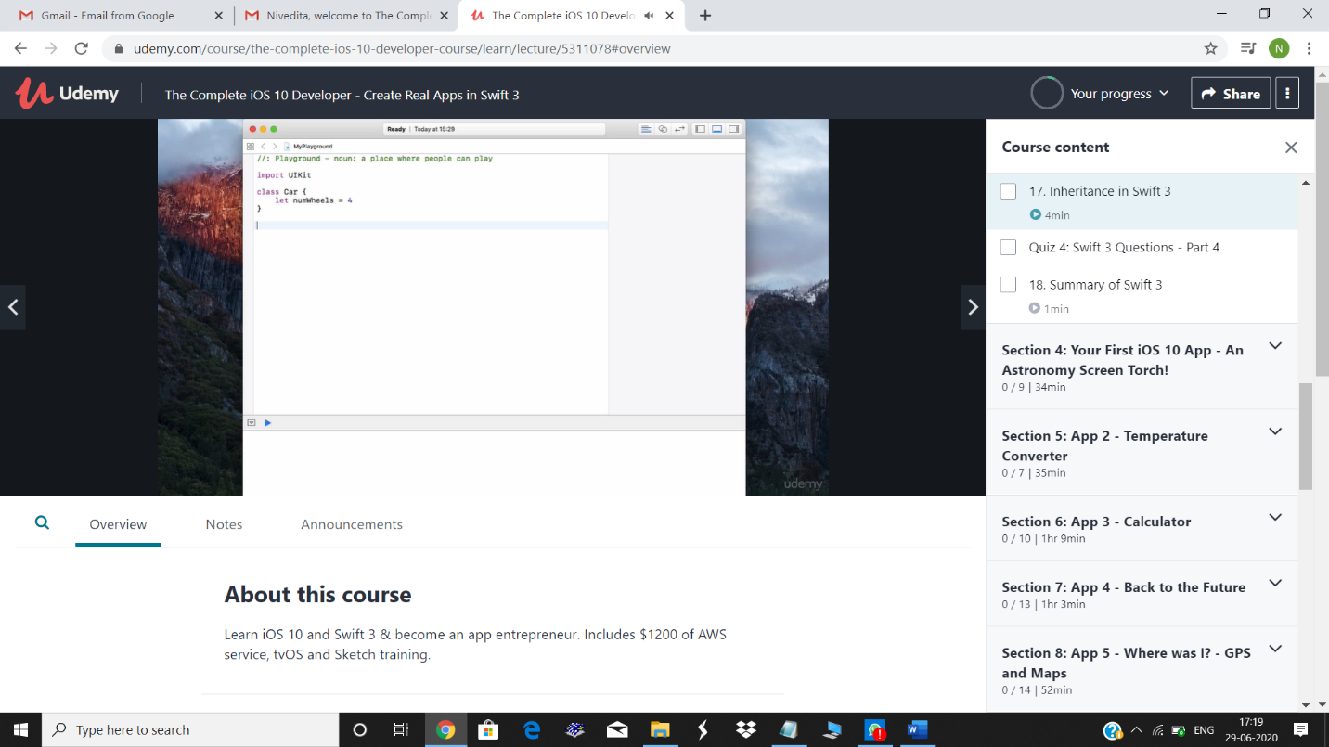

Coding Challenges Details: Given a list of numbers, write a Python program to count Even and Odd numbers in a List.

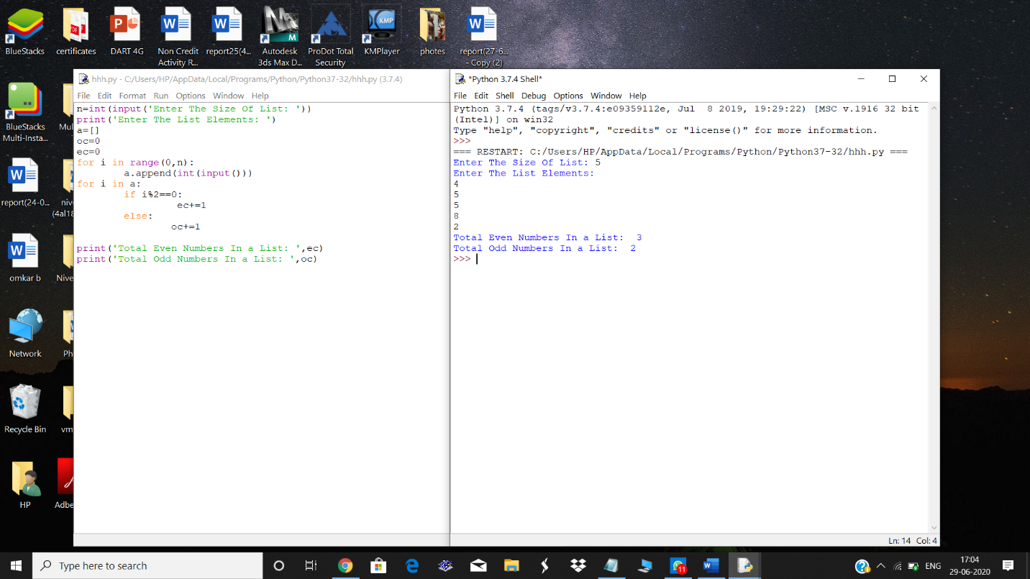

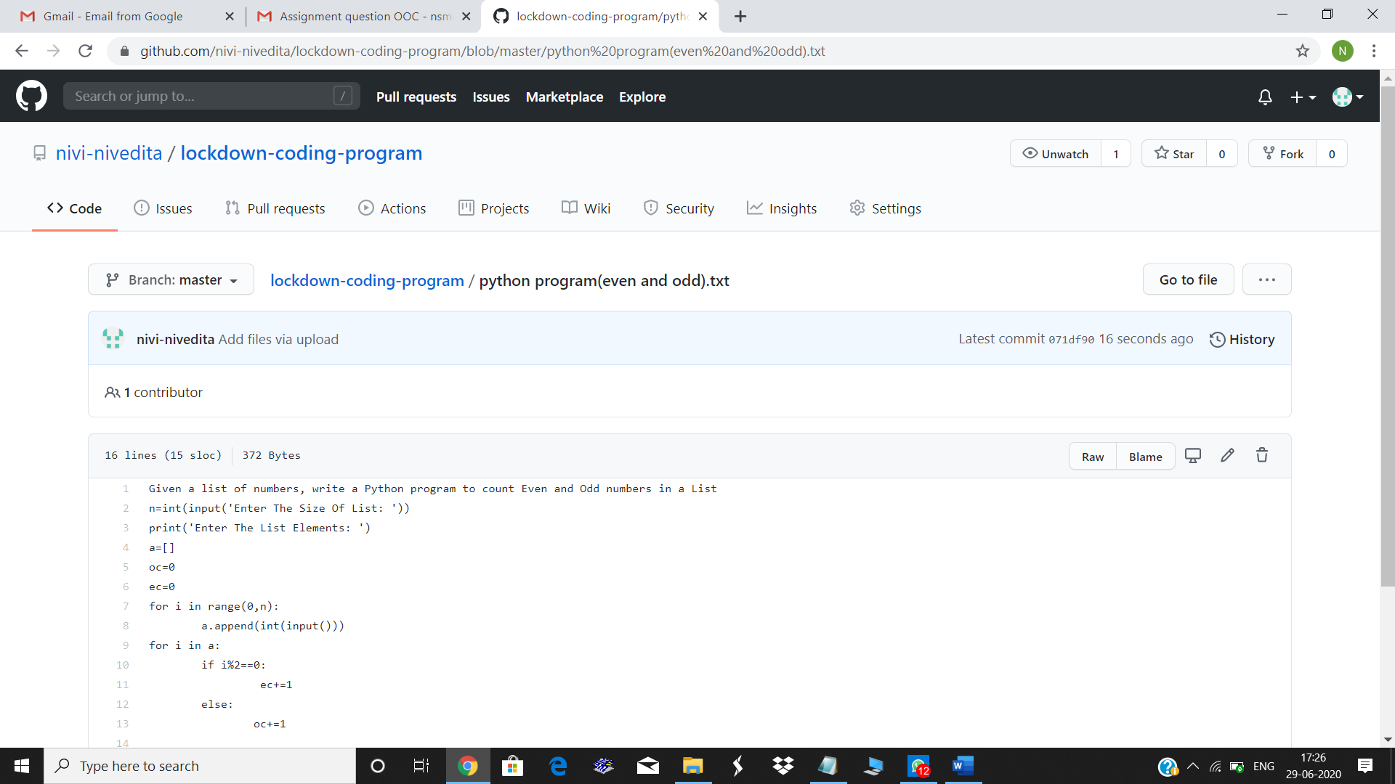

I attended online webinar of CYBER SECURITY(HOD sir)

