**DAILY ONLINE ACTIVITIES SUMMARY**

|  |  |  |  |  |  |  |  |  |
| --- | --- | --- | --- | --- | --- | --- | --- | --- |
| **Date:** | **6/7/2020** | | | | | **Name:** | **Nivedita** | |
| **Sem & Sec** | **4th sem /A** | | | | | **USN:** | **4al18cs053** | |
| **Online Test Summary** | | | | | | | | |
| **Subject** | | **Maths** | | | | | | |
| **Max. Marks** | | **30** | | **Score** | | | **---** | |
| **Certification Course Summary** | | | | | | | | |
| **Course** | **Computer science** | | | | | | | |
| **Certificate Provider** | | | **Saylor.org** | | **Duration** | | | **40 hours** |
| **Coding Challenges** | | | | | | | | |
| **Problem Statement:** **Write a Java program to find the Nth natural number with exactly two bits set** | | | | | | | | |
| **Status: done** | | | | | | | | |
| **Uploaded the report in Github** | | | | | **Yes** | | | |
| **If yes Repository name** | | | | | [**https://github.com/nivi-nivedita/lockdown-coding-program/blob/master/java%20program%20(two%20bit%20set).txt**](https://github.com/nivi-nivedita/lockdown-coding-program/blob/master/java%20program%20(two%20bit%20set).txt) | | | |
| **Uploaded the report in slack** | | | | | **Yes** | | | |

Online Test Details: today I wrote maths exam in written type in A4 sheet. Only 3 questions.

Certification Course Details: I continued same course and completed few modules and quiz.

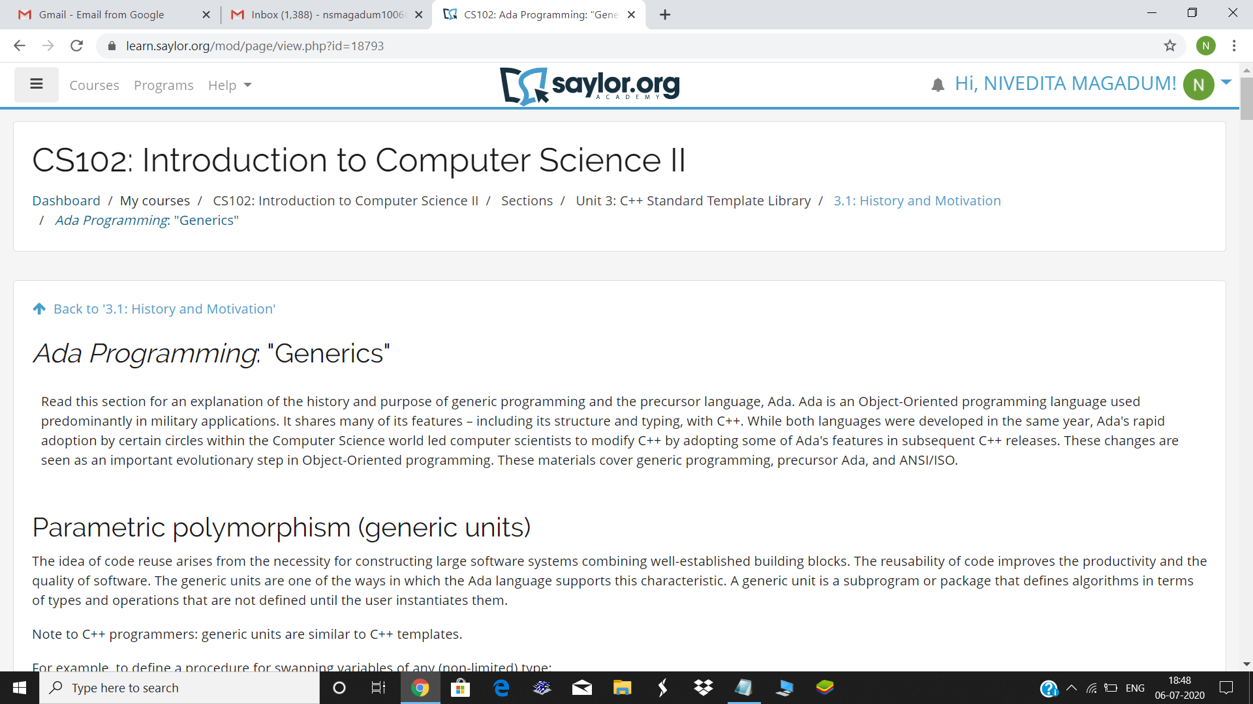

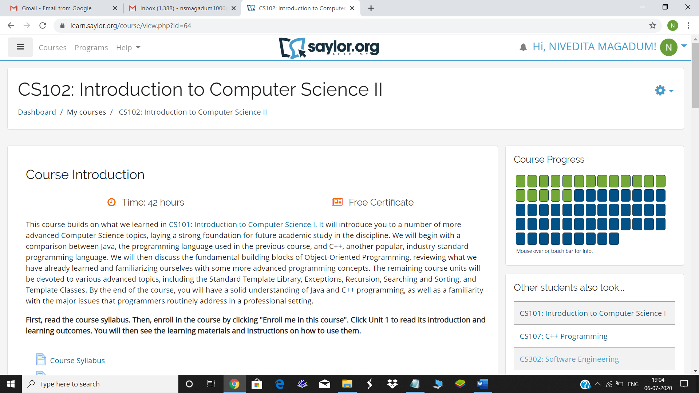

Coding Challenges Details: Write a Java program to find the Nth natural number with exactly two bits set

