**DAILY ONLINE ACTIVITIES SUMMARY**

|  |  |  |  |  |  |  |  |  |
| --- | --- | --- | --- | --- | --- | --- | --- | --- |
| **Date:** | **8/7/2020** | | | | | **Name:** | **Nivedita** | |
| **Sem & Sec** | **4th sem/A** | | | | | **USN:** | **4a18cs053** | |
| **Online Test Summary** | | | | | | | | |
| **Subject** | | **DAA** | | | | | | |
| **Max. Marks** | | **30** | | **Score** | | | **--** | |
| **Certification Course Summary** | | | | | | | | |
| **Course** | **Python data structures** | | | | | | | |
| **Certificate Provider** | | | **Coursera of student** | | **Duration** | | | **9 weeks** |
| **Coding Challenges** | | | | | | | | |
| **Problem Statement:** **Write a java program to find whether the given strings are anagram** | | | | | | | | |
| **Status: done** | | | | | | | | |
| **Uploaded the report in Github** | | | | | **yes** | | | |
| **If yes Repository name** | | | | | **<https://github.com/nivi-nivedita/lockdown-coding-program>** | | | |
| **Uploaded the report in slack** | | | | | **yes** | | | |

Online Test Details: today I wrote DAA test at 10:15 to 11am .

I uploaded soft copy to google classroom.

Certification Course Details: I continued same course and completed 1 week .

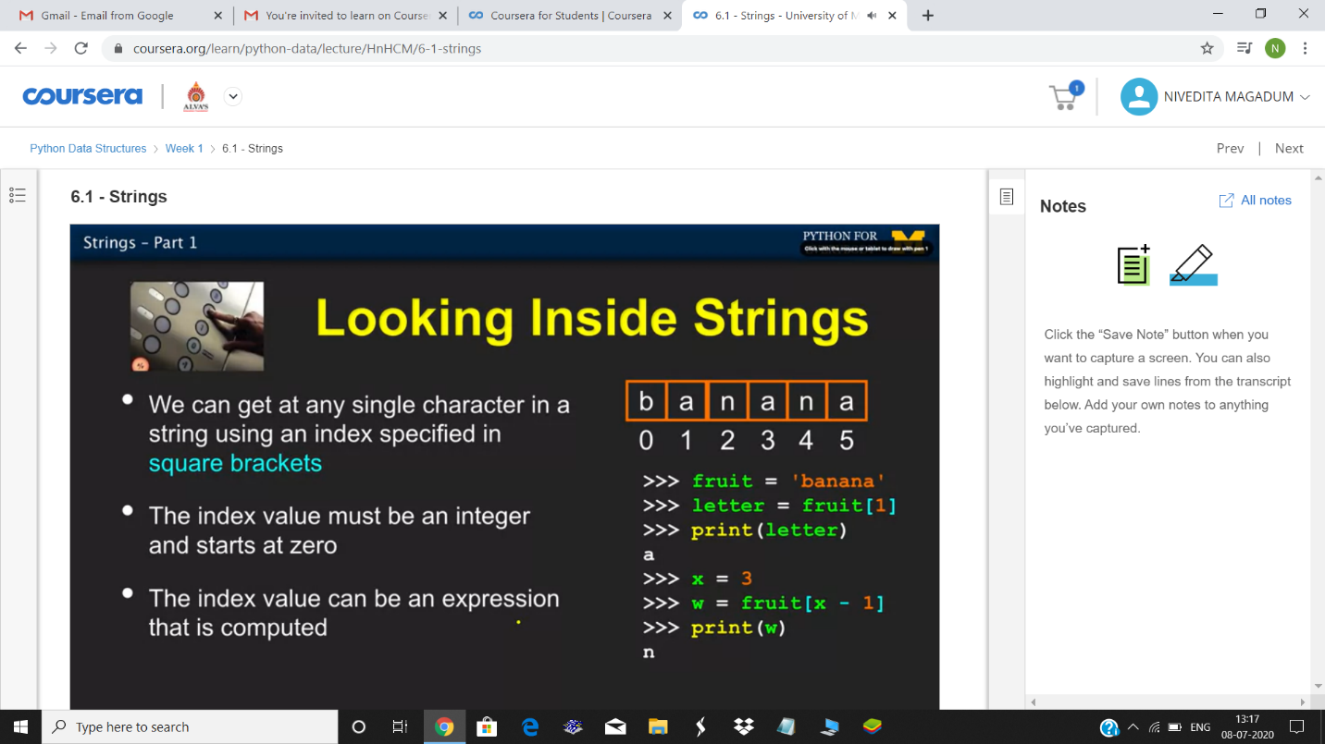

Coding Challenges Details: Write a java program to find whether the given strings are anagram