**DAILY ONLINE ACTIVITIES SUMMARY**

|  |  |  |  |  |  |  |  |  |
| --- | --- | --- | --- | --- | --- | --- | --- | --- |
| **Date:** | **28/05/2020** | | | | | **Name:** | **Nivedita** | |
| **Sem & Sec** | **4th sem/A- sec** | | | | | **USN:** | **4al18cs053** | |
| **Online Test Summary** | | | | | | | | |
| **Subject** | | **MES**  **kannada** | | | | | | |
| **Max. Marks** | | **20**  **50** | | **Score** | | | **16**  **25** | |
| **Certification Course Summary** | | | | | | | | |
| **Course** | **Intr0duction of IOT** | | | | | | | |
| **Certificate Provider** | | | **Cisco networking** | | **Duration** | | | **20 hours** |
| **Coding Challenges** | | | | | | | | |
| **Problem Statement:** C program to find digital root of a number | | | | | | | | |
| **Status:done** | | | | | | | | |
| **Uploaded the report in Github** | | | | | **yes** | | | |
| **If yes Repository name** | | | | | [**https://github.com/nivi-nivedita/lockdown-coding-program/blob/master/digital%20root.txt**](https://github.com/nivi-nivedita/lockdown-coding-program/blob/master/digital%20root.txt) | | | |
| **Uploaded the report in slack** | | | | | **yes** | | | |

Online Test Details: today two are conducted .one is MES (20 questions) and kannada(50 marks).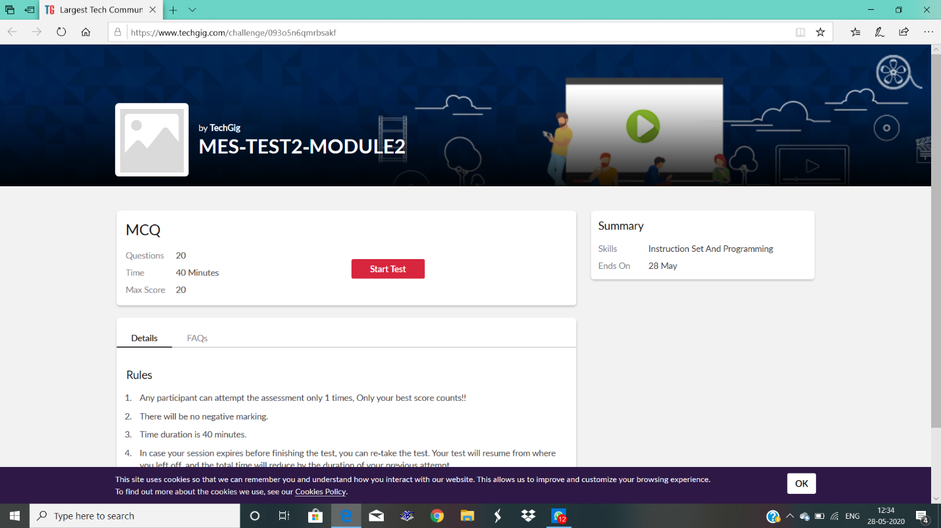

Certification Course Details: In cisco networking Introduction of iot was a course today started.

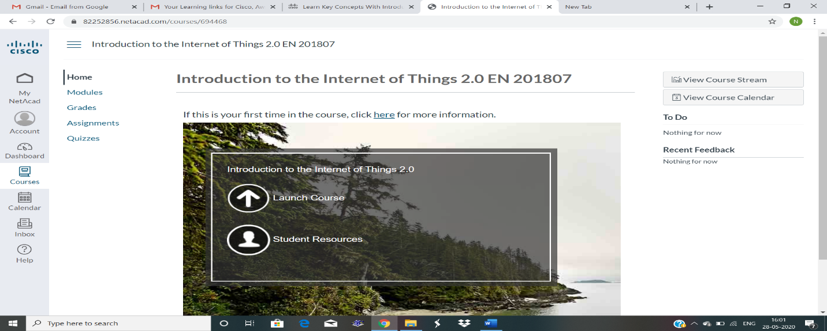

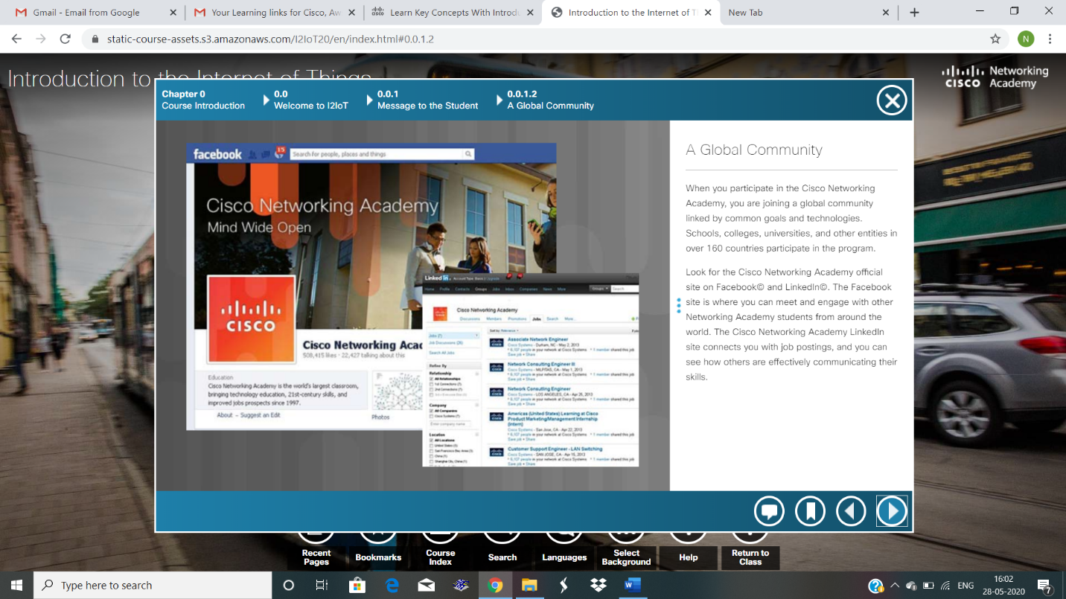

Coding Challenges Details: C program to find digital root of a number

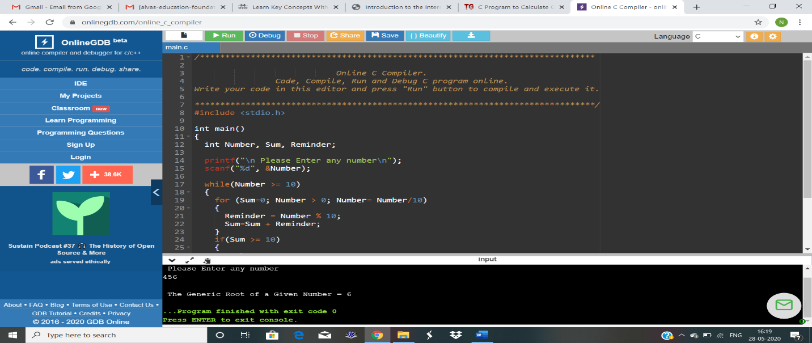

Executed.

