**DAILY ONLINE ACTIVITIES SUMMARY**

|  |  |  |  |  |  |  |  |  |
| --- | --- | --- | --- | --- | --- | --- | --- | --- |
| **Date:** | **29/05/2020** | | | | | **Name:** | **Nivedita** | |
| **Sem & Sec** | **4th sem/ A-sec** | | | | | **USN:** | **4al18cs053** | |
| **Online Test Summary** | | | | | | | | |
| **Subject** | | **OS** | | | | | | |
| **Max. Marks** | | **30** | | **Score** | | | **28** | |
| **Certification Course Summary** | | | | | | | | |
| **Course** | **Introduction of iot** | | | | | | | |
| **Certificate Provider** | | | **Cisco networking** | | **Duration** | | | **20 hours** |
| **Coding Challenges** | | | | | | | | |
| **Problem Statement:** **Write a Java program to Find size of the largest ‘+’ formed by all ones in a binary matrix** | | | | | | | | |
| **Status:done** | | | | | | | | |
| **Uploaded the report in Github** | | | | | **yes** | | | |
| **If yes Repository name** | | | | | [**https://github.com/nivi-nivedita/lockdown-coding-program**](https://github.com/nivi-nivedita/lockdown-coding-program) | | | |
| **Uploaded the report in slack** | | | | | **yes** | | | |

Online Test Details: OS test taken for 45 mins of 30 marks, it contains module 2.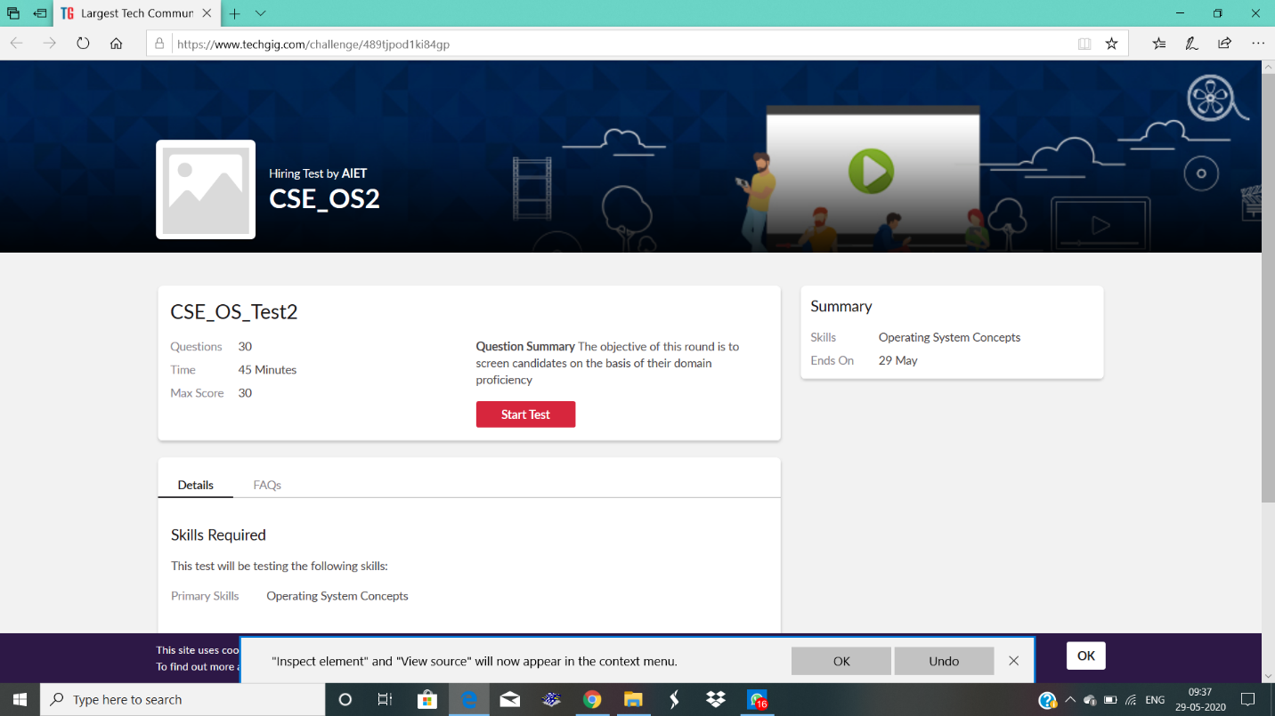

Certification Course Details: I continued same course of cisco (introduction of iot)completed 4 modules .it contains 6 modules, quizes and final exam.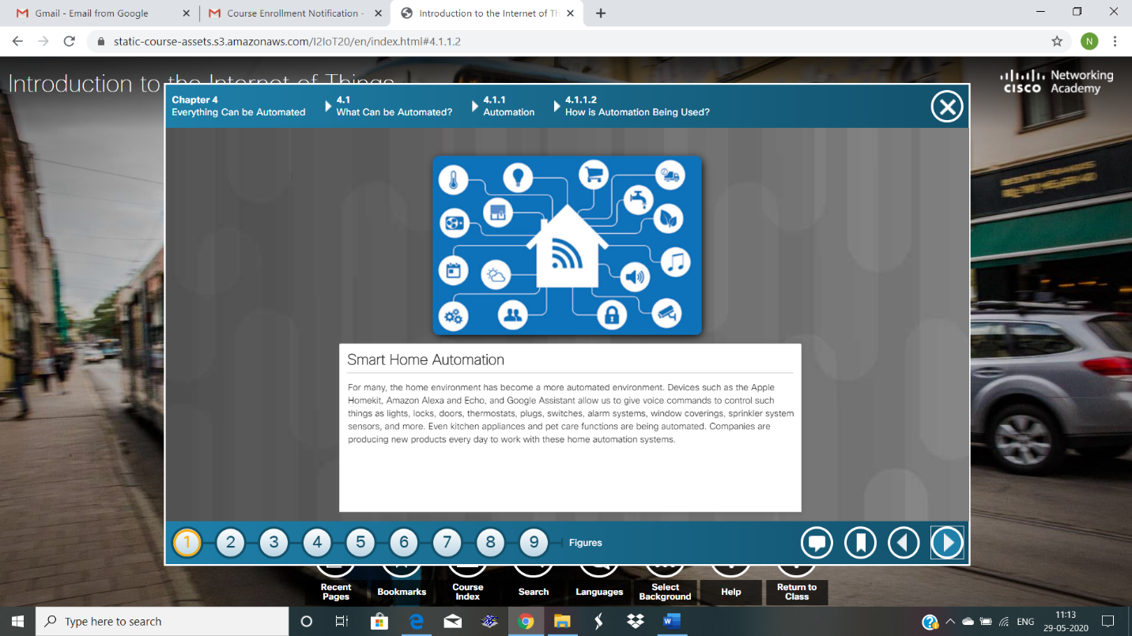

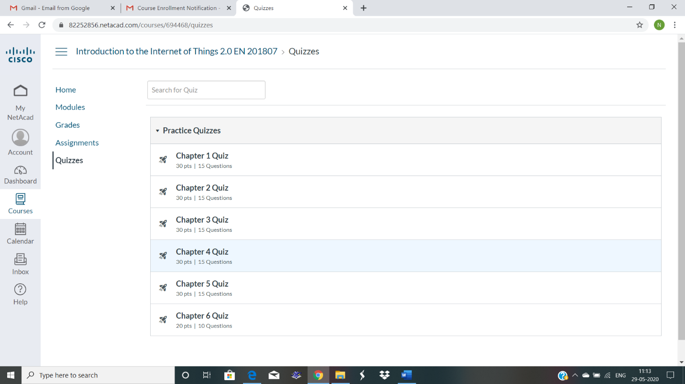

coding Challenges Details: Write a Java program to Find size of the largest ‘+’ formed by all ones in a binary matrix.

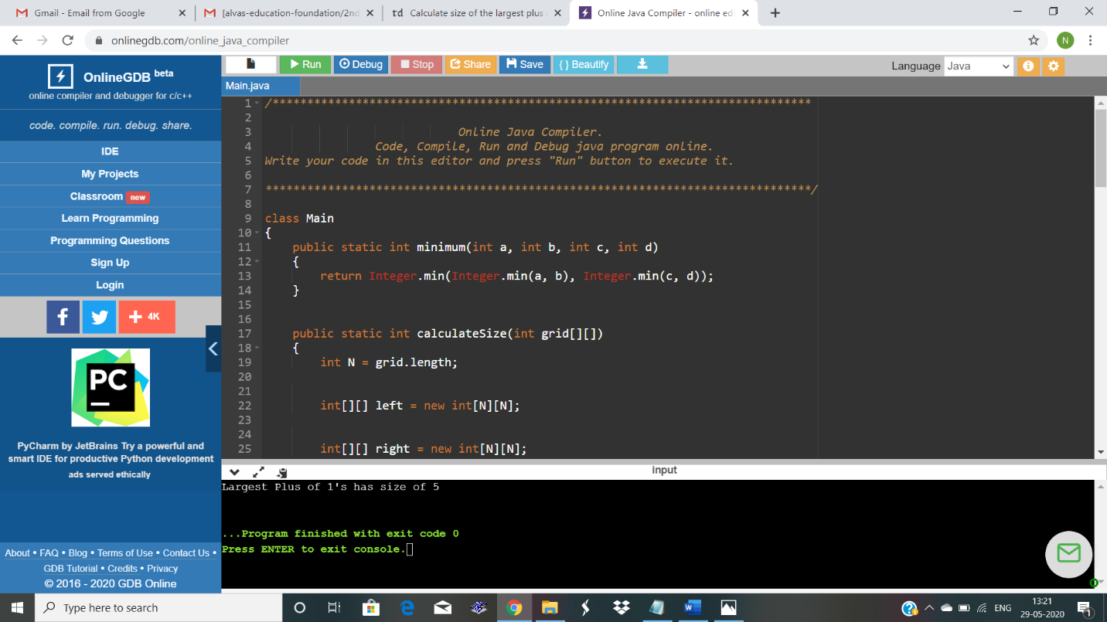

Executed and uploaded in github.

