**DAILY ONLINE ACTIVITIES SUMMARY**

|  |  |  |  |  |  |  |  |  |
| --- | --- | --- | --- | --- | --- | --- | --- | --- |
| **Date:** | **1/06/2020** | | | | | **Name:** | **Nivedita** | |
| **Sem & Sec** | **4th sem/A-sec** | | | | | **USN:** |  | |
| **Online Test Summary** | | | | | | | | |
| **Subject** | | **MATHS** | | | | | | |
| **Max. Marks** | | **30** | | **Score** | | | **28** | |
| **Certification Course Summary** | | | | | | | | |
| **Course** | **Step of RPA(automation anywhere)** | | | | | | | |
| **Certificate Provider** | | | **RPA** | | **Duration** | | | **4 hour** |
| **Coding Challenges** | | | | | | | | |
| **Problem Statement:** Given an array of positive integers. Write a C Program to find the leaders in the array | | | | | | | | |
| **Status:DONE** | | | | | | | | |
| **Uploaded the report in Github** | | | | | **yes** | | | |
| **If yes Repository name** | | | | | <https://github.com/nivi-nivedita/lockdown-coding-program/blob/master/leader.txt> | | | |
| **Uploaded the report in slack** | | | | | **yes** | | | |

Online Test Details: taday maths test foe 30 marks in that 10 are one marks questions and 20 are 2 marks questions of module 5.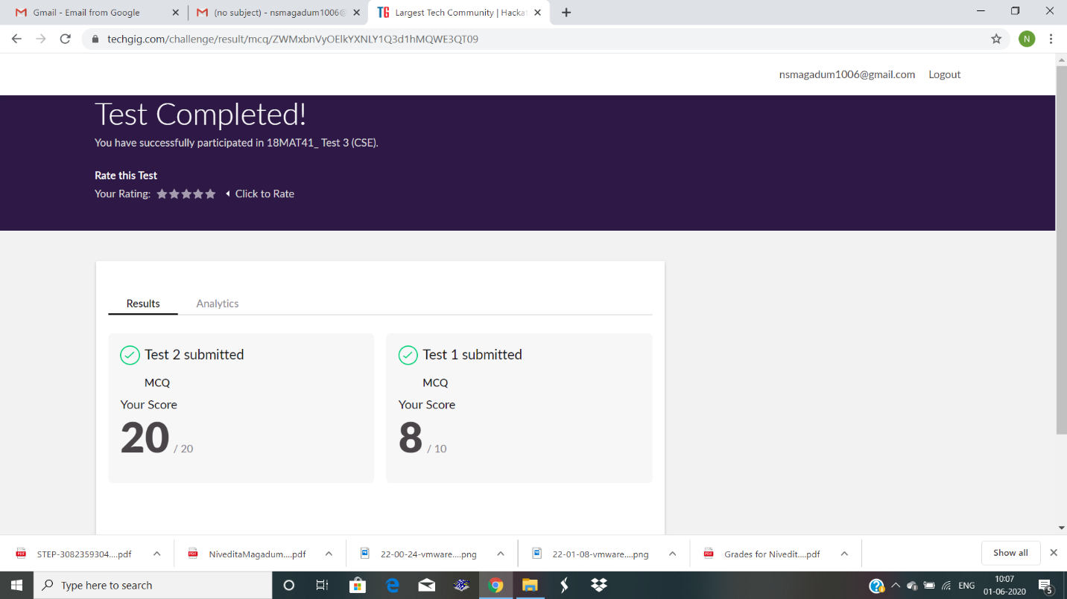

Certification Course Details: step of RPA course held at 4 hours .its all about robotics. And I completed course.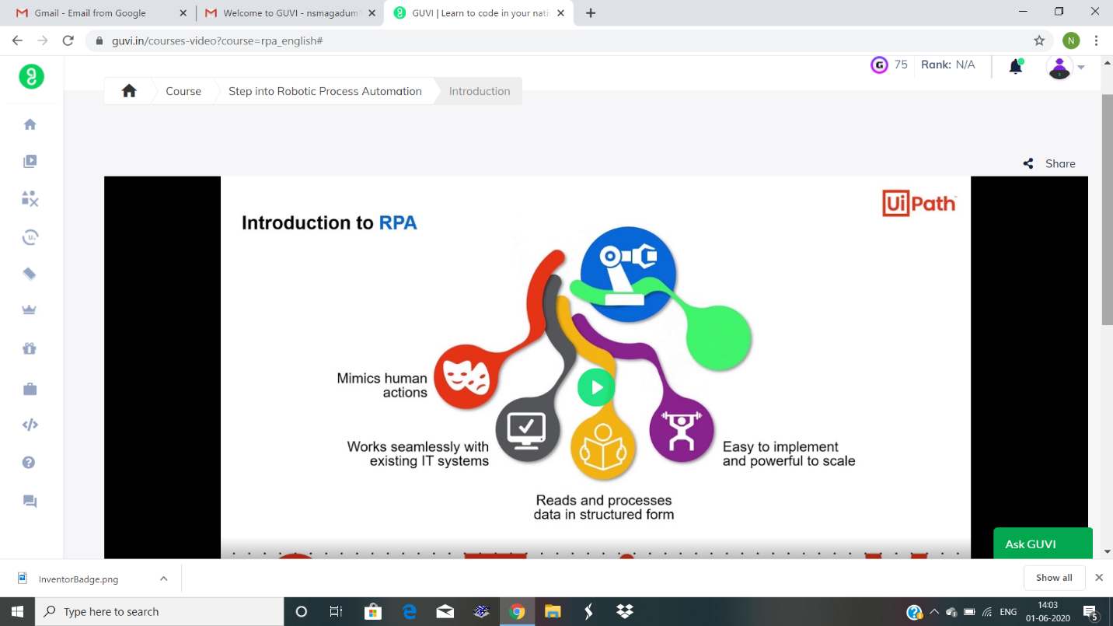

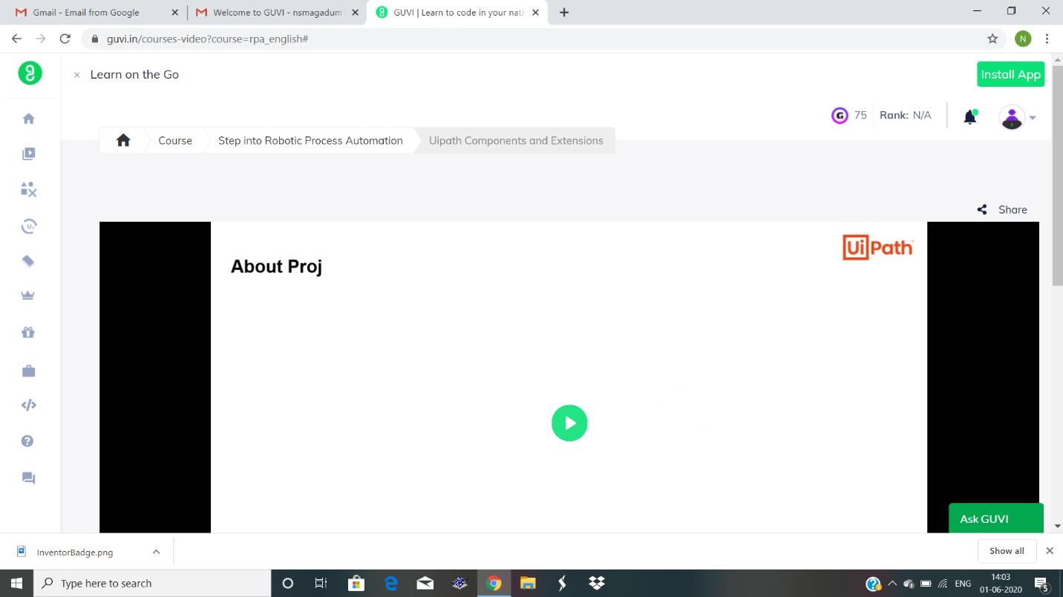

Coding Challenges Details: Given an array of positive integers. Write a C Program to find the leaders in the array

Uploaded in git hub.

