**DAILY ONLINE ACTIVITIES SUMMARY**

|  |  |  |  |  |  |  |  |  |
| --- | --- | --- | --- | --- | --- | --- | --- | --- |
| **Date:** | **2/06/2020** | | | | | **Name:** | **Nivedita** | |
| **Sem & Sec** | **4th sem/ A-sec** | | | | | **USN:** | **4al18cs053** | |
| **Online Test Summary** | | | | | | | | |
| **Subject** | | **-** | | | | | | |
| **Max. Marks** | | **-** | | **Score** | | | **-** | |
| **Certification Course Summary** | | | | | | | | |
| **Course** | **Fundamental of digital marketing** | | | | | | | |
| **Certificate Provider** | | | **Google digital unloaked** | | **Duration** | | | **40 hours** |
| **Coding Challenges** | | | | | | | | |
| **Problem Statement:** **Write a Java program to find Perfect Sum Problem** | | | | | | | | |
| **Status:done** | | | | | | | | |
| **Uploaded the report in Github** | | | | | **yes** | | | |
| **If yes Repository name** | | | | | [**https://github.com/nivi-nivedita/lockdown-coding-program/blob/master/java-program(subsets)**](https://github.com/nivi-nivedita/lockdown-coding-program/blob/master/java-program(subsets)) | | | |
| **Uploaded the report in slack** | | | | | **yes** | | | |

Certification Course Details: “google digital unloaked” in that fundamental of digital marketing course started today and half

Completed.

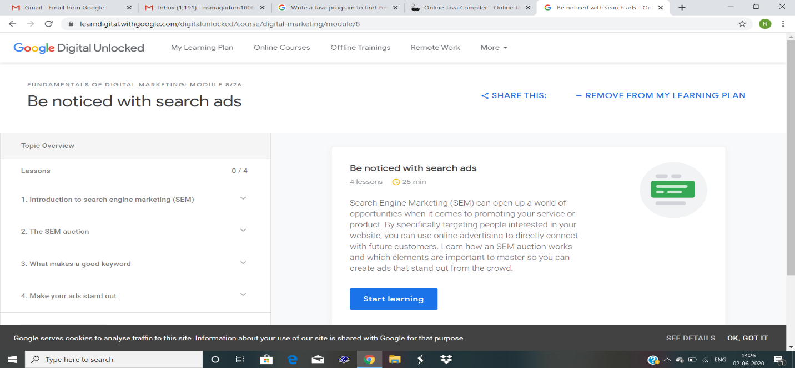

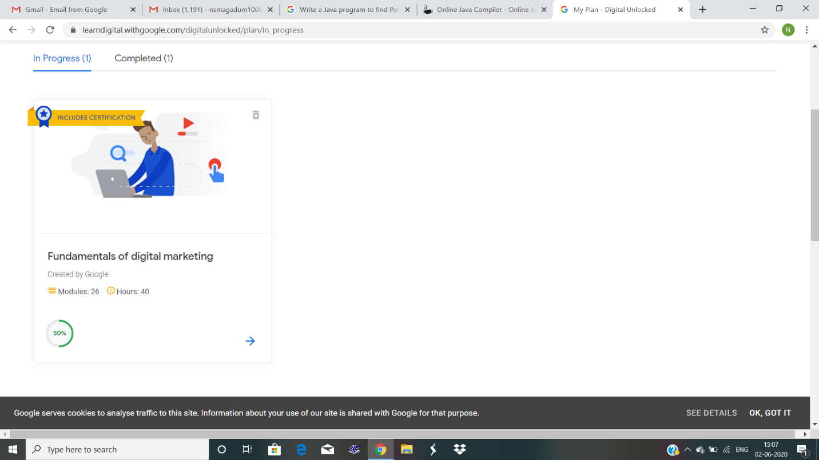

Coding Challenges Details: Given an array arr[] of integers and an integer K, the task is to print all subsets of the given array with the sum equal to the given target K.

Examples:

Input: arr[] = {5, 10, 12, 13, 15, 18}, K = 30

Output: {12, 18}, {5, 12, 13}, {5, 10, 15}

Explanation:

Subsets with sum 30 are:

12 + 18 = 30

5 + 12 + 13 = 30

5 + 10 + 15 = 30

Executed and uploaded.