**DAILY ONLINE ACTIVITIES SUMMARY**

|  |  |  |  |  |  |  |  |  |
| --- | --- | --- | --- | --- | --- | --- | --- | --- |
| **Date:** | **03/06/2020** | | | | | **Name:** | **Nivedita** | |
| **Sem & Sec** | **4th sem/ A-sec** | | | | | **USN:** | **4al18cs053** | |
| **Online Test Summary** | | | | | | | | |
| **Subject** | | **Ooc** | | | | | | |
| **Max. Marks** | | **30** | | **Score** | | | **15** | |
| **Certification Course Summary** | | | | | | | | |
| **Course** | **Fundamental of digital marketing** | | | | | | | |
| **Certificate Provider** | | | **Google digitalunloaked** | | **Duration** | | | **40 hours** |
| **Coding Challenges** | | | | | | | | |
| **Problem Statement: Write a Java program to find Last Digit of a^b (a to the power b) for Large Numbers** | | | | | | | | |
| **Status:done** | | | | | | | | |
| **Uploaded the report in Github** | | | | | **yes** | | | |
| **If yes Repository name** | | | | | [**https://github.com/nivi-nivedita/lockdown-coding-program**](https://github.com/nivi-nivedita/lockdown-coding-program) | | | |
| **Uploaded the report in slack** | | | | | **yes** | | | |

Online Test Details: OOC test conducted today for 30 marks and coding problems only.

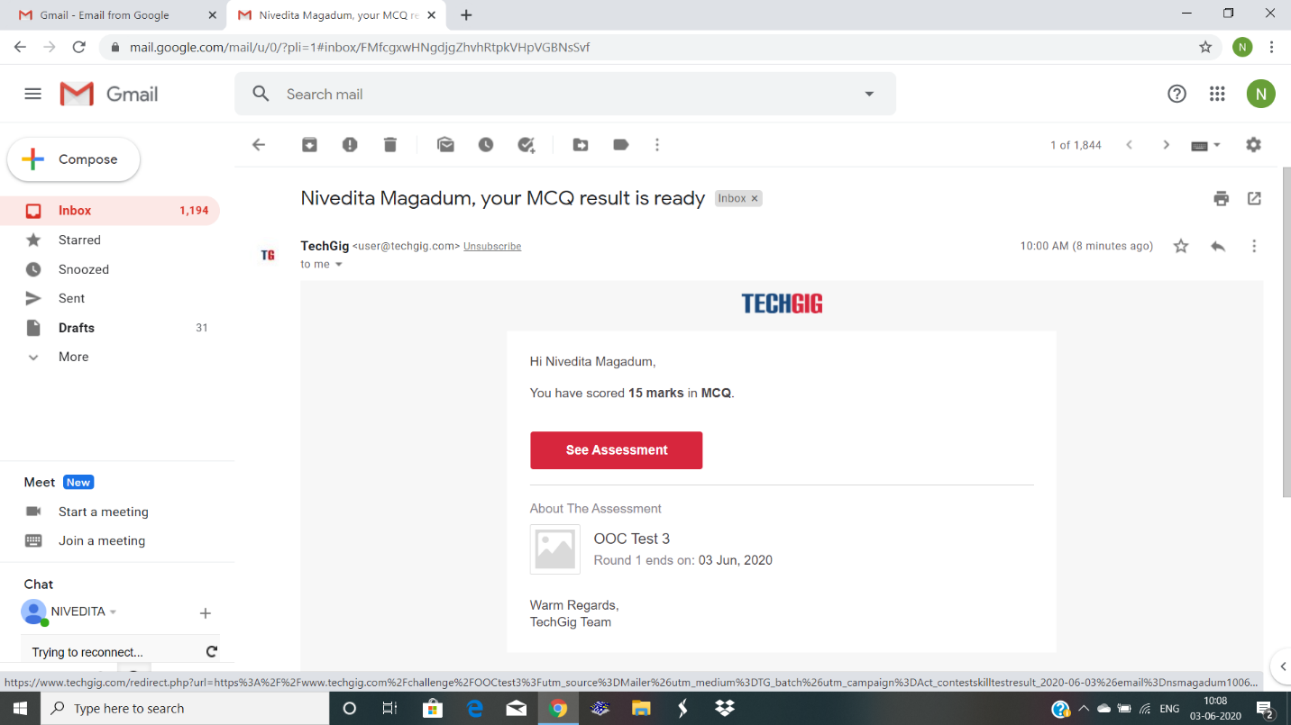

Certification Course Details: I continued same course and completed 70% .its for marketing and online usage.





Coding Challenges Details: Write a Java program to find Last Digit of a^b (a to the power b) for Large Numbers

You are given two integer numbers, the base a (number of digits d, such that 1 <= d <= 1000) and the index b (0 <= b <= 922*10^15). You have to find the last digit of a^b.

Uploaded and executed.

