**DAILY ONLINE ACTIVITIES SUMMARY**

|  |  |  |  |  |  |  |  |  |
| --- | --- | --- | --- | --- | --- | --- | --- | --- |
| **Date:** | **04/06/2020** | | | | | **Name:** | **Nivedita** | |
| **Sem & Sec** | **4th sem/A** | | | | | **USN:** | **4AL18CS053** | |
| **Online Test Summary** | | | | | | | | |
| **Subject** | | **MES** | | | | | | |
| **Max. Marks** | | **20** | | **Score** | | | **16** | |
| **Certification Course Summary** | | | | | | | | |
| **Course** | **Fundamental of digital marketing** | | | | | | | |
| **Certificate Provider** | | | **Google digitalunloaked** | | **Duration** | | | **40 hours** |
| **Coding Challenges** | | | | | | | | |
| **Problem Statement:** **Write a C++ program to find the missing number in array** | | | | | | | | |
| **Status:done** | | | | | | | | |
| **Uploaded the report in Github** | | | | | **yes** | | | |
| **If yes Repository name** | | | | | [**https://github.com/nivi-nivedita/lockdown-coding-program/blob/master/c%2B%2B%20program%20(missing%20element).txt**](https://github.com/nivi-nivedita/lockdown-coding-program/blob/master/c%2B%2B%20program%20(missing%20element).txt) | | | |
| **Uploaded the report in slack** | | | | | **yes** | | | |

Online Test Details: MES test taken at 2 pm to 2:30 pm for 20 marks.

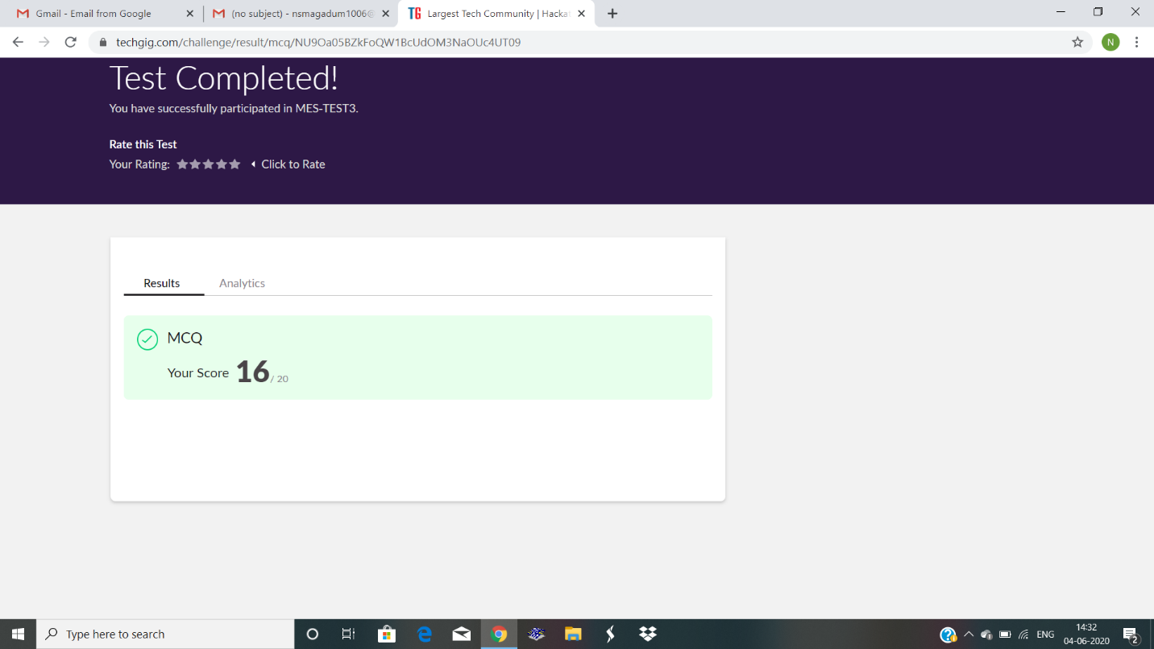

Certification Course Details: I continued course and completed 99%.but 1%was test.to complete and completing.

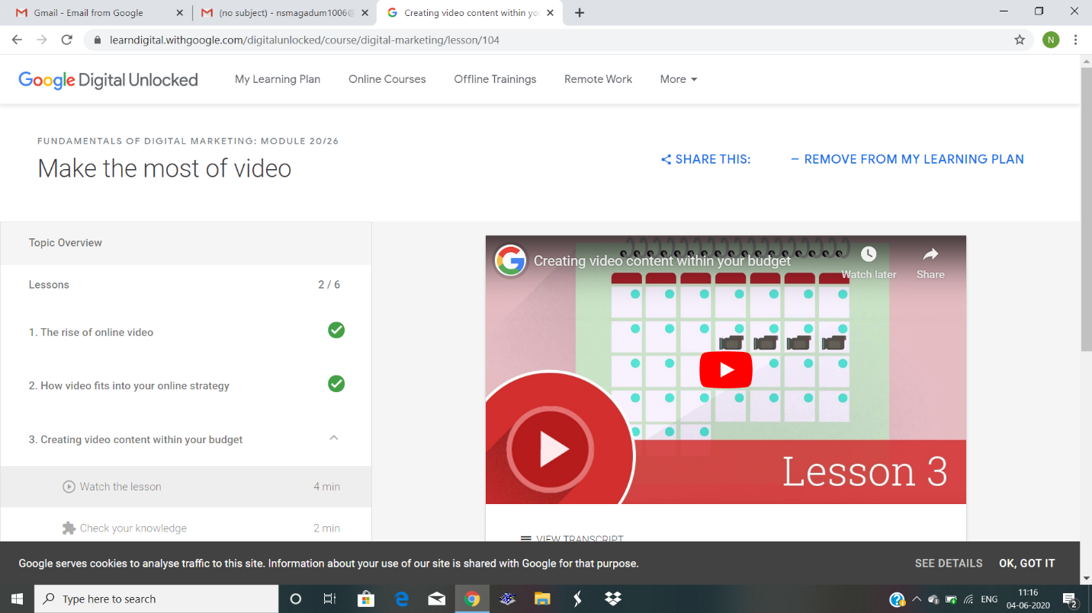

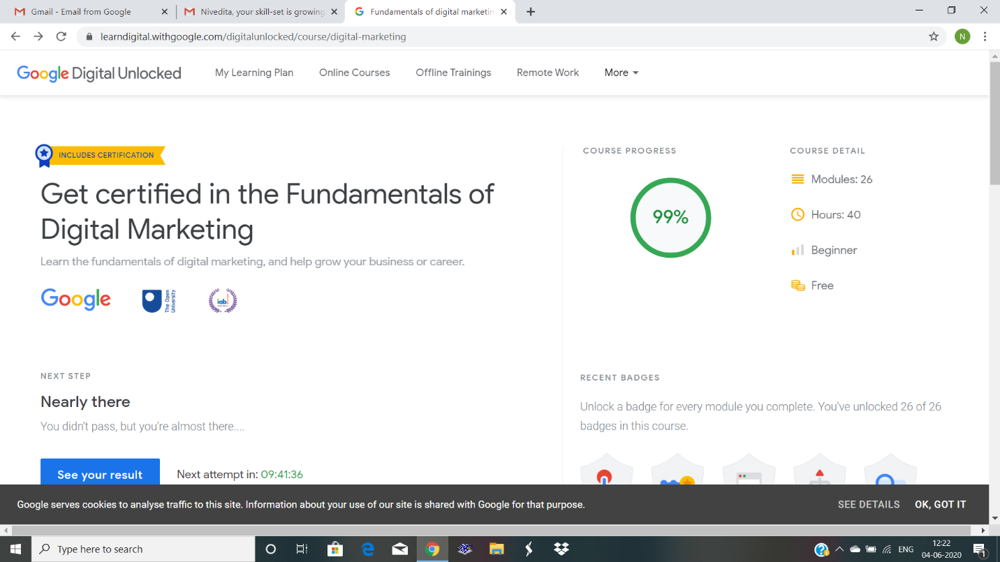Coding Challenges Details: Write a C++ program to find the missing number in array

