**DAILY ONLINE ACTIVITIES SUMMARY**

|  |  |  |  |  |  |  |  |  |
| --- | --- | --- | --- | --- | --- | --- | --- | --- |
| **Date:** | **5/06/2020** | | | | | **Name:** | **Nivedita** | |
| **Sem & Sec** | **4th sem/A** | | | | | **USN:** | **4al18cs053** | |
| **Online Test Summary** | | | | | | | | |
| **Subject** | | **--** | | | | | | |
| **Max. Marks** | | **--** | | **Score** | | | **--** | |
| **Certification Course Summary** | | | | | | | | |
| **Course** | **Fundamental of digital marketing**  **Design patterns** | | | | | | | |
| **Certificate Provider** | | | **Google digitalunloaked** | | **Duration** | | | **40 hours** |
| **Coding Challenges** | | | | | | | | |
| **Problem Statement:** **write a java program to read three integer values from the keyboard and find the sum of the values. Declare a variable "sum" of type int and store the result in it.** | | | | | | | | |
| **Status:done** | | | | | | | | |
| **Uploaded the report in Github** | | | | | **yes** | | | |
| **If yes Repository name** | | | | | [**https://github.com/nivi-nivedita/lockdown-coding-program/blob/master/java%20program(sum%20of%20number)**](https://github.com/nivi-nivedita/lockdown-coding-program/blob/master/java%20program(sum%20of%20number)) | | | |
| **Uploaded the report in slack** | | | | | **yes** | | | |

Certification Course Details: I completed course and got certificate.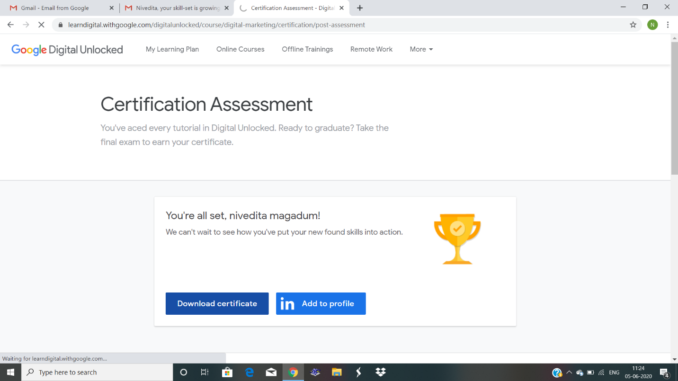



I started new course “design patterns”.

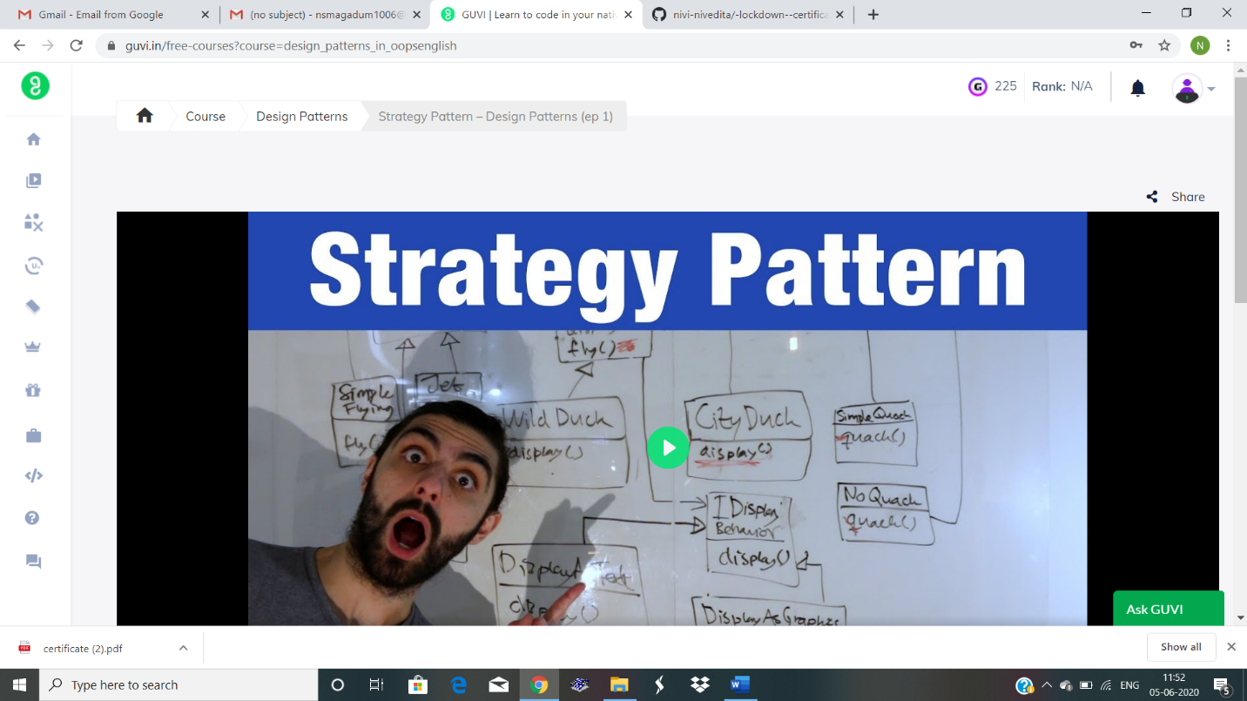

Coding Challenges Details: write a java program to read three integer values from the keyboard and find the sum of the values. Declare a variable "sum" of type int and store the result in it.

Executed and uploaded in github.

