**DAILY ONLINE ACTIVITIES SUMMARY**

|  |  |  |  |  |  |  |  |  |
| --- | --- | --- | --- | --- | --- | --- | --- | --- |
| **Date:** | **6/06/2020** | | | | | **Name:** | **Nivedita** | |
| **Sem & Sec** | **4th sem/ A-sec** | | | | | **USN:** | **4al18cs053** | |
| **Online Test Summary** | | | | | | | | |
| **Subject** | | **DC** | | | | | | |
| **Max. Marks** | | **30** | | **Score** | | | **27** | |
| **Certification Course Summary** | | | | | | | | |
| **Course** | **Introduction of cybersecurity** | | | | | | | |
| **Certificate Provider** | | | **Cisco networking** | | **Duration** | | | **15 hours** |
| **Coding Challenges** | | | | | | | | |
| **Problem Statement:1.** **Write a Java Program**  **Given an array A of size N containing 0s, 1s, and 2s; you need to sort the array in ascending order**  **2.** **Write a program in C to rotate an array by N positions** | | | | | | | | |
| **Status:done** | | | | | | | | |
| **Uploaded the report in Github** | | | | | **yes** | | | |
| **If yes Repository name** | | | | | [**https://github.com/nivi-nivedita/lockdown-coding-program**](https://github.com/nivi-nivedita/lockdown-coding-program) | | | |
| **Uploaded the report in slack** | | | | | **yes** | | | |

Online Test Details: today DC test taken at 9:30 and for 30 marks.

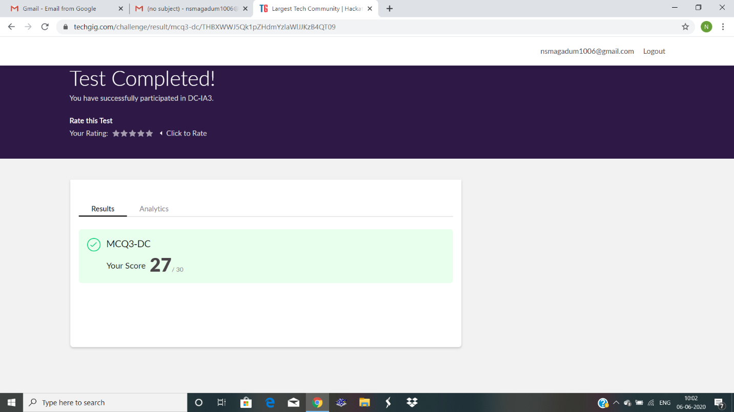Certification Course Details:” introduction of cybersecurity” was taken from cisco networking and I continued.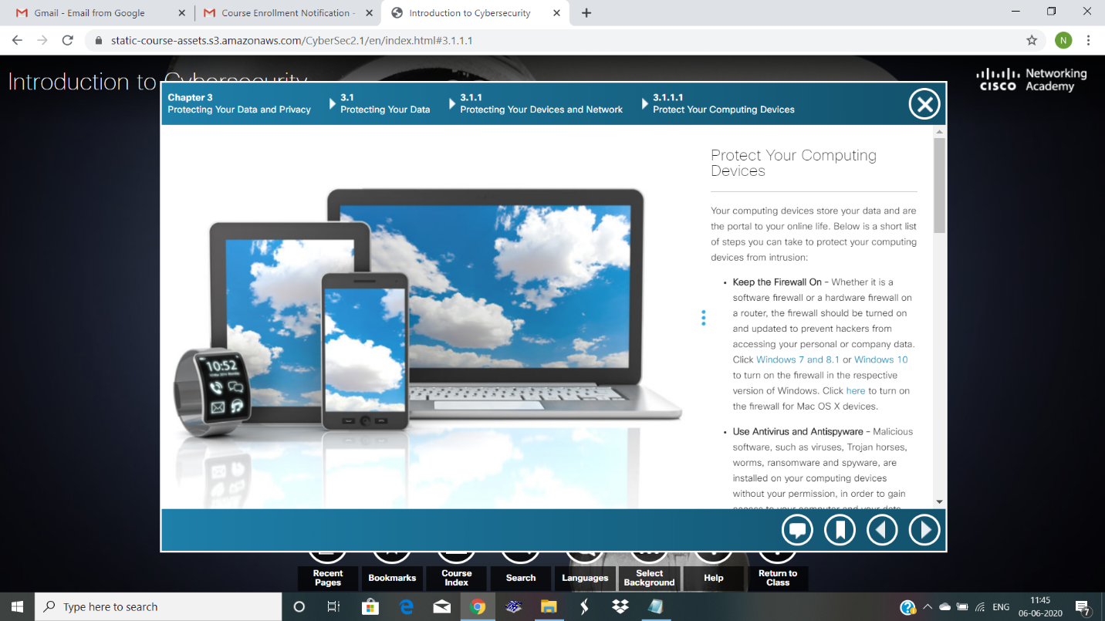

Coding Challenges Details:

1. Write a program in C to rotate an array by N positions

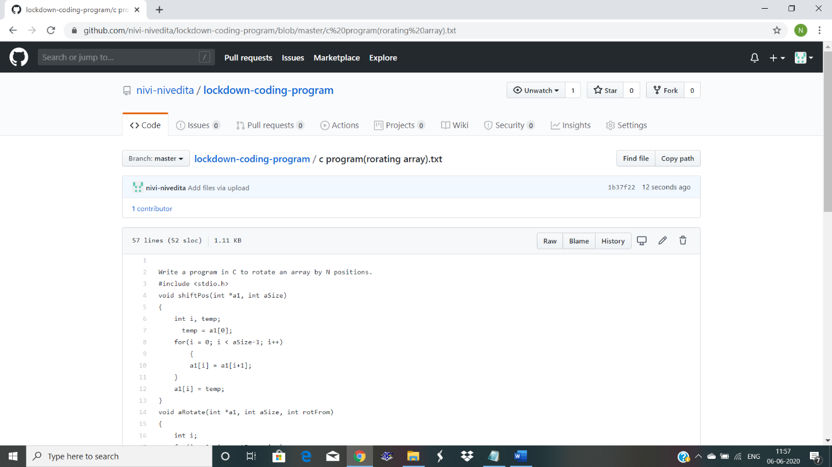Uploaded in git hub and executed.

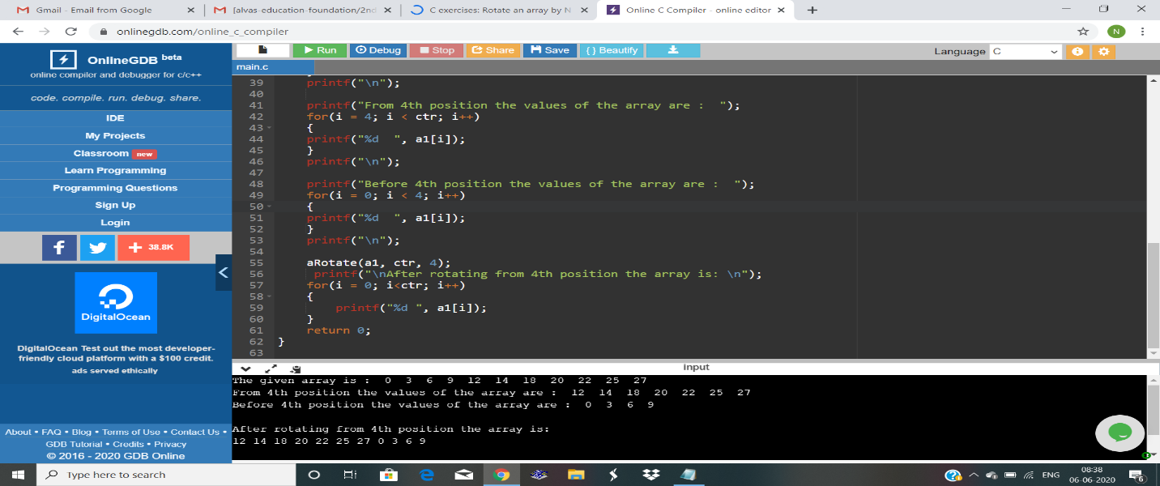

2. Write a Java Program

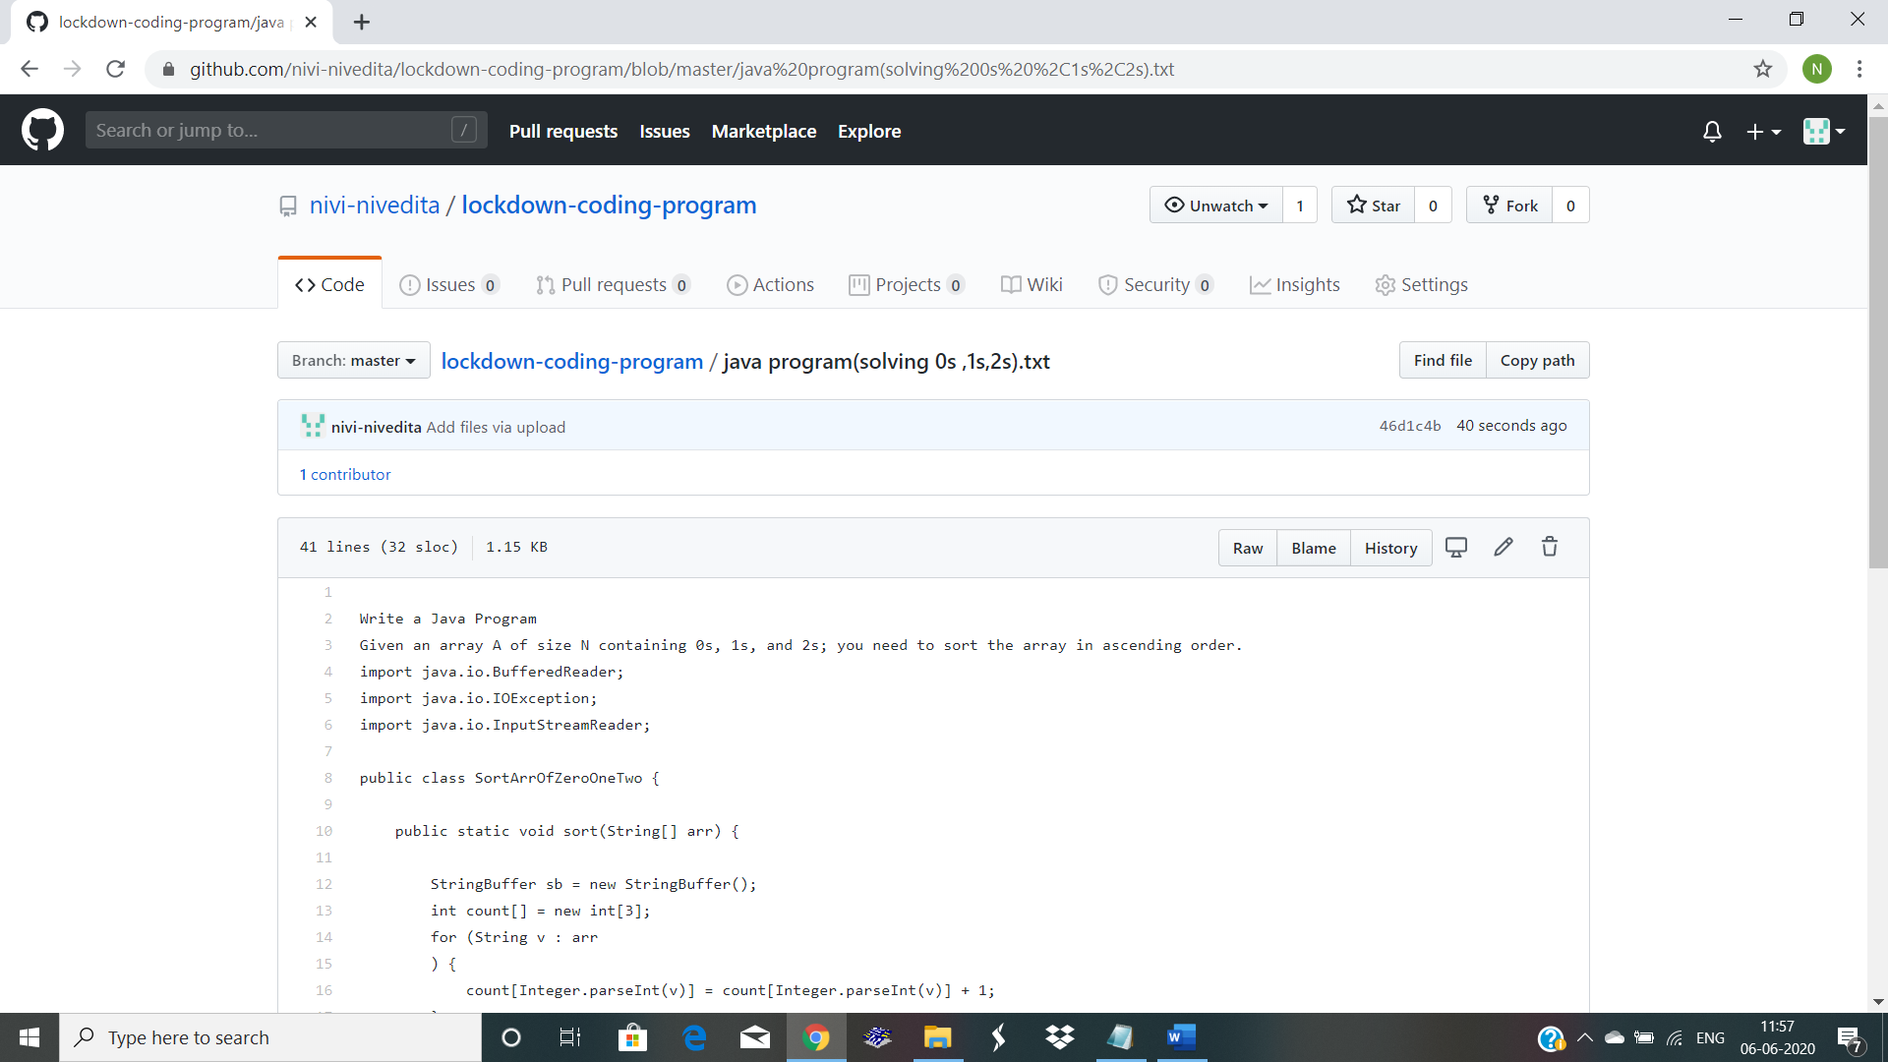Given an array A of size N containing 0s, 1s, and 2s; you need to sort the array in ascending order.

Uploaded and executed.

