**DAILY ONLINE ACTIVITIES SUMMARY**

|  |  |  |  |  |  |  |  |  |
| --- | --- | --- | --- | --- | --- | --- | --- | --- |
| **Date:** | **19/5/2020** | | | | | **Name:** | **Nivedita** | |
| **Sem & Sec** | **2nd year/4th sem/A-section** | | | | | **USN:** | **4al10cs053** | |
| **Online Test Summary** | | | | | | | | |
| **Subject** | | **Design and analysis and algoritham** | | | | | | |
| **Max. Marks** | | **30** | | **Score** | | | **19** | |
| **Certification Course Summary** | | | | | | | | |
| **Course** | **Introduction of cyber security** | | | | | | | |
| **Certificate Provider** | | | **Laura quantina** | | **Duration** | | |  |
| **Coding Challenges** | | | | | | | | |
| **Problem Statement1:** **A user will input two strings, and we find if one of the strings is a sub sequence of the other. Program prints “yes” if either the first string is a sub sequence of the second string or the second string is a sub sequence of the first string.**  **Assume that, the length of the first string is smaller than or equal to the length of the second string.** | | | | | | | | |
| **Status:completed** | | | | | | | | |
| **Uploaded the report in Github** | | | | | **yes** | | | |
| **If yes Repository name** | | | | | <https://github.com/nivi-nivedita/lockdown-coding-program> | | | |
| **Uploaded the report in slack** | | | | | **yes** | | | |

Online Test Details: online test of DAA contains 25 marks of 20 questions and 5 questions of 2 marks.

Certification Course Details: I started course at 10am it took for 3 hours to complete with quizzes ,assesement final exam of 100 points. Its only introduction of cyber security .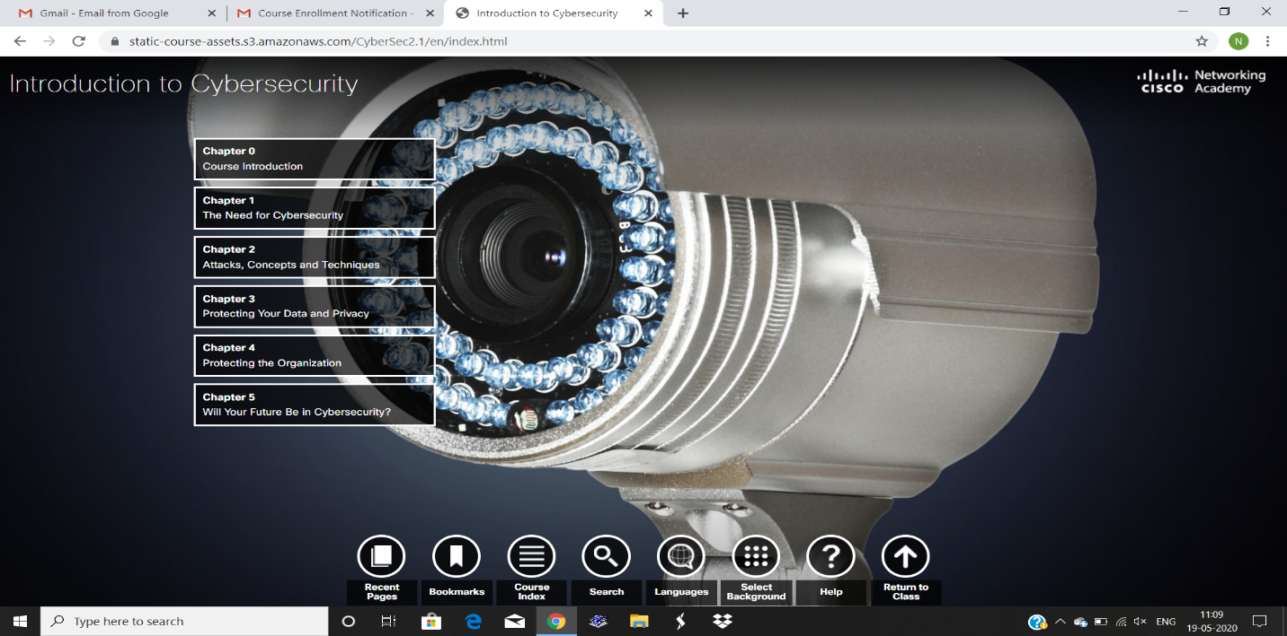

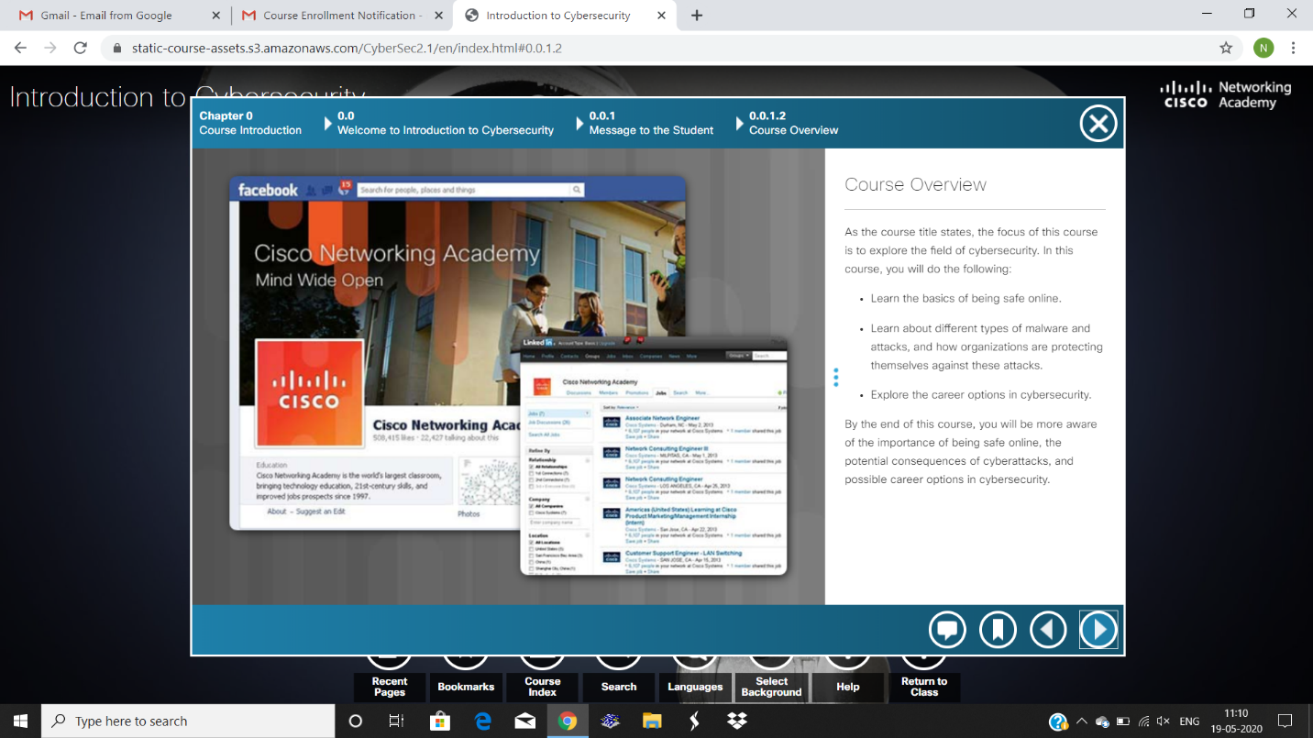

After completing course I got certificate of cyber security,with manager signature

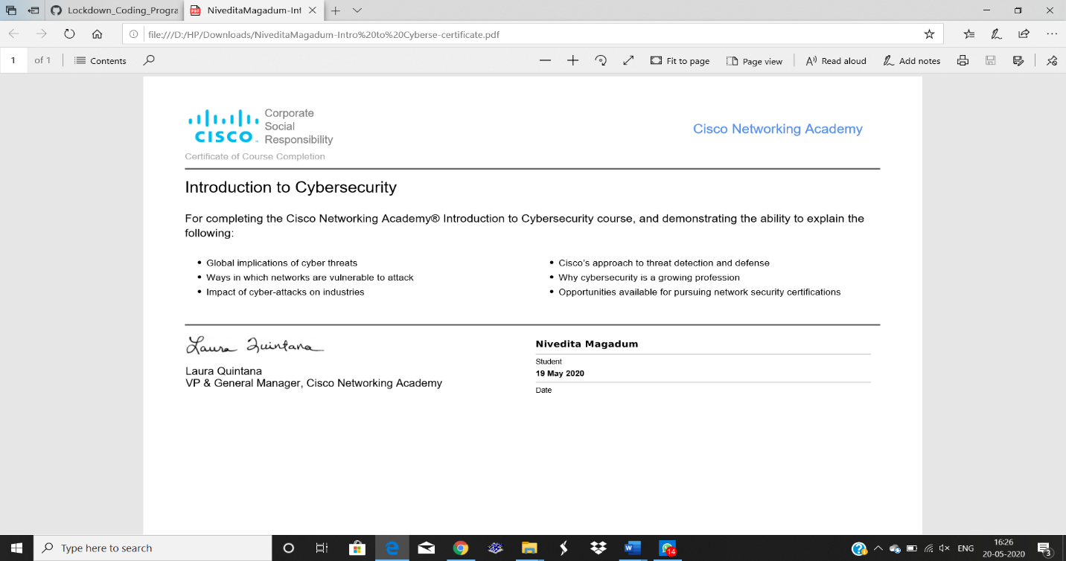

Coding Challenges Details: A user will input two strings, and we find if one of the strings is a sub sequence of the other. Program prints “yes” if either the first string is a sub sequence of the second string or the second string is a sub sequence of the first string.

An expected output of the program: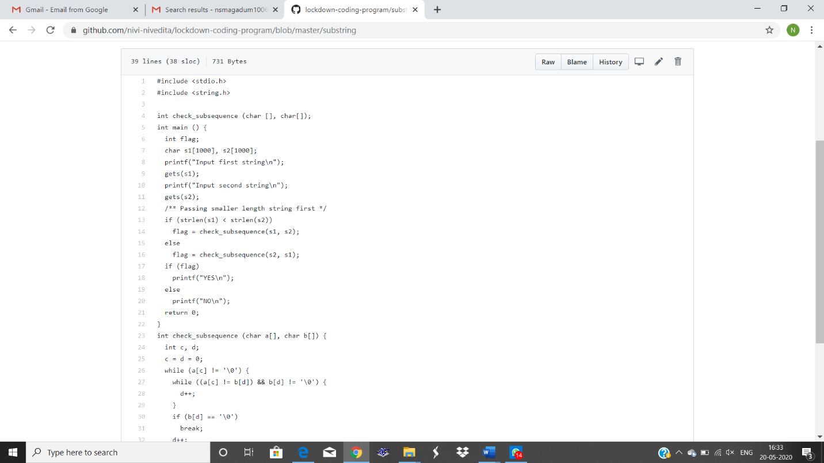Input the first string

Tree

Input the second string

Computer science is awesome

YES

|  |
| --- |
|  |
|  |  |
|  |  |
|  |  |
|  |  |
|  |  |
|  |  |
|  |  |
|  |  |
|  |  |