**DAILY ONLINE ACTIVITIES SUMMARY**

|  |  |  |  |  |  |  |  |  |
| --- | --- | --- | --- | --- | --- | --- | --- | --- |
| **Date:** | **07/06/2020** | | | | | **Name:** | **Nivedita** | |
| **Sem & Sec** | **4th sem/ A-sec** | | | | | **USN:** | **4al18cs053** | |
| **Online Test Summary** | | | | | | | | |
| **Subject** | | **---** | | | | | | |
| **Max. Marks** | | **--** | | **Score** | | | **--** | |
| **Certification Course Summary** | | | | | | | | |
| **Course** | **Introduction of cybersecurity** | | | | | | | |
| **Certificate Provider** | | | **Cisco networking** | | **Duration** | | | **15 hours** |
| **Coding Challenges** | | | | | | | | |
| **Problem Statement:1.** **Write a C++ Program to swap two numbers using friend as a bridge concept** | | | | | | | | |
| **Status:done** | | | | | | | | |
| **Uploaded the report in Github** | | | | | **yes** | | | |
| **If yes Repository name** | | | | | <https://github.com/nivi-nivedita/lockdown-coding-program/blob/master/c%2B%2Bprogram%20(swaping%20number).txt> | | | |
| **Uploaded the report in slack** | | | | | **yes** | | | |

Certification Course Details: I completed course today and I got certificate. which consist of 5 modules ,5 quizzes and one final exam.

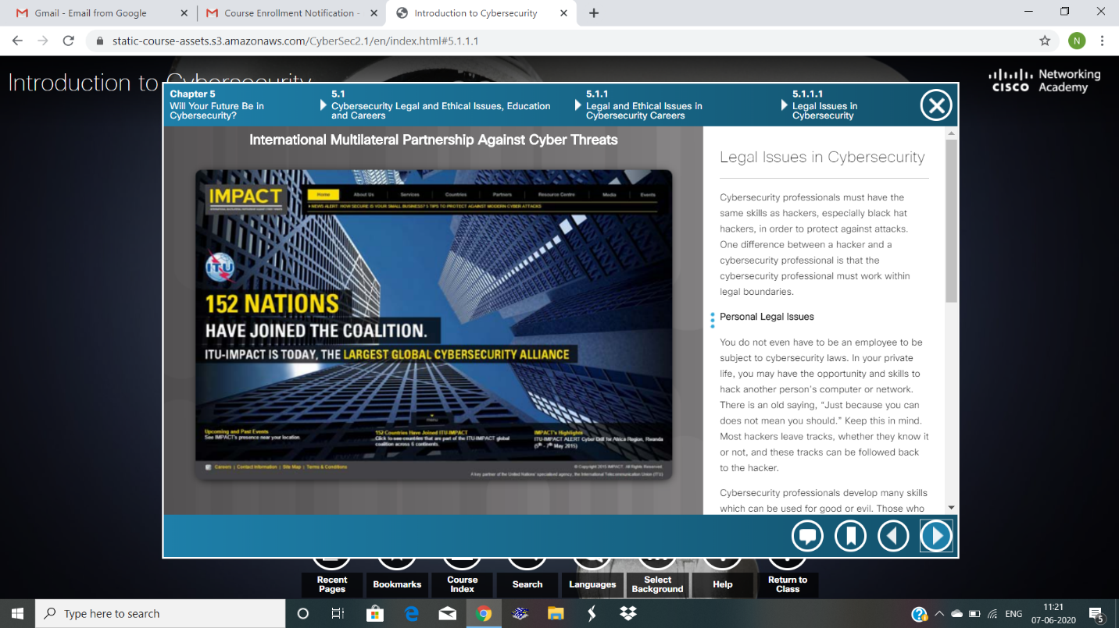

Coding Challenges Details: Write a C++ Program to swap two numbers using friend as a bridge concept.

Executed and uploaded in git hu

Program used the concept of **friend function**  
***Example***

**Input**  
a=10  
b=20  
**Output**  
a=20  
b=10

