**DAILY ONLINE ACTIVITIES SUMMARY**

|  |  |  |  |  |  |  |  |  |
| --- | --- | --- | --- | --- | --- | --- | --- | --- |
| **Date:** | **8/06/2020** | | | | | **Name:** | **Nivedita** | |
| **Sem & Sec** | **4th sem/ A-sec** | | | | | **USN:** | **4al18cs053** | |
| **Online Test Summary** | | | | | | | | |
| **Subject** | | **MATHS** | | | | | | |
| **Max. Marks** | | **30** | | **Score** | | | **20** | |
| **Certification Course Summary** | | | | | | | | |
| **Course** | **Introduction of IOT** | | | | | | | |
| **Certificate Provider** | | | **Cisco networking** | | **Duration** | | | **20 hours** |
| **Coding Challenges** | | | | | | | | |
| **Problem Statement:1.** **Write a Java Program to check whether the given matrix is magic square or not**  **2.** **Write a Java Program to check whether the given matrix is magic square or not** | | | | | | | | |
| **Status:done** | | | | | | | | |
| **Uploaded the report in Github** | | | | | **yes** | | | |
| **If yes Repository name** | | | | | [**https://github.com/nivi-nivedita/lockdown-coding-program**](https://github.com/nivi-nivedita/lockdown-coding-program) | | | |
| **Uploaded the report in slack** | | | | | **yes** | | | |

Online Test Details: today test was 9:30 am.it contains 15 questions each 2 marks.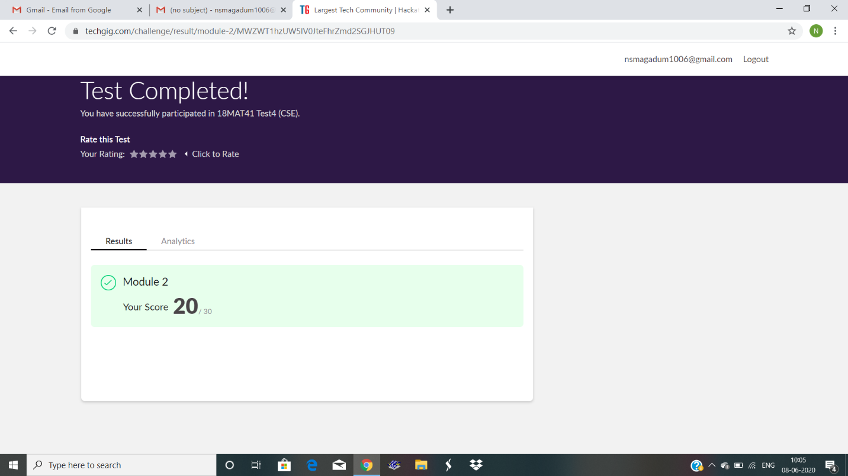

Certification Course Details: today I started new course that is introduction of iot.it contains 6 modules, 6 quizzs and final exam.

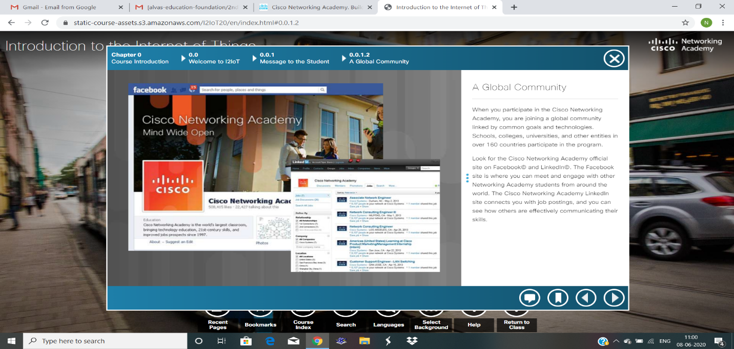

Coding Challenges Details:

1. C Program to Generate All the Set Partitions of n Numbers Beginning from 1 and so on.

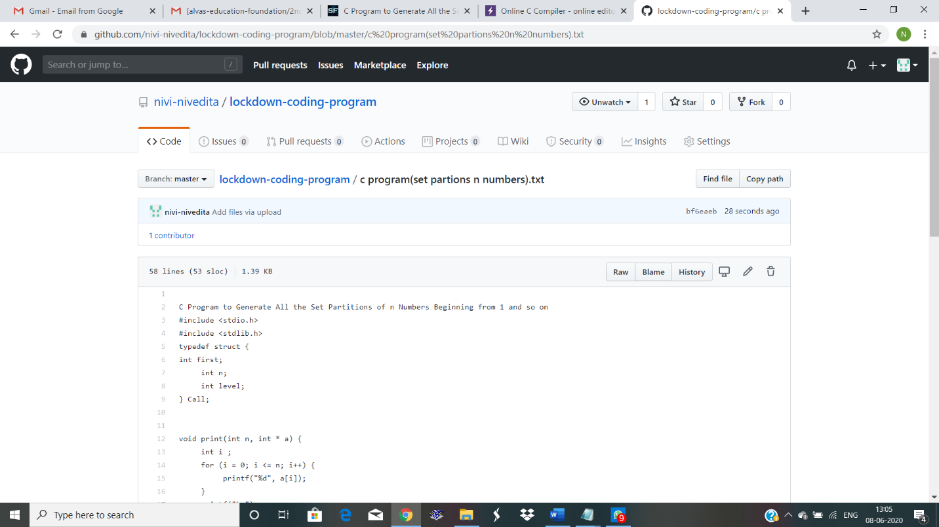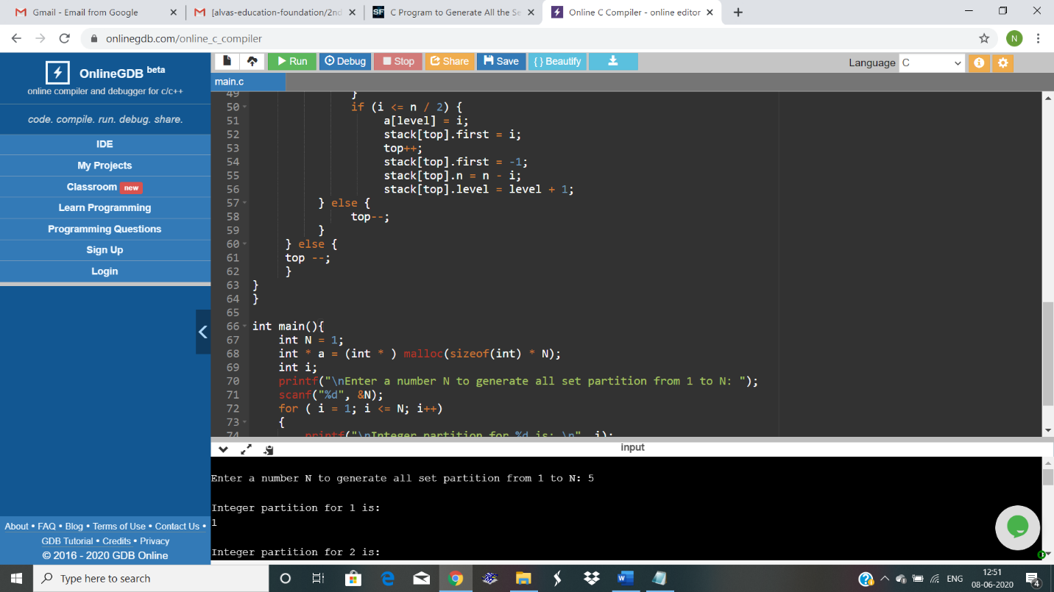

1. Write a Java Program to check whether the given matrix is magic square or not .

