**DAILY ONLINE ACTIVITIES SUMMARY**

|  |  |  |  |  |  |  |  |  |
| --- | --- | --- | --- | --- | --- | --- | --- | --- |
| **Date:** | **10/06/2020** | | | | | **Name:** | **Nivedita** | |
| **Sem & Sec** | **4th sem/ A-sec** | | | | | **USN:** | **4al18cs053** | |
| **Online Test Summary** | | | | | | | | |
| **Subject** | | **OOC** | | | | | | |
| **Max. Marks** | | **30** | | **Score** | | | **22** | |
| **Certification Course Summary** | | | | | | | | |
| **Course** | **Python machine learning** | | | | | | | |
| **Certificate Provider** | | | **Greatlearning** | | **Duration** | | | **15 hours** |
| **Coding Challenges** | | | | | | | | |
| **Problem Statement:** **Write a java program to count all the triplets such that sum of two elements equals the third element** | | | | | | | | |
| **Status:done** | | | | | | | | |
| **Uploaded the report in Github** | | | | | **yes** | | | |
| **If yes Repository name** | | | | | [**https://github.com/nivi-nivedita/lockdown-coding-program/blob/master/java%20program(subarray).txt**](https://github.com/nivi-nivedita/lockdown-coding-program/blob/master/java%20program(subarray).txt) | | | |
| **Uploaded the report in slackheld a** | | | | | **yes** | | | |

Online Test Details: today OOC TEST held at 9:15. Contains programs coding problems for 15 questions 2 marks.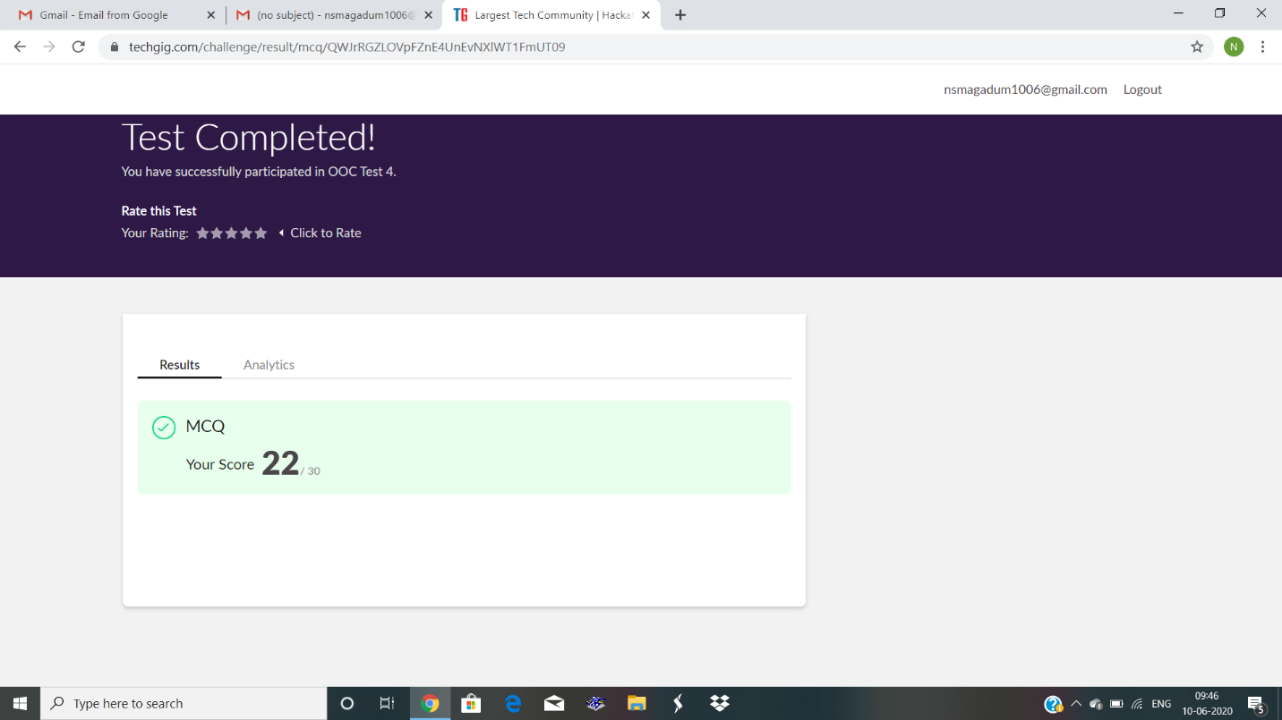

Certification Course Details: today I continued with “python for machine learning”.

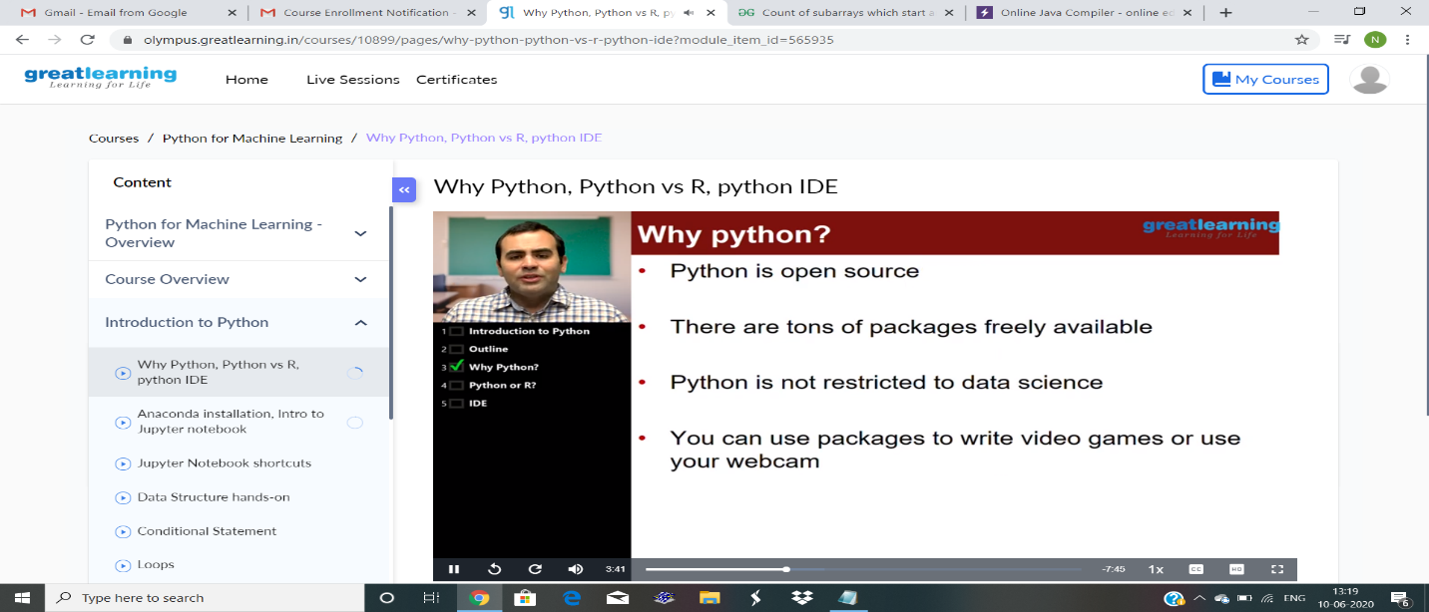

Coding Challenges Details: Write a java program to count all the triplets such that sum of two elements equals the third element.

