**DAILY ONLINE ACTIVITIES SUMMARY**

|  |  |  |  |  |  |  |  |  |
| --- | --- | --- | --- | --- | --- | --- | --- | --- |
| **Date:** | **11/062020** | | | | | **Name:** | **Nivedita** | |
| **Sem & Sec** | **4th sem/ A-sec** | | | | | **USN:** | **4al18cs053** | |
| **Online Test Summary** | | | | | | | | |
| **Subject** | | **---** | | | | | | |
| **Max. Marks** | | **---** | | **Score** | | | **----** | |
| **Certification Course Summary** | | | | | | | | |
| **Course** | **Python of machine learning** | | | | | | | |
| **Certificate Provider** | | | **Greatlearning** | | **Duration** | | | **15hours** |
| **Coding Challenges** | | | | | | | | |
| **Problem Statement:** **Write a Java Program to Segregate Even and Odd numbers**   |  |  | | --- | --- | |  |  | | | | | | | | | |
| **Status:done** | | | | | | | | |
| **Uploaded the report in Github** | | | | | **yes** | | | |
| **If yes Repository name** | | | | | [**https://github.com/nivi-nivedita/lockdown-coding-program/blob/master/java%20program(separate%20odd%20and%20even).txt**](https://github.com/nivi-nivedita/lockdown-coding-program/blob/master/java%20program(separate%20odd%20and%20even).txt) | | | |
| **Uploaded the report in slack** | | | | | **yes** | | | |

Certification Course Details: today I continued same course. Completed.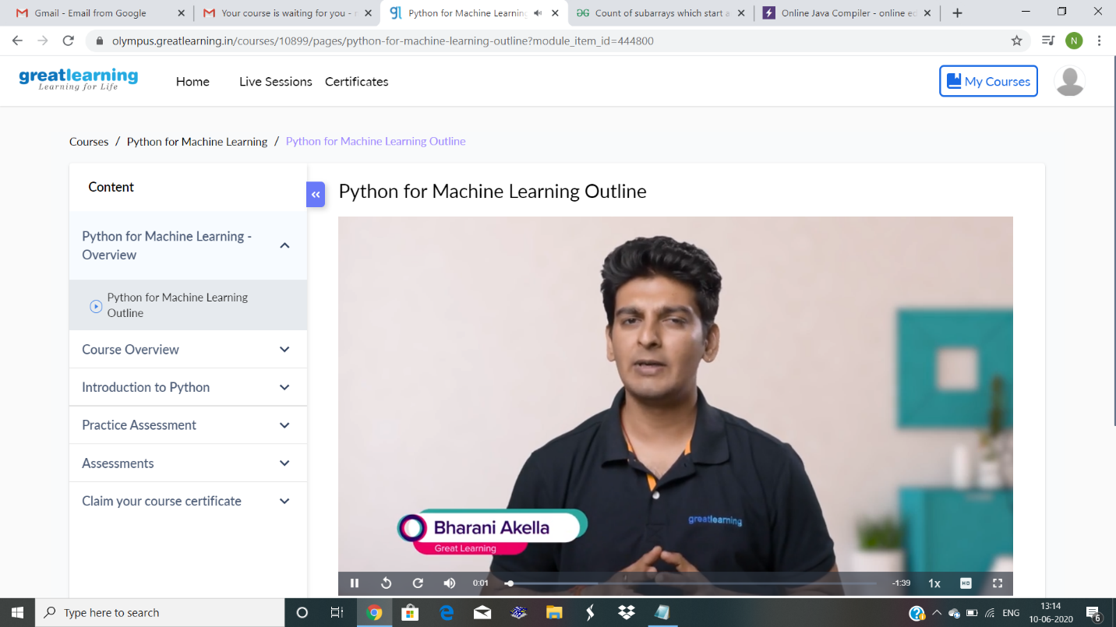

Coding Challenges Details: Write a Java Program to Segregate Even and Odd numbers .

Given an array A[], write a function that segregates even and odd numbers. The functions should put all even numbers first, and then odd numbers.  
Example:

Input = {12, 34, 45, 9, 8, 90, 3}  
Output = {12, 34, 8, 90, 45, 9, 3}

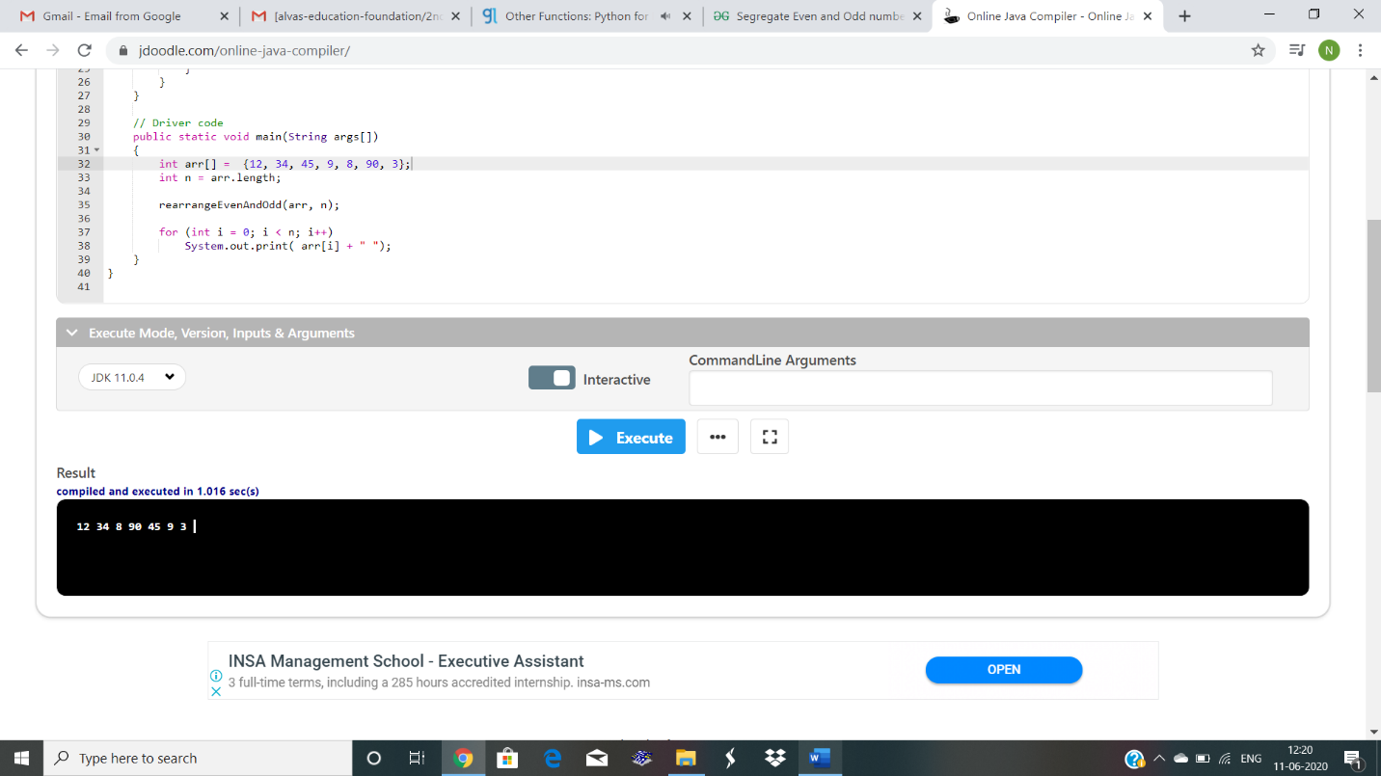

Executed and uploaded.

