**DAILY ONLINE ACTIVITIES SUMMARY**

|  |  |  |  |  |  |  |  |  |
| --- | --- | --- | --- | --- | --- | --- | --- | --- |
| **Date:** | **12/6/2020** | | | | | **Name:** | **Nivedita** | |
| **Sem & Sec** | **4th sem/ A-sec** | | | | | **USN:** | **4al18cs053** | |
| **Online Test Summary** | | | | | | | | |
| **Subject** | | **kannada** | | | | | | |
| **Max. Marks** | | **25** | | **Score** | | | **16** | |
| **Certification Course Summary** | | | | | | | | |
| **Course** | **Python of machine learning** | | | | | | | |
| **Certificate Provider** | | | **Great learning** | | **Duration** | | | **15 hours** |
| **Coding Challenges** | | | | | | | | |
| **Problem Statement:** **Given two positive integer start and end. The task is to write a Python program to print all Prime numbers in an Interval** | | | | | | | | |
| **Status:done** | | | | | | | | |
| **Uploaded the report in Github** | | | | | **yes** | | | |
| **If yes Repository name** | | | | | [**https://github.com/nivi-nivedita/lockdown-coding-program/blob/master/python%20program(prime%20number).txt**](https://github.com/nivi-nivedita/lockdown-coding-program/blob/master/python%20program(prime%20number).txt) | | | |
| **Uploaded the report in slack** | | | | | **yes** | | | |

Online Test Details: today kannada test at 11:30 for 25 marks.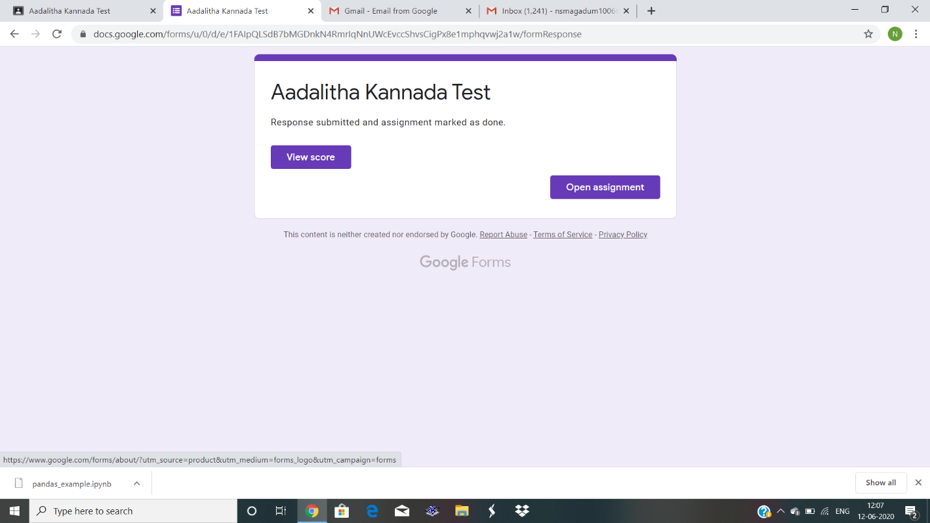

Certification Course Details:python of machine learning was completed.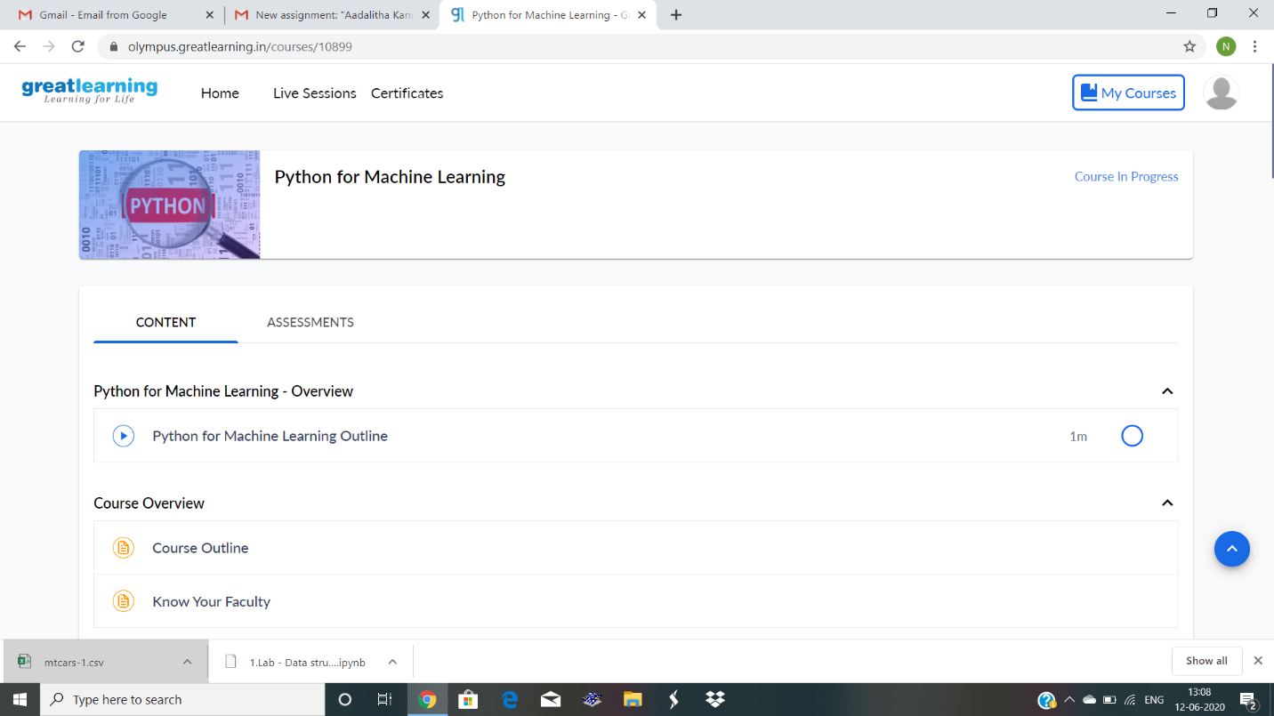

Coding Challenges Details: Given two positive integer start and end. The task is to write a Python program to print all Prime numbers in an Interval.

Executed and uploaded.

