**DAILY ONLINE ACTIVITIES SUMMARY**

|  |  |  |  |  |  |  |  |  |
| --- | --- | --- | --- | --- | --- | --- | --- | --- |
| **Date:** | **13/6/2020** | | | | | **Name:** | **Nivedita** | |
| **Sem & Sec** | **4th sem/ A-sec** | | | | | **USN:** | **4al18cs053** | |
| **Online Test Summary** | | | | | | | | |
| **Subject** | | **------** | | | | | | |
| **Max. Marks** | | **30** | | **Score** | | | **----** | |
| **Certification Course Summary** | | | | | | | | |
| **Course** | **Linux essential** | | | | | | | |
| **Certificate Provider** | | | **Cisco networking** | | **Duration** | | | **40 hours** |
| **Coding Challenges** | | | | | | | | |
| **Problem Statement:** **Write a Java Program to find if string is K-Palindrome or not** | | | | | | | | |
| **Status:done** | | | | | | | | |
| **Uploaded the report in Github** | | | | | **yes** | | | |
| **If yes Repository name** | | | | | **<https://github.com/nivi-nivedita/lockdown-coding-program/blob/master/java%20program%20(k-palidrome.txt>** | | | |
| **Uploaded the report in slack** | | | | | **yes** | | | |

Certification Course Details: today I continued same course and completed 2 modules.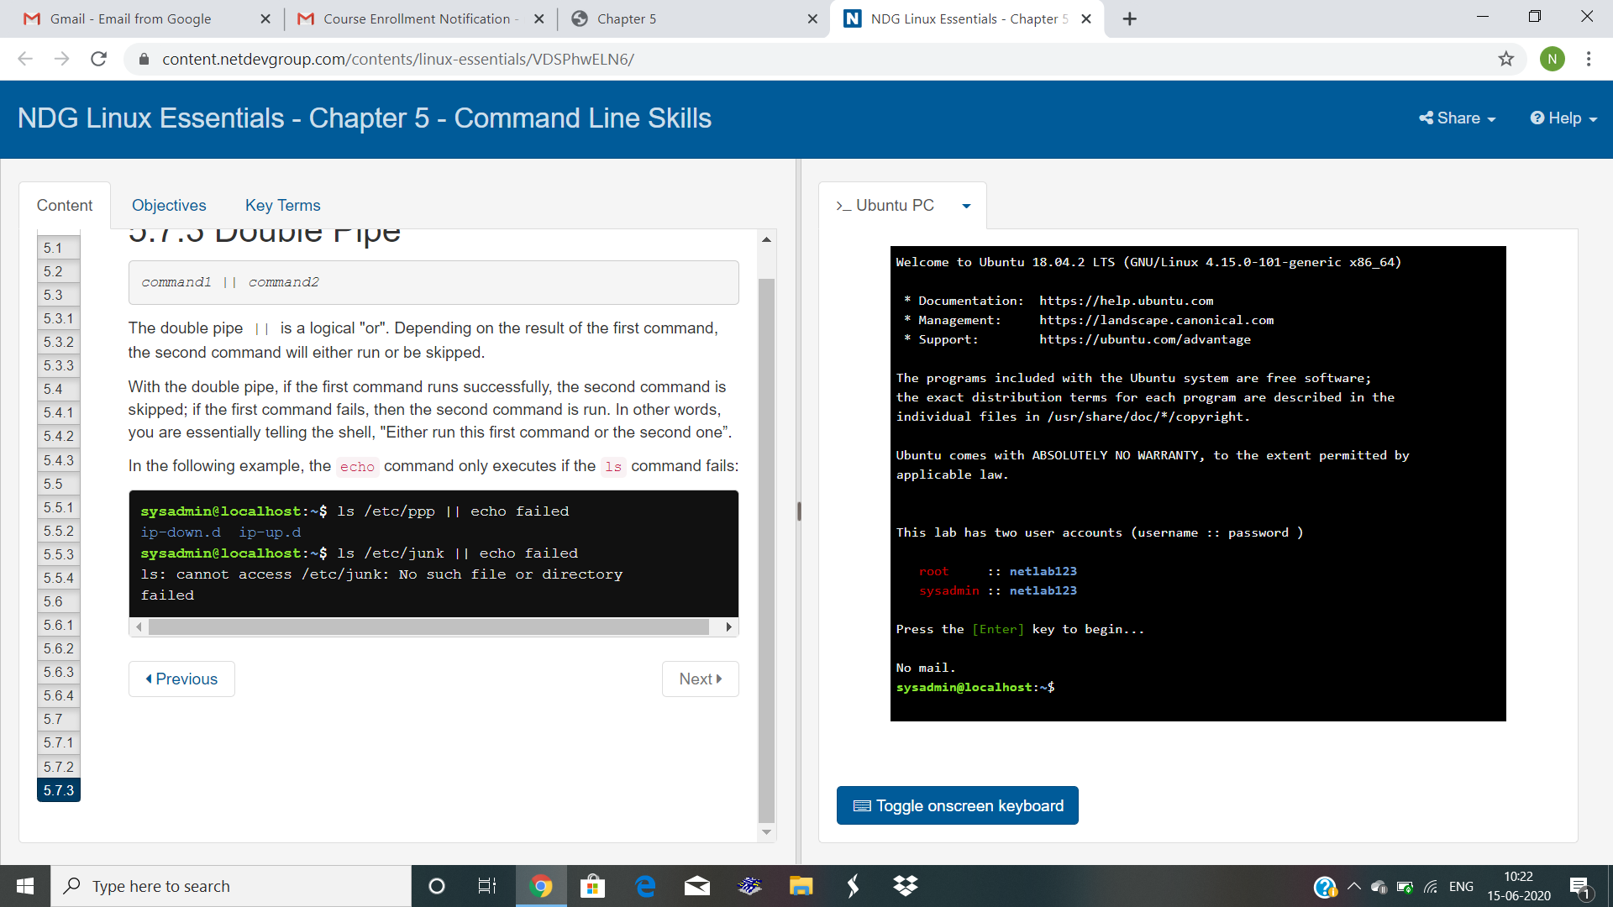

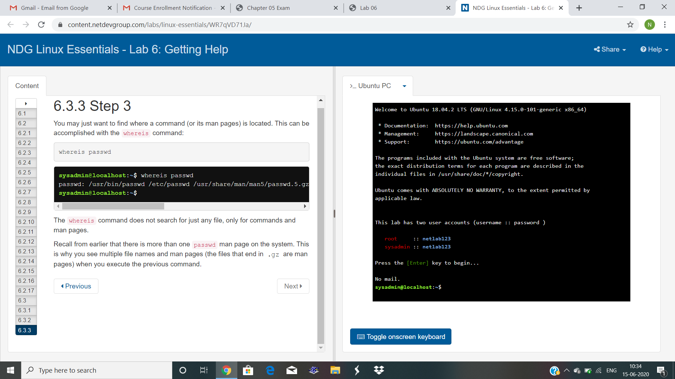

Coding Challenges Details: Write a Java Program to find if string is K-Palindrome or not .executed and uploaded.