**DAILY ONLINE ACTIVITIES SUMMARY**

|  |  |  |  |  |  |  |  |  |
| --- | --- | --- | --- | --- | --- | --- | --- | --- |
| **Date:** | **20/5/2020** | | | | | **Name:** | **Nivedita** | |
| **Sem & Sec** | **4th sem/A-sec** | | | | | **USN:** | **4al18cs053** | |
| **Online Test Summary** | | | | | | | | |
| **Subject** | | **OOC** | | | | | | |
| **Max. Marks** | | **30** | | **Score** | | | **20** | |
| **Certification Course Summary** | | | | | | | | |
| **Course** | **Introduction of quality management (alison)** | | | | | | | |
| **Certificate Provider** | | | **No certificator** | | **Duration** | | | **2 hours** |
| **Coding Challenges** | | | | | | | | |
| **Problem Statement:** **Given an array a[] of size n which contains elements from 0 to n-1, write a program printDuplicates which prints the duplicate elements of the given array. If no duplicate element is found print -1.** | | | | | | | | |
| **Status:done** | | | | | | | | |
| **Uploaded the report in Github** | | | | | **yes** | | | |
| **If yes Repository name** | | | | | <https://github.com/nivi-nivedita/lockdown-coding-program/blob/master/duplicate%20number> | | | |
| **Uploaded the report in slack** | | | | | **yes** | | | |

Online Test Details: Ooc test start at 9:30 and finished at 10:15. 20 questions of one marks and 10 questions of programmatical questions.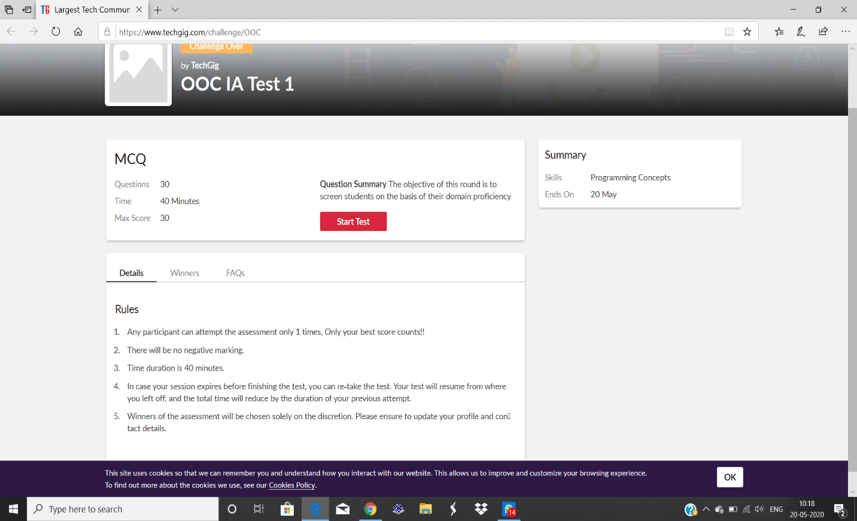

Certification Course Details: today I started new course of Alison company .introduction of quality management This course gives an overview of Total Quality Management and describes Quality specifications and costs. It explains explain ISO 9000 and Total Quality Management tools.

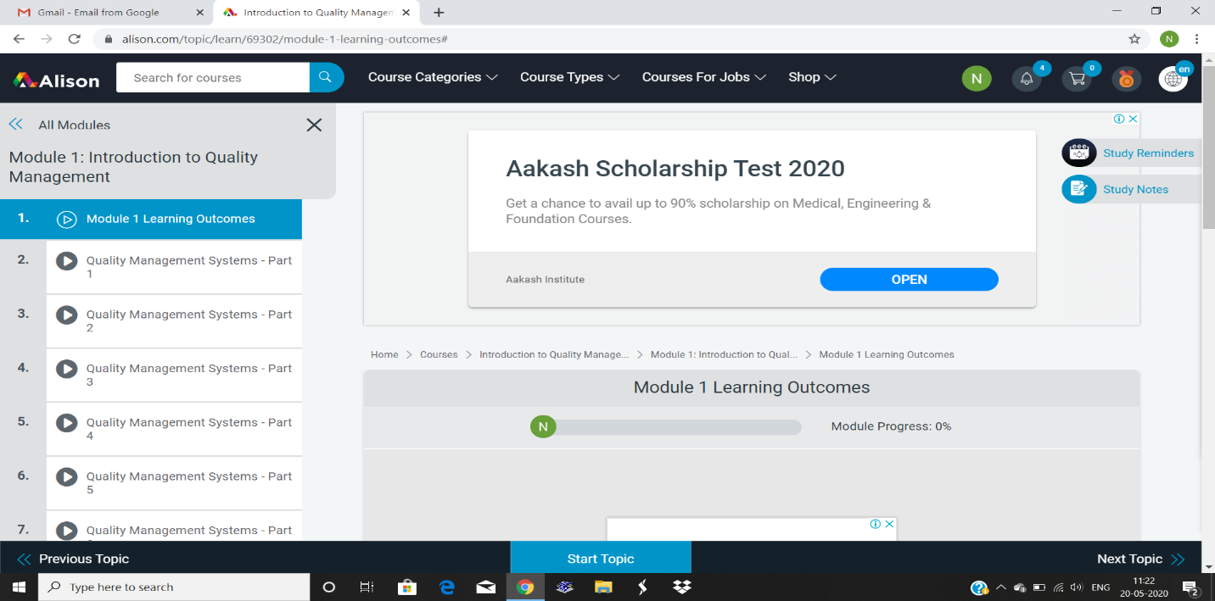

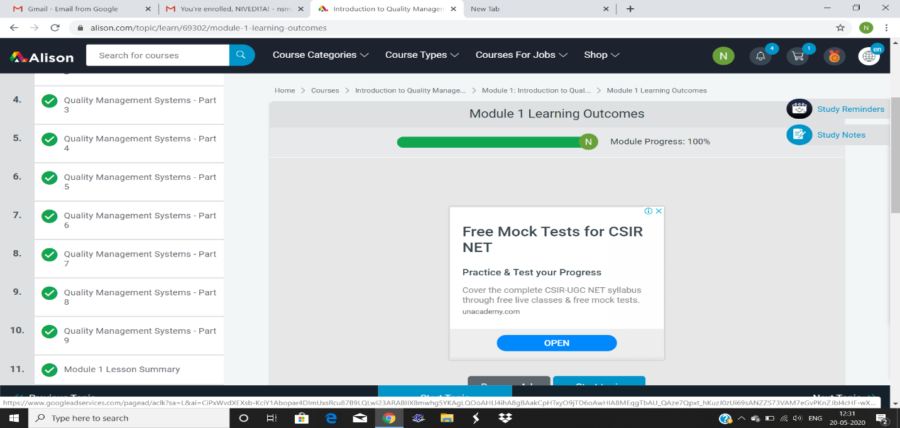

Coding Challenges Details: Given an array a[] of size n which contains elements from 0 to n-1, write a program printDuplicates which prints the duplicate elements of the given array. If no duplicate element is found print -1.

Input:

The first line of input must contains an integer n which denotes number of elements of Array. Second line contains n space separated integers denoting elements of array a[].

Output:

Print the duplicate elements from the given array.

.

