**DAILY ONLINE ACTIVITIES SUMMARY**

|  |  |  |  |  |  |  |  |  |
| --- | --- | --- | --- | --- | --- | --- | --- | --- |
| **Date:** | **23/05/2020** | | | | | **Name:** | **Nivedita** | |
| **Sem & Sec** | **4th sem/ A-sec** | | | | | **USN:** | **4al18cs053** | |
| **Online Test Summary** | | | | | | | | |
| **Subject** | | **Data communication** | | | | | | |
| **Max. Marks** | | **30** | | **Score** | | | **27** | |
| **Certification Course Summary** | | | | | | | | |
| **Course** | **R for data analysis**  **Introduction of packet tracer mobile** | | | | | | | |
| **Certificate Provider** | | | **Alison**  **Cisco networking** | | **Duration** | | | **2 -3hours**  **2 hours** |
| **Coding Challenges** | | | | | | | | |
| **Problem Statement:** **Write a C Program to generate first N Triangular Numbers (Where N is Read from the Key board)** | | | | | | | | |
| **Status:done** | | | | | | | | |
| **Uploaded the report in Github** | | | | | **yes** | | | |
| **If yes Repository name** | | | | | [**https://github.com/nivi-nivedita/lockdown-coding-program/blob/master/tringle**](https://github.com/nivi-nivedita/lockdown-coding-program/blob/master/tringle) | | | |
| **Uploaded the report in slack** | | | | | **yes** | | | |

Online Test Details: toady test held at 9:15 to 9:55 am. DC contain module 1 and 2 concepts. 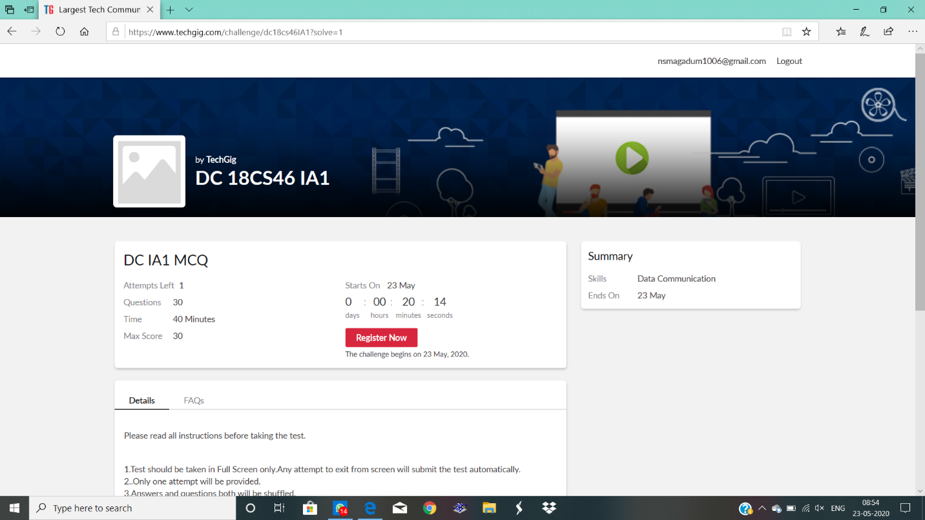

Certification Course Details: courses are data analysis and packet tracer of mobile. In Alison I completed two course so I got gold medal for that course. And for 2nd course I got certificate.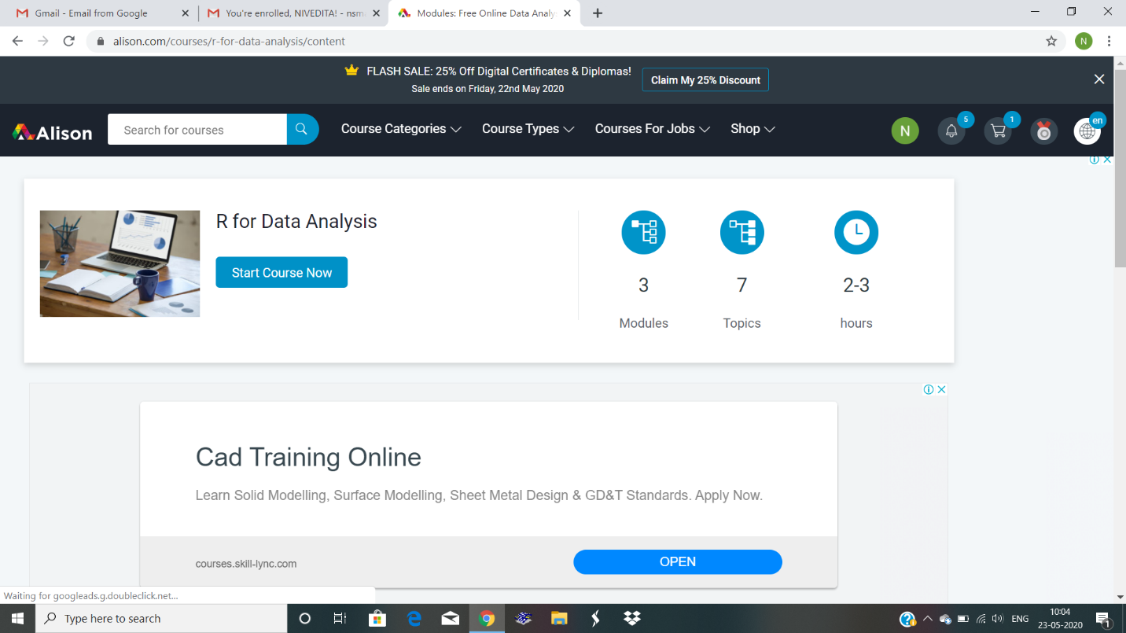

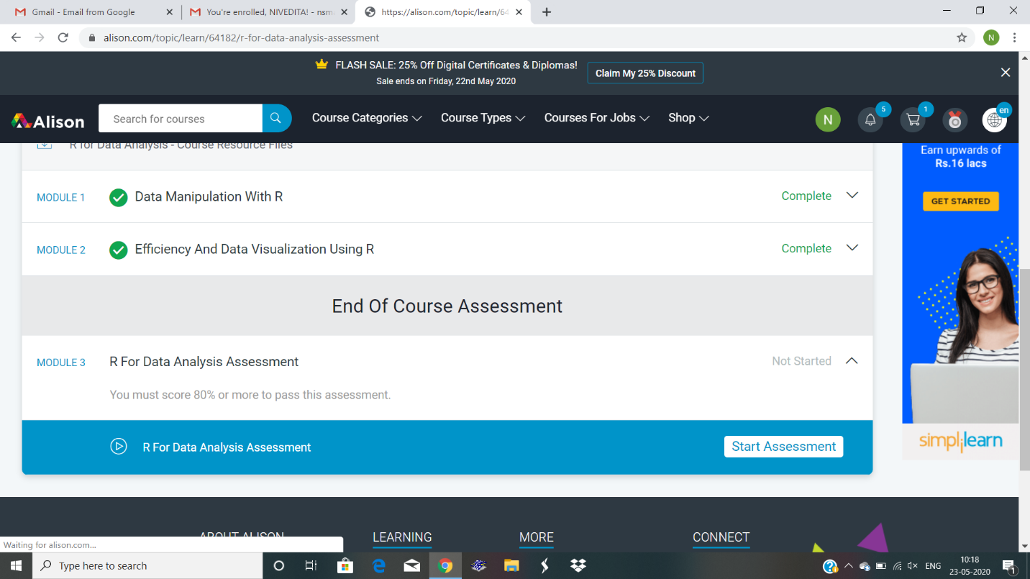

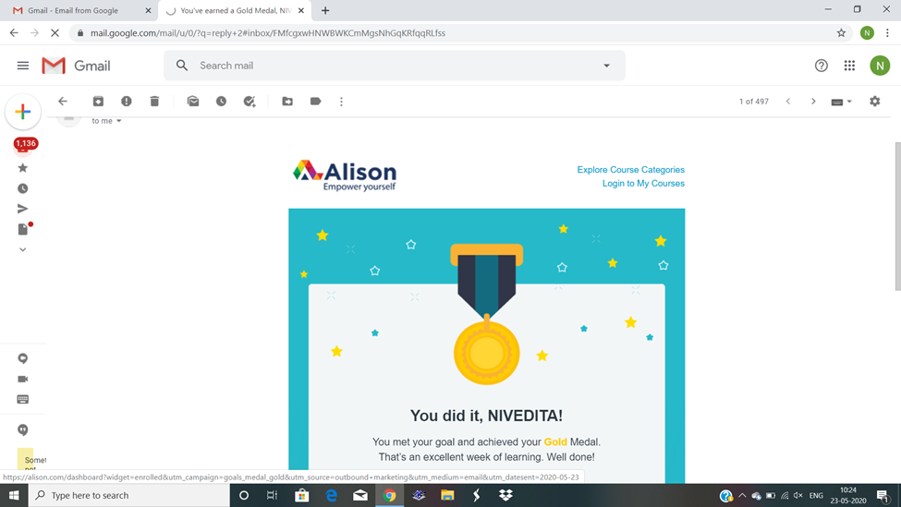

2nd course: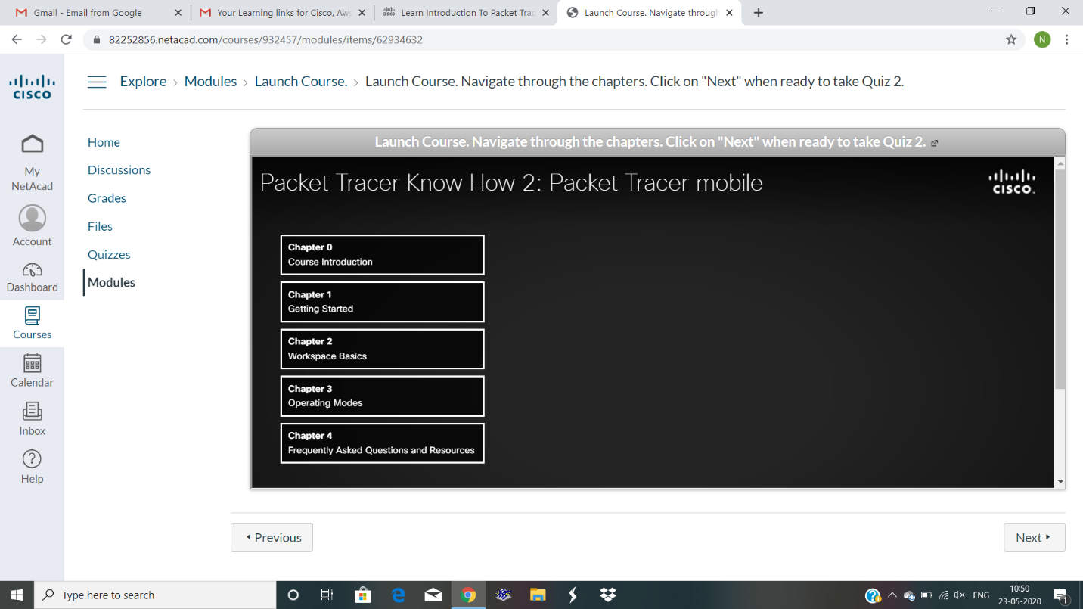

Coding Challenges Details:

Write a C Program to generate first N Triangular Numbers (Where N is Read from the Key board.

