**DAILY ONLINE ACTIVITIES SUMMARY**

|  |  |  |  |  |  |  |  |  |
| --- | --- | --- | --- | --- | --- | --- | --- | --- |
| **Date:** | **25/05/2020** | | | | | **Name:** | **Nivedita** | |
| **Sem & Sec** | **4th sem /A-sec** | | | | | **USN:** | **4al18cs053** | |
| **Online Test Summary** | | | | | | | | |
| **Subject** | | **No test** | | | | | | |
| **Max. Marks** | | **-** | | **Score** | | | **-** | |
| **Certification Course Summary** | | | | | | | | |
| **Course** | **Step Hindu .**  **“Deep learning web”-you tube course** | | | | | | | |
| **Certificate Provider** | | | **Step hindu** | | **Duration** | | | **9-10hours**  **1 hours** |
| **Coding Challenges** | | | | | | | | |
| **Problem Statement: no problem** | | | | | | | | |
| **Status: not given** | | | | | | | | |
| **Uploaded the report in Github** | | | | | **no** | | | |
| **If yes Repository name** | | | | |  | | | |
| **Uploaded the report in slack** | | | | | **no** | | | |

Certification Course Details: course was done by today is deep learning architecture webinar in you tube .to get e-certificate.i completed it and I got certificate. 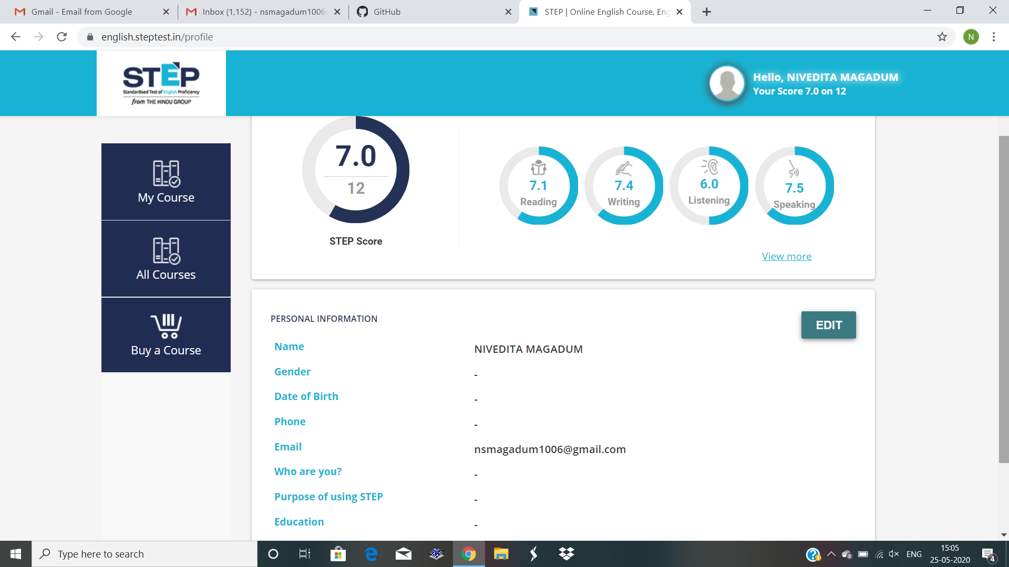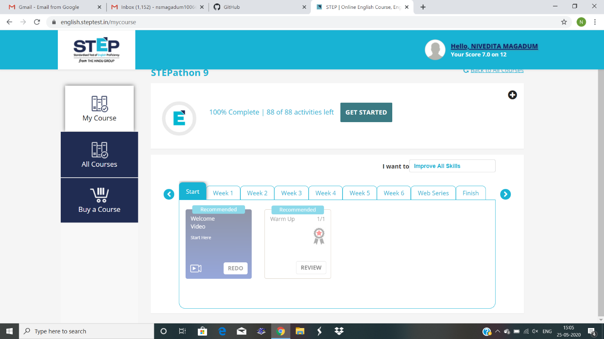

you tube learning: Deep learning architecture webnir”