**DAILY ONLINE ACTIVITIES SUMMARY**

|  |  |  |  |  |  |  |  |  |
| --- | --- | --- | --- | --- | --- | --- | --- | --- |
| **Date:** | **26/05/2020** | | | | | **Name:** | **Nivedita** | |
| **Sem & Sec** | **4th sem /A-sec** | | | | | **USN:** | **4al18cs053** | |
| **Online Test Summary** | | | | | | | | |
| **Subject** | | **DAA** | | | | | | |
| **Max. Marks** | | **30** | | **Score** | | | **26** | |
| **Certification Course Summary** | | | | | | | | |
| **Course** | **Mobility fundamental.** | | | | | | | |
| **Certificate Provider** | | | **Cisco networking** | | **Duration** | | | **9 hours** |
| **Coding Challenges** | | | | | | | | |
| **Problem Statement:** Write a program in C to print all permutations of a given string using pointers. | | | | | | | | |
| **Status:done** | | | | | | | | |
| **Uploaded the report in Github** | | | | | **yes** | | | |
| **If yes Repository name** | | | | | <https://github.com/nivi-nivedita/lockdown-coding-program/blob/master/permutation.txt> | | | |
| **Uploaded the report in slack** | | | | | **yes** | | | |

Online Test Details: today DAA test held .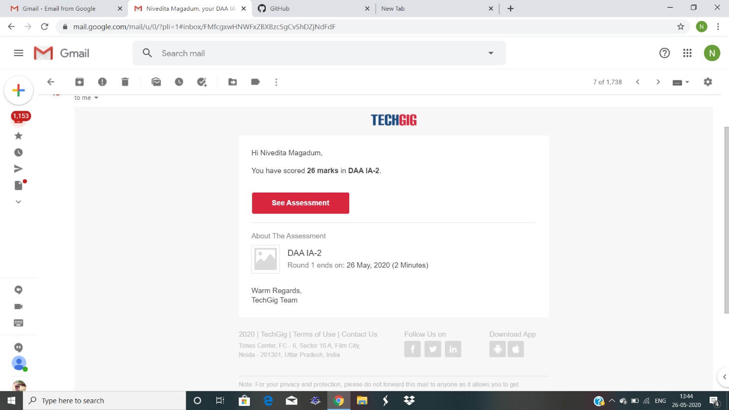

Certification Course Details: cisco networking was taking so many course in that “Mobility fundamental”.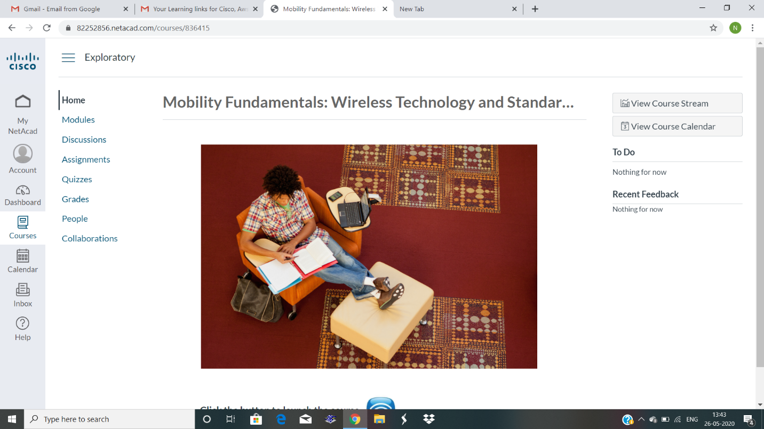

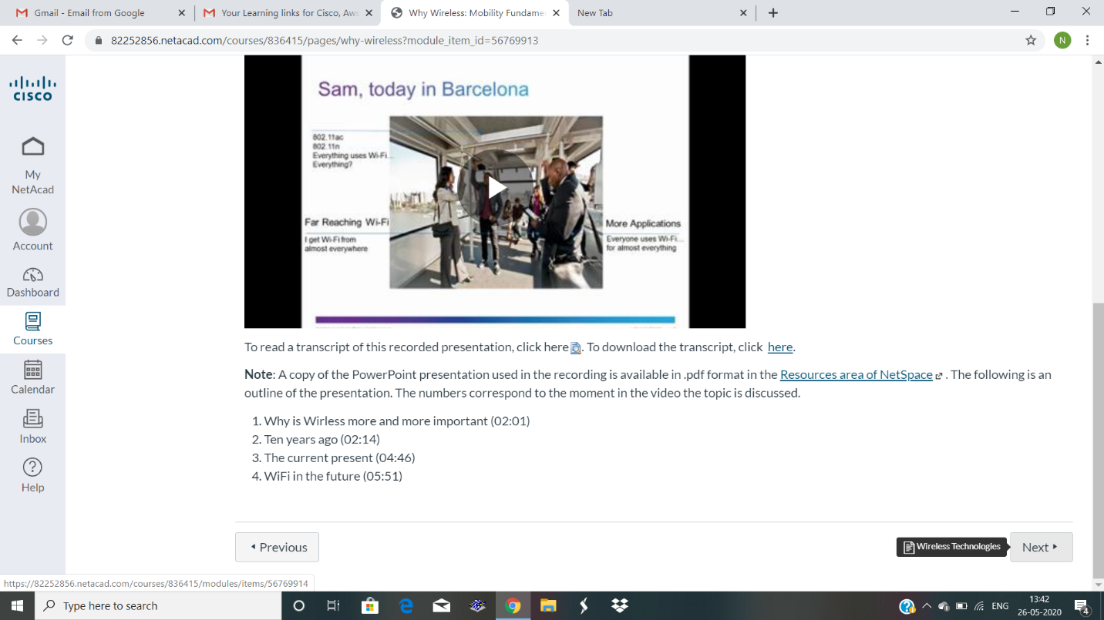

Coding Challenges Details: Write a program in C to print all permutations of a given string using pointers.

