**DAILY ONLINE ACTIVITIES SUMMARY**

|  |  |  |  |  |  |  |  |  |
| --- | --- | --- | --- | --- | --- | --- | --- | --- |
| **Date:** | **27/05/2020** | | | | | **Name:** | **Nivedita** | |
| **Sem & Sec** | **4th sem/A-sec** | | | | | **USN:** | **4al18cs053** | |
| **Online Test Summary** | | | | | | | | |
| **Subject** | | **OOC** | | | | | | |
| **Max. Marks** | | **30** | | **Score** | | | **25** | |
| **Certification Course Summary** | | | | | | | | |
| **Course** | **Mobility fundamental** | | | | | | | |
| **Certificate Provider** | | | **Cisco networking** | | **Duration** | | | **9 hours** |
| **Coding Challenges** | | | | | | | | |
| **Problem Statement:** **Write a C Program to sort an array of integers in ascending order and display the sorted array and Number of passes performed for sorting** | | | | | | | | |
| **Status:done** | | | | | | | | |
| **Uploaded the report in Github** | | | | | **yes** | | | |
| **If yes Repository name** | | | | | [**https://github.com/nivi-nivedita/lockdown-coding-program/blob/master/bubble%20sort.txt**](https://github.com/nivi-nivedita/lockdown-coding-program/blob/master/bubble%20sort.txt) | | | |
| **Uploaded the report in slack** | | | | | **yes** | | | |

Online Test Details: OOC test of 30 marks 30 questions and module 5(applet ,swing).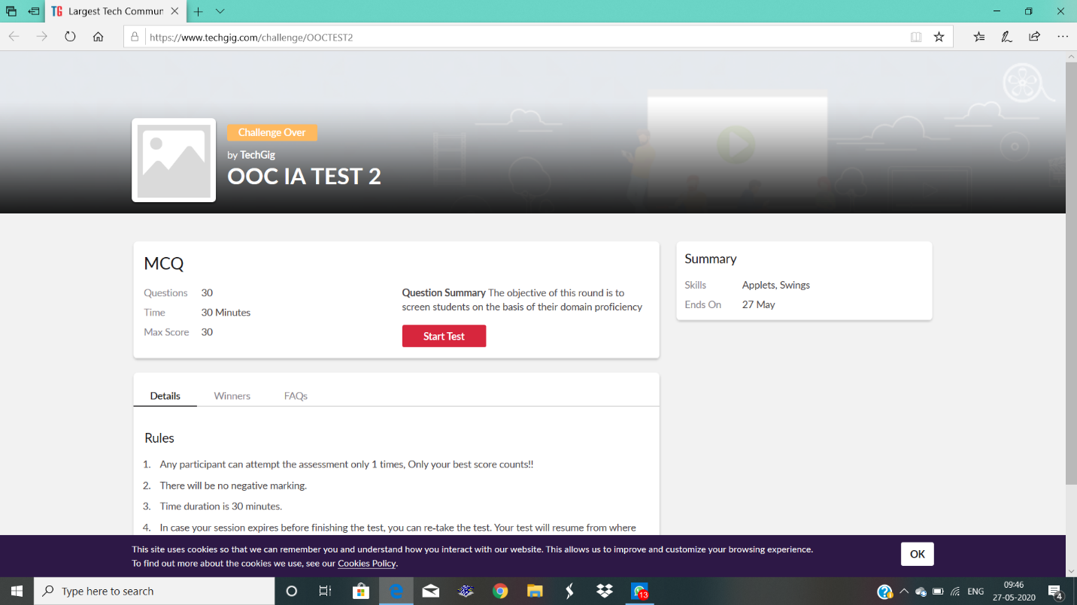

Certification Course Details: yesterday course was continued and I completed .which contains wire less systems and about its working.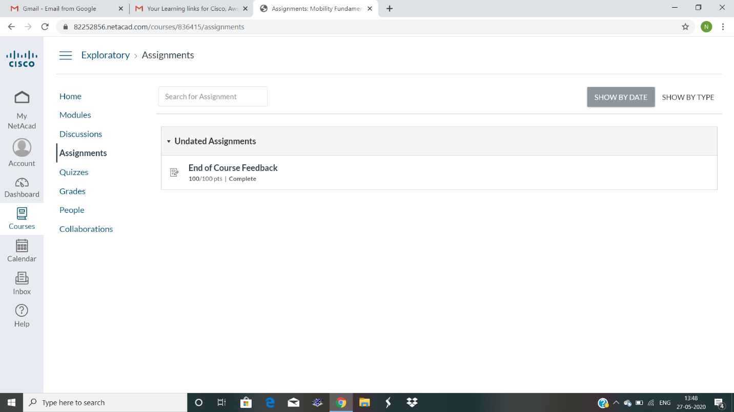

Coding Challenges Details: Write a C Program to sort an array of integers in ascending order and display the sorted array and Number of passes performed for sorting.

Out put of this program.

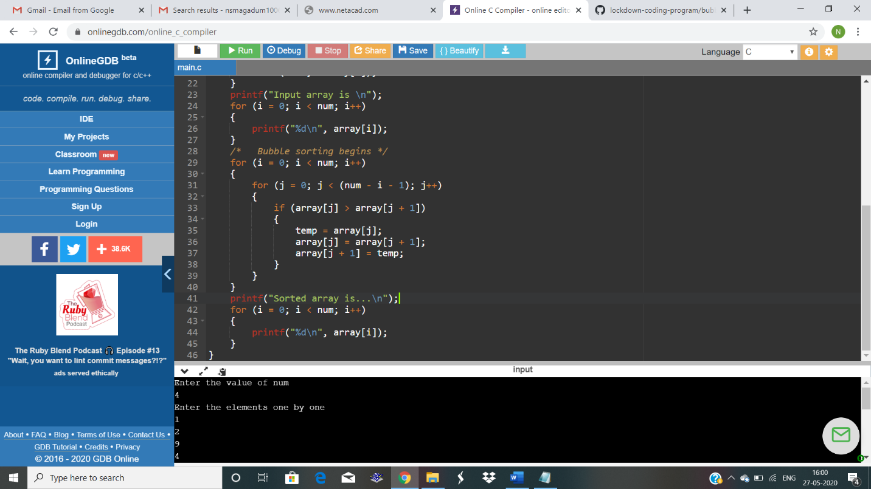Uploaded in github