**DAILY ONLINE ACTIVITIES SUMMARY**

|  |  |  |  |  |  |  |  |  |
| --- | --- | --- | --- | --- | --- | --- | --- | --- |
| **Date:** | **18/05/2020** | | | | | **Name:** | **Prajwal** | |
| **Sem & Sec** | **IV sem & B sec** | | | | | **USN:** | **4AL18CS057** | |
| **Online Test Summary** | | | | | | | | |
| **Subject** | | **Complex Analysis, Probability And Statistical Methods** | | | | | | |
| **Max. Marks** | | **30** | | **Score** | | | **---** | |
| **Certification Course Summary** | | | | | | | | |
| **Course** | **Machine Learning With Python** | | | | | | | |
| **Certificate Provider** | | | **COGNITIVE CLASS** | | **Duration** | | | **12 hours** |
| **Coding Challenges** | | | | | | | | |
| **Problem Statement: Write a C program to check whether the two strings are Anagram or not .** | | | | | | | | |
| **Status: Done** | | | | | | | | |
| **Uploaded the report in Github** | | | | | **YES** | | | |
| **If yes Repository name** | | | | | <https://github.com/PRAJWALKOTIAN/lockdown-coding> | | | |
| **Uploaded the report in slack** | | | | | **YES** | | | |

**Online test details** :- Test was conducted from 9:30 to 10:00 am dated 18 may 2020 .The test includes MCQ kind of questions

For Complex Analysis, Probability And Statistical Methods,

No snapshot is attached because marks was not given for this subject.

**Certification Course Details:**

The cource I have choosen is MACHINE LEARNING WITH PYTHON in this at first I studied basics of python and what are the important modules covered in this cource.

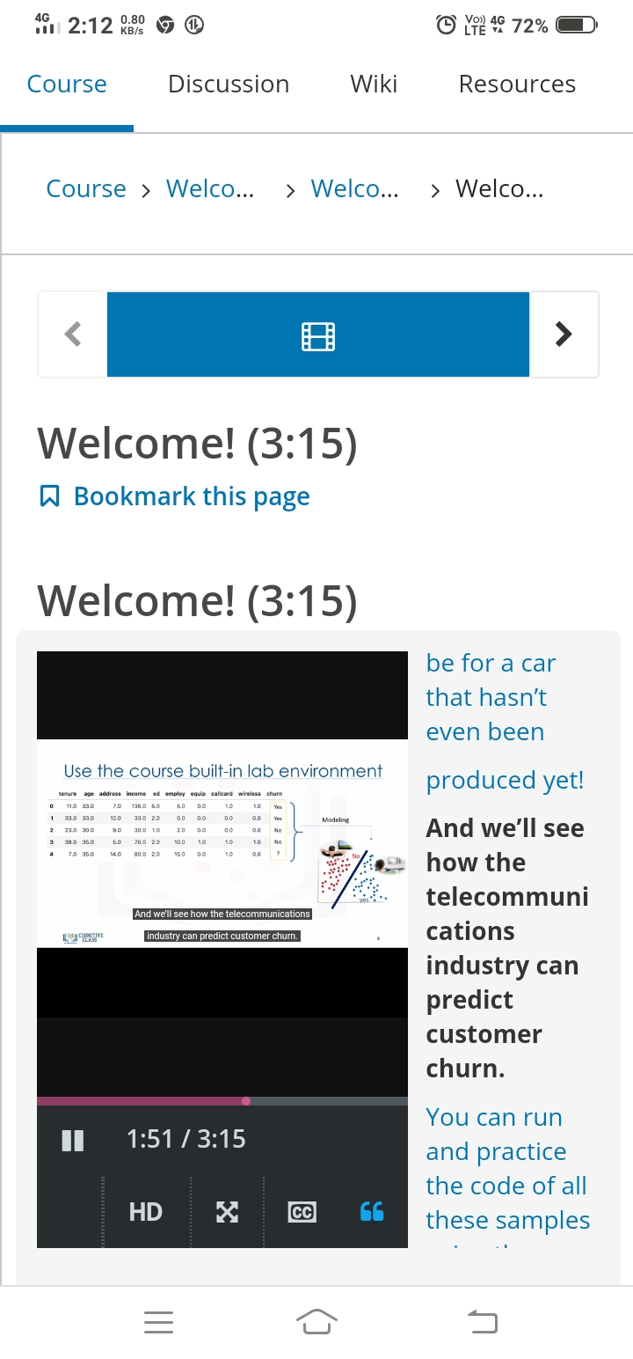

**Coding Challenges Details**

The question I took to code is Write a C program to check whether the two strings are Anagram or not. The bellow code is there on my github repository.