**DAILY ONLINE ACTIVITIES SUMMARY**

|  |  |  |  |  |  |  |  |  |
| --- | --- | --- | --- | --- | --- | --- | --- | --- |
| **Date:** | **19/05/2020** | | | | | **Name:** | **Prajwal** | |
| **Sem & Sec** | **IV sem & B sec** | | | | | **USN:** | **4AL18CS057** | |
| **Online Test Summary** | | | | | | | | |
| **Subject** | | **Design And Analysis Algorithm** | | | | | | |
| **Max. Marks** | | **30** | | **Score** | | | **15** | |
| **Certification Course Summary** | | | | | | | | |
| **Course** | **Machine Learning With Python** | | | | | | | |
| **Certificate Provider** | | | **COGNITIVE CLASS** | | **Duration** | | | **12 hours** |
| **Coding Challenges** | | | | | | | | |
| **Problem Statement: We have a Letter or a word then we need add some letters to it and need to find out shortest palindrome** | | | | | | | | |
| **Status: Done** | | | | | | | | |
| **Uploaded the report in Github** | | | | | **YES** | | | |
| **If yes Repository name** | | | | | <https://github.com/PRAJWALKOTIAN/lockdown-coding> | | | |
| **Uploaded the report in slack** | | | | | **YES** | | | |

**Online test details :-**

Test was conducted from 09:15 to 09:55 am dated 19 may 2020.The test includes MCQ kind of questions which contains 20 question of 1 mark and 5 question of 2 marks each.

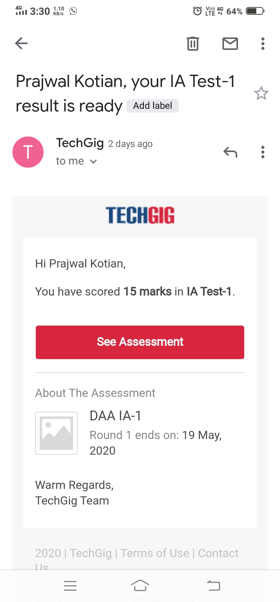

**Certification Course Details:**

The cource I have choosen is MACHINE LEARNING WITH PYTHON in this I studied how machine language works and some important concept in machine learning.

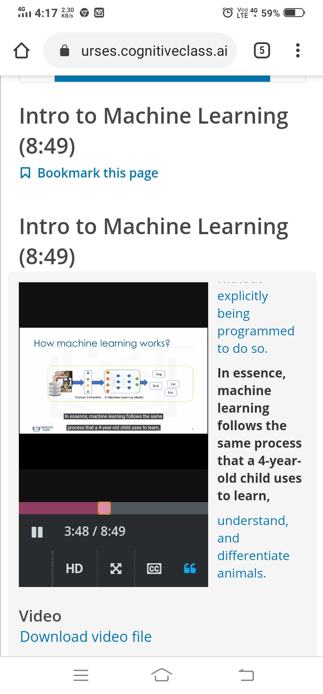

**Coding Challenges Details**

The question I took to code is We have a letter or a word we need to add some letters to it and need to find out shortest palindrome. The bellow code is there on my github repository

