**DAILY ONLINE ACTIVITIES SUMMARY**

|  |  |  |  |  |  |  |  |  |
| --- | --- | --- | --- | --- | --- | --- | --- | --- |
| **Date:** | **20/05/2020** | | | | | **Name:** | **Prajwal** | |
| **Sem & Sec** | **IV sem & B sec** | | | | | **USN:** | **4AL18CS057** | |
| **Online Test Summary** | | | | | | | | |
| **Subject** | | **Object Oriented Concept** | | | | | | |
| **Max. Marks** | | **30** | | **Score** | | | **21** | |
| **Certification Course Summary** | | | | | | | | |
| **Course** | **Machine Learning With Python** | | | | | | | |
| **Certificate Provider** | | | **COGNITIVE CLASS** | | **Duration** | | | **12 hours** |
| **Coding Challenges** | | | | | | | | |
| **Problem Statement: Write a C program to reverse a Linked List (SLL) in groups of given size** | | | | | | | | |
| **Status: Done** | | | | | | | | |
| **Uploaded the report in Github** | | | | | **YES** | | | |
| **If yes Repository name** | | | | | <https://github.com/PRAJWALKOTIAN/lockdown-coding> | | | |
| **Uploaded the report in slack** | | | | | **YES** | | | |

**Online test details :-**

Test was conducted from 09:25 to 10:10 am dated 20 may 2020.The test includes MCQ kind of questions and also there was a question to predict the output.

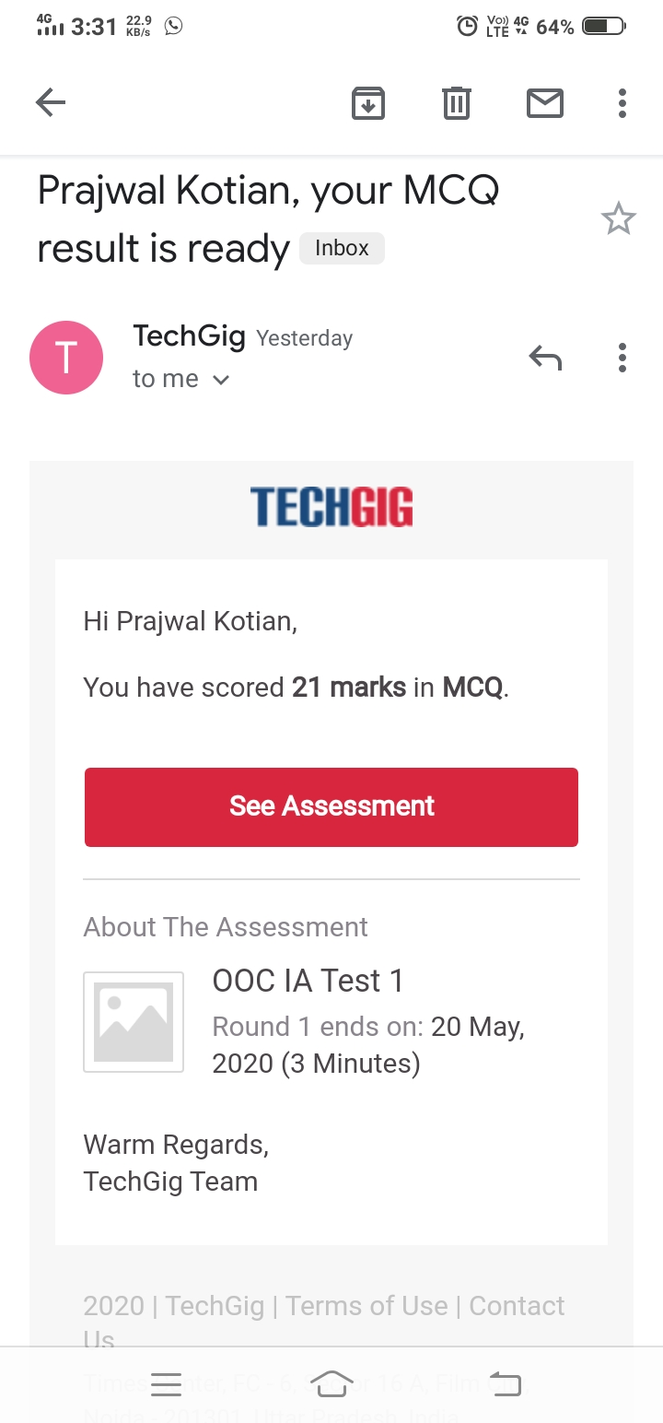

**Certification Course Details:**

The cource I have choosen is MACHINE LEARNING WITH PYTHON in this I studied the difference between Supervised and Unsupervised and the definitions of that concept.

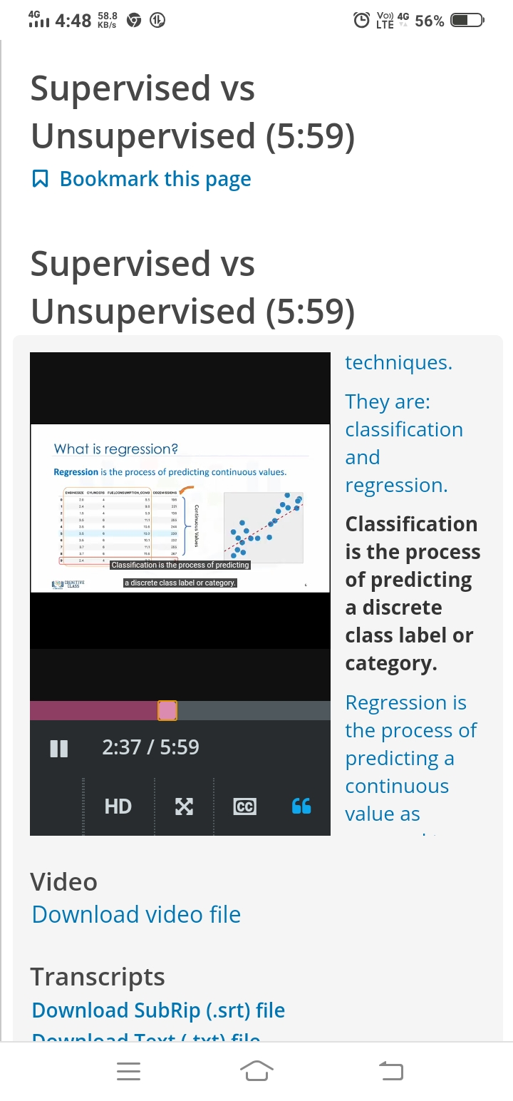

**Coding Challenges Details**

The question I took to code isWrite a C program to reverse a Linked List (SLL) in groups of given size. The bellow code is there on my github repository

