DAILY ASSESSMENT FORMAT

|  |  |  |  |
| --- | --- | --- | --- |
| Date | 21/05/2020 | Name: | Prajna |
| Course: | TCS ion | USN: | 4AL16EC047 |
| Topic: | Learn Corporate Telephone Etiquette  Understand According Fundamentals  Gain fundamental Skills in IT | Semester &  Section: | 8 “A” |
| FORENOON SESSION DETAILS | | | |
| Image of the session | | | |

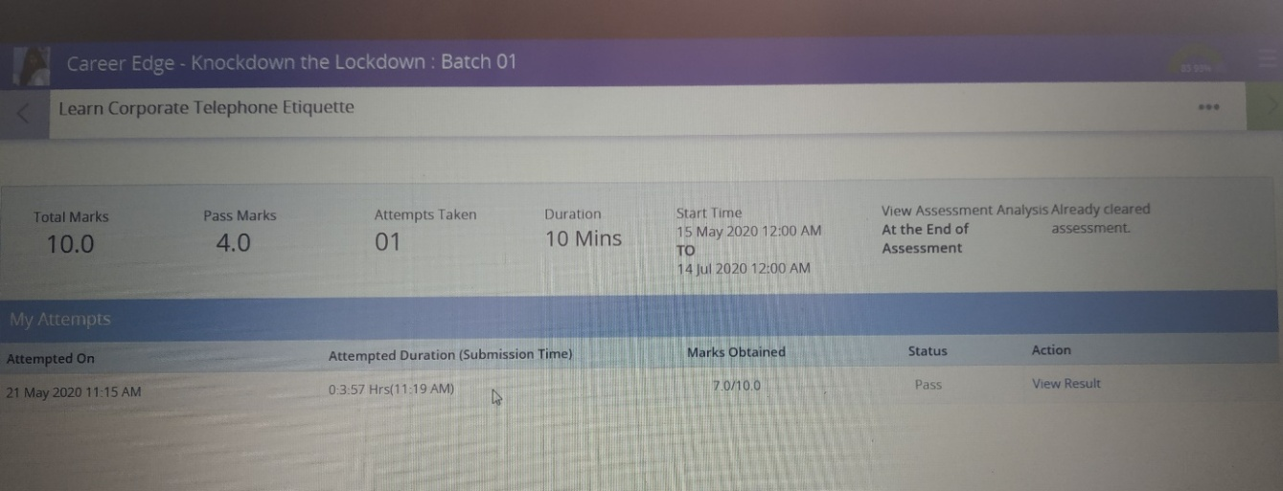

Learn Corporate Telephone Etiquette

* For good first impression remember **APEND** i.e., Be **A**lert, **P**leasant, **E**xpression, **N**atural and **D**istinctive.
* Attend and make calls in a professional manner.
* Create a good first impression.
* Observe good telephone etiquette.
* Use appropriate phrases and expressions.
* Speak with clarity over the phone.
* Take messages for others, put calls on hold or arrange for call backs.
* Take or give voice mail messages.
* Avoid negative expressions.

Understand According Fundamentals

* Accounting is a system which collects and processes financial information of a business.
* Business transaction includes – identifying, recording, classifying, summarizing, analyzing, interpreting and communicating.
* Double entry system is that each amount is recorded at least in two accounts.
* A journal is the process of making entries in the book.
* A ledger is a principal book containing all the accounts.
* Liabilities are loan payable, interest payable, accounts payable, deferred income and outstanding expenses.
* Accounts can be classified as assets, liabilities, capital, incomes and expenses.

Gain fundamental Skills in IT

* Understanding the functionalities if the operating systems such as memory management, process management, file system management, device management.
* Enhance problem solving skills.
* Improve office etiquette, email and telephone etiquette.
* Manage time at work using time management.
* Work in teams with assertiveness and resolving conflicts.
* Create the work breakdown structure.

|  |  |  |  |
| --- | --- | --- | --- |
| Date | 21/05/2020 | Name: | Prajna |
| Course: | PYTHON | USN: | 4AL16EC047 |
| Topic: | Variables | Semester &  Section: | 8 “A” |
| AFTERNOON SESSION DETAILS | | | |

Variables:

Variables are containers for storing data values.Unlike other programming languages, Python has no command for declaring a variable.

A variable is created the moment you first assign a value to it.

Example

x = 5  
y = "Lion"  
print(x)  
print(y)Try it Yourself »

Variables do not need to be declared with any particular type and can even change type after they have been set.

Example

x = 4 # x is of type int  
x = "Sally" # x is now of type str  
print(x)

String variables can be declared either by using single or double quotes:

Example

x = "John"  
# is the same as  
x = 'John'self

Variable Names

A variable can have a short name (like x and y) or a more descriptive name (age, carname, total_volume). Rules for Python variables:

* A variable name must start with a letter or the underscore character
* A variable name cannot start with a number
* A variable name can only contain alpha-numeric characters and underscores (A-z, 0-9, and _ )
* Variable names are case-sensitive (age, Age and AGE are three different variables)

Example

#Legal variable names:  
myvar = "John"  
my_var = "John"  
_my_var = "John"  
myVar = "John"  
MYVAR = "John"  
myvar2 = "John"  
  
#Illegal variable names:  
2myvar = "John"  
my-var = "John"  
my var = "John"Try »

Built-in Data Types

In programming, data type is an important concept. Variables can store data of different types, and different types can do different things. Python has the following data types built-in by default, in these categories:

|  |  |
| --- | --- |
| Text Type: | Str |
| Numeric Types: | int, float,complex |
| Sequence Types: | list, tuple, range |
| Mapping Type: | Dict |
| Set Types: | set, frozenset |
| Boolean Type: | Bool |
| Binary Types: | bytes, bytearray,memoryview |

Python numbers:

Here are three numeric types in Python:

* Int
* Float
* complex

Variables of numeric types are created when you assign a value to them:

Example

x = 1    # int  
y = 2.8  # float  
z = 1j   # complex

To verify the type of any object in Python, use the type() function:

Example

print(type(x))  
print(type(y))  
print(type(z))Try it Yourself

Int

Int, or integer, is a whole number, positive or negative, without decimals, of unlimited length.

Example

Integers:

x = 1  
y = 35656222554887711  
z = -3255522  
  
print(type(x))  
print(type(y))  
print(type(z))Try it Yourself »

Float

Float, or "floating point number" is a number, positive or negative, containing one or more decimals.

Example

Floats:

x = 1.10  
y = 1.0  
z = -35.59  
  
print(type(x))  
print(type(y))  
print(type(z))Try it Yourself »

Float can also be scientific numbers with an "e" to indicate the power of 10.

Example

Floats:

x = 35e3  
y = 12E4  
z = -87.7e100  
  
print(type(x))  
print(type(y))  
print(type(z))

Complex

Complex numbers are written with a "j" as the imaginary part:

Example

Complex:

x = 3+5j  
y = 5j  
z = -5j  
  
print(type(x))  
print(type(y))  
print(type(z))Try it Yourself »

Print few things and understand variable types.

Integer vs float type and what happens at interaction!

a = 5.01

b=1

c=a*b

type(c)

print("Carefully observe the formatting of the output:")

print("Balls", 25 + 30 / 6)

print("Stick", 100 - 14 * 3 % 4)

print("Oh, did you observe the difference?.")

print("Is it true that 3 + 8 < 12 - 7?")

print("Oh, that's why it's False.")

What is happening with dot and whole numbers?

lines= 100

word = 4.0

pages=100

lines_pages= lines- pages

diff= lines - word

division = lines/word

print("There are", lines, "liens available.")

print("There are only", pages, "pages available.")

print("There will be", division , "lines per word")

print("Difference", diff, "lines minus word.")

# Observe the interaction between the decimal and the non decimal variables!

Reading from a system file of azure.

a = 'this is a string'

#a[10] = 'f'

b = a.replace('string', 'longer string')

b