DAILY ASSESSMENT FORMAT

|  |  |  |  |
| --- | --- | --- | --- |
| Date | 28/05/2020 | Name: | Prajna |
| Course: | Resume | USN: | 4AL16EC047 |
| Topic: | Why you should write your own resume? | Semester &  Section: | 8 “A” |
| FORENOON SESSION DETAILS | | | |

**Why you should write your own resume?**

**Image of session**

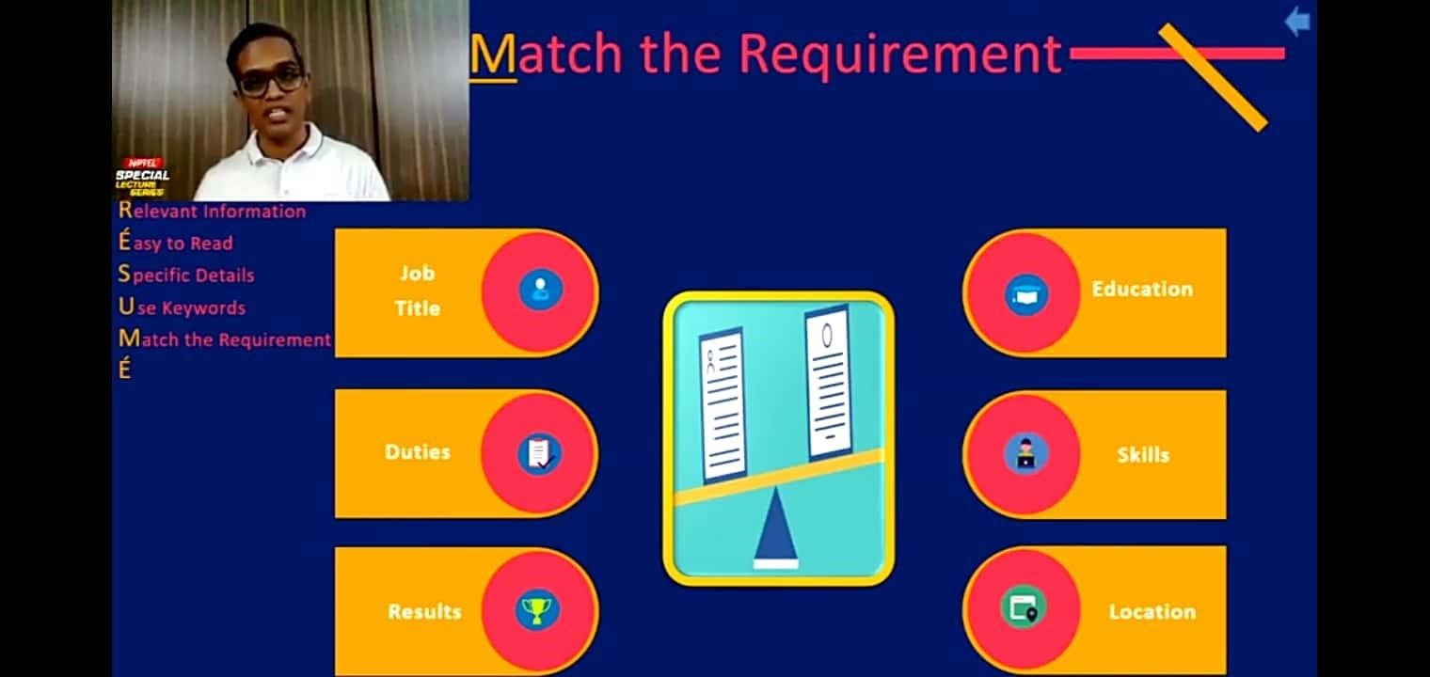

Basics:

* Job requirement:

**Job requirements** are “**must haves**” that an employer is looking for in a candidate for a certain job position.

* Job Description:

**A good job description performs a number of important functions:**

1. It describes the skills and competencies that are needed to perform the role;
2. It defines where the job fits within the overall company hierarchy;
3. It is used as the basis for the employment contract; and.
4. It is a valuable performance management tool.

* Sourcing:

**Sourcing**, also known as **procurement**, is the practice of locating and selecting businesses or individuals based on set criteria. **Sourcing** is carried out in business in many different areas and for different reasons. One of the most common uses of **sourcing** is in supply chain management.

* Screening:

A **screening test** is performed as a preventative measure – to detect a potential health problem or disease in someone that doesn't yet have signs or symptoms. The purpose of **screening** is early detection; helping to reduce the risk of disease, or to detect a condition early enough to treat it most effectively.

* Profile evaluation:

The act or process of extrapolating information about a **person** based on known traits or tendencies consumer **profiling** specifically : the act of suspecting or targeting a **person** on the basis of observed characteristics or behavior racial **profiling**.

* Interview:

An interview is the way of face to face conversation between the interviewer and the interviewee, where the interviewer seeks replies from the interviewee for choosing a potential [**human resource**](https://www.iedunote.com/human-resource-planning).

* Selection:

The Selection is the process of choosing the most suitable candidate for the vacant position in the organization. In other words, selection means weeding out unsuitable applicants and selecting those individuals with prerequisite qualifications and capabilities to fill the jobs in the organization

Anatomy of a good email

Every email you write has the same basic structure: Subject line, greeting, email body, and closing. But as with every written form of professional communication, there’s a right way to do it and standards that should be followed. Here’s how to write a proper email:

**1 Subject line**

The subject line could be the most important part of the email, though it’s often overlooked in favor of the email body. But if you’re cold-emailing someone, or just establishing a professional relationship, your subject line can entice people to open the message as well as set expectations about what’s enclosed. On the other hand, a poorly crafted or generic subject line (like “Hi” or “You don’t wAnt to missthos”) can deter the reader and result in your email landing in the spam folder.

“Spend double the amount of time crafting the right subject line as you do on the [body] because if they don’t open the email, it doesn’t matter,” says Cole Schafer, founder and copy chief of Honey Copy.

**2 Openers**

In most email writing situations, you’ll want to include a quick greeting to acknowledge the reader before diving into your main message or request.

The exception: When you’re on an email chain with close colleagues, it often becomes more natural to drop the opener (as well as the closing). Though it may initially feel like a faux pas, it signals a better professional rapport.

**3 Body**

The body of an email is the meat of your message, and it must have a clear and specific purpose, such as getting feedback on a presentation or arranging a meeting with a new client. It should also be concise. That way, people will be more inclined to read it, rather than skimming it and risking missing critical information. If you can, boil it down to a few choice sentences.

And for emails that require more length and detail, keep it as focused as you can. “Nobody wants to receive a novel. You want to keep it between three, four, or five lines of text,” says Schafer.

**4 Closings**

Just as you want to start things off on the right foot with your greeting, you also want to part well. That means writing a friendly sign-off. And there are plenty of options to choose from.

**Six steps for writing professional emails**

**1. Identify your goal**

Before you write an email, ask yourself what you want the recipient to do after they’ve read it. Once you’ve determined the purpose of your email, you can ensure everything you include in your message supports this action. For example, if you want the recipient to review a report you’ve attached, let them know what the report is, why you need them to review it, what sort of feedback you need and when you need the task completed.

**2. Consider your audience**

When you compose an email message, make sure your tone matches your audience. For example, if you’re emailing a business executive you’ve never met, keep the email polished and free of any jokes or informalities. On the other hand, if you’re emailing a colleague with whom you have a good relationship, you might use a less formal, more friendly approach.

**3. Keep it concise**

Your audience might have little time to read through your email, so make it as brief as possible without leaving out key information. Try not to address too many subjects at once as this can make your message lengthy, challenging to read and difficult to take action on. When editing your email, take out any information that’s irrelevant to the topic you’re addressing. Use short, simple sentences by removing filler words and extraneous information. This will make your note shorter and easier to read.

**4. Proofread your email**

An error-free email demonstrates diligence and professionalism. Before you send an email, take a moment to check for any spelling, grammar or syntax errors. Also, double-check to ensure you’ve included any attachments you may have referenced in your message. If it is an important email to critical stakeholders, you might ask your direct supervisor or a trusted colleague to read over it before you send it.

**5. Use proper etiquette**

Include a courteous greeting and closing to sound friendly and polite. Additionally, be considerate of the recipient and their time. For example, unless it’s an emergency, avoid emailing a contact asking for something after-hours or while they’re on leave.

**6. Remember to follow up**

Most people receive several emails per day, so they might miss or forget to respond to your message. If the recipient hasn’t replied within two working days, consider reaching back out with a friendly follow-up email.