**DAILY ASSESSMENT FORMAT**

|  |  |  |  |
| --- | --- | --- | --- |
| **Date:** | **17/07/2020** | **Name:** | **Prajwal Kamagethi Chakravarti P L** |
| **Course:** | **Coursera** | **USN:** | **4AL17EC107** |
| **Topic:** | * **Mathematics for machine learning: Linear Algebra** | **Semester & Section:** | **6 & B** |
| **Github Repository:** | **https://github.com/alvas-education-foundation/Prajwal-Kamagethi.git** |  |  |

|  |
| --- |
| **SESSION DETAILS**  **Session images**    **Report:**  **An eigenvector, corresponding to a**[**real**](https://en.wikipedia.org/wiki/Real_number)**nonzero eigenvalue, points in a direction in which it is**[**stretched**](https://en.wikipedia.org/wiki/Scaling_(geometry))**by the transformation and the eigenvalue is the factor by which it is stretched. If the eigenvalue is negative, the direction is reversed. Loosely speaking, in a multidimensional**[**vector space**](https://en.wikipedia.org/wiki/Vector_space)**, the eigenvector is not rotated. However, in a one-dimensional vector space, the concept of**[**rotation**](https://en.wikipedia.org/wiki/Rotation)**is meaningless.**  **If *T* is a linear transformation from a vector space *V* over a**[**field**](https://en.wikipedia.org/wiki/Field_(mathematics))***F* into itself and v is a**[**nonzero**](https://en.wikipedia.org/wiki/Zero_vector)**vector in *V*, then v is an eigenvector of *T* if *T*(v) is a scalar multiple of v. This can be written as {\displaystyle T(\mathbf {v} )=\lambda \mathbf {v} ,}where *λ* is a scalar in *F*, known as the eigenvalue, characteristic value, or characteristic root associated with v.**  **There is a direct correspondence between *n*-by-*n***[**square matrices**](https://en.wikipedia.org/wiki/Square_matrix)**and linear transformations from an**[***n*-dimensional**](https://en.wikipedia.org/wiki/Dimension)**vector space into itself, given any**[**basis**](https://en.wikipedia.org/wiki/Basis_(linear_algebra))**of the vector space. Hence, in a finite-dimensional vector space, it is equivalent to define eigenvalues and eigenvectors using either the language of**[**matrices**](https://en.wikipedia.org/wiki/Matrix_(mathematics))**or the language of linear transformations.**  **If *V* is finite-dimensional, the above equation is equivalent to {\displaystyle A\mathbf {u} =\lambda \mathbf {u} .}where *A* is the matrix representation of *T* and u is the coordinate vector of v.**  **In essence, an eigenvector v of a linear transformation *T* is a nonzero vector that, when *T* is applied to it, does not change direction. Applying *T* to the eigenvector only scales the eigenvector by the scalar value *λ*, called an eigenvalue. This condition can be written as the equation {\displaystyle T(\mathbf {v} )=\lambda \mathbf {v} ,}referred to as the eigenvalue equation or eigenequation. In general, *λ* may be any**[**scalar**](https://en.wikipedia.org/wiki/Scalar_(mathematics))**. For example, *λ* may be negative, in which case the eigenvector reverses direction as part of the scaling, or it may be zero or**[**complex**](https://en.wikipedia.org/wiki/Complex_number)**.**  **Linear transformations can take many different forms, mapping vectors in a variety of vector spaces, so the eigenvectors can also take many forms. For example, the linear transformation could be a**[**differential operator**](https://en.wikipedia.org/wiki/Differential_operator)**like {\displaystyle {\tfrac {d}{dx}}}, in which case the eigenvectors are functions called**[**eigenfunctions**](https://en.wikipedia.org/wiki/Eigenfunction)**that are scaled by that differential operator, such as{\displaystyle {\frac {d}{dx}}e^{\lambda x}=\lambda e^{\lambda x}.}**  **Alternatively, the linear transformation could take the form of an *n* by *n* matrix, in which case the eigenvectors are *n* by 1 matrices. If the linear transformation is expressed in the form of an *n* by *n* matrix *A*, then the eigenvalue equation above for a linear transformation can be rewritten as the matrix multiplication{\displaystyle Av=\lambda v,}**  **where the eigenvector *v* is an *n* by 1 matrix. For a matrix, eigenvalues and eigenvectors can be used to**[**decompose the matrix**](https://en.wikipedia.org/wiki/Matrix_decomposition)**, for example by**[**diagonalizing**](https://en.wikipedia.org/wiki/Diagonalizable_matrix)**it.**  **Eigenvalues and eigenvectors give rise to many closely related mathematical concepts, and the prefix *eigen-* is applied liberally when naming them:**   * **The set of all eigenvectors of a linear transformation, each paired with its corresponding eigenvalue, is called the eigensystem of that transformation.**[**[5]**](https://en.wikipedia.org/wiki/Eigenvalues_and_eigenvectors#cite_note-FOOTNOTEPressTeukolskyVetterlingFlannery2007536-5)[**[6]**](https://en.wikipedia.org/wiki/Eigenvalues_and_eigenvectors#cite_note-FOOTNOTEWolfram.com:_Eigenvector-6) * **The set of all eigenvectors of *T* corresponding to the same eigenvalue, together with the zero vector, is called an eigenspace or characteristic space of *T* associated with that eigenvalue.** * **If a set of eigenvectors of *T* forms a**[**basis**](https://en.wikipedia.org/wiki/Basis_(linear_algebra))**of the domain of *T*, then this basis is called an eigenaxis.** |

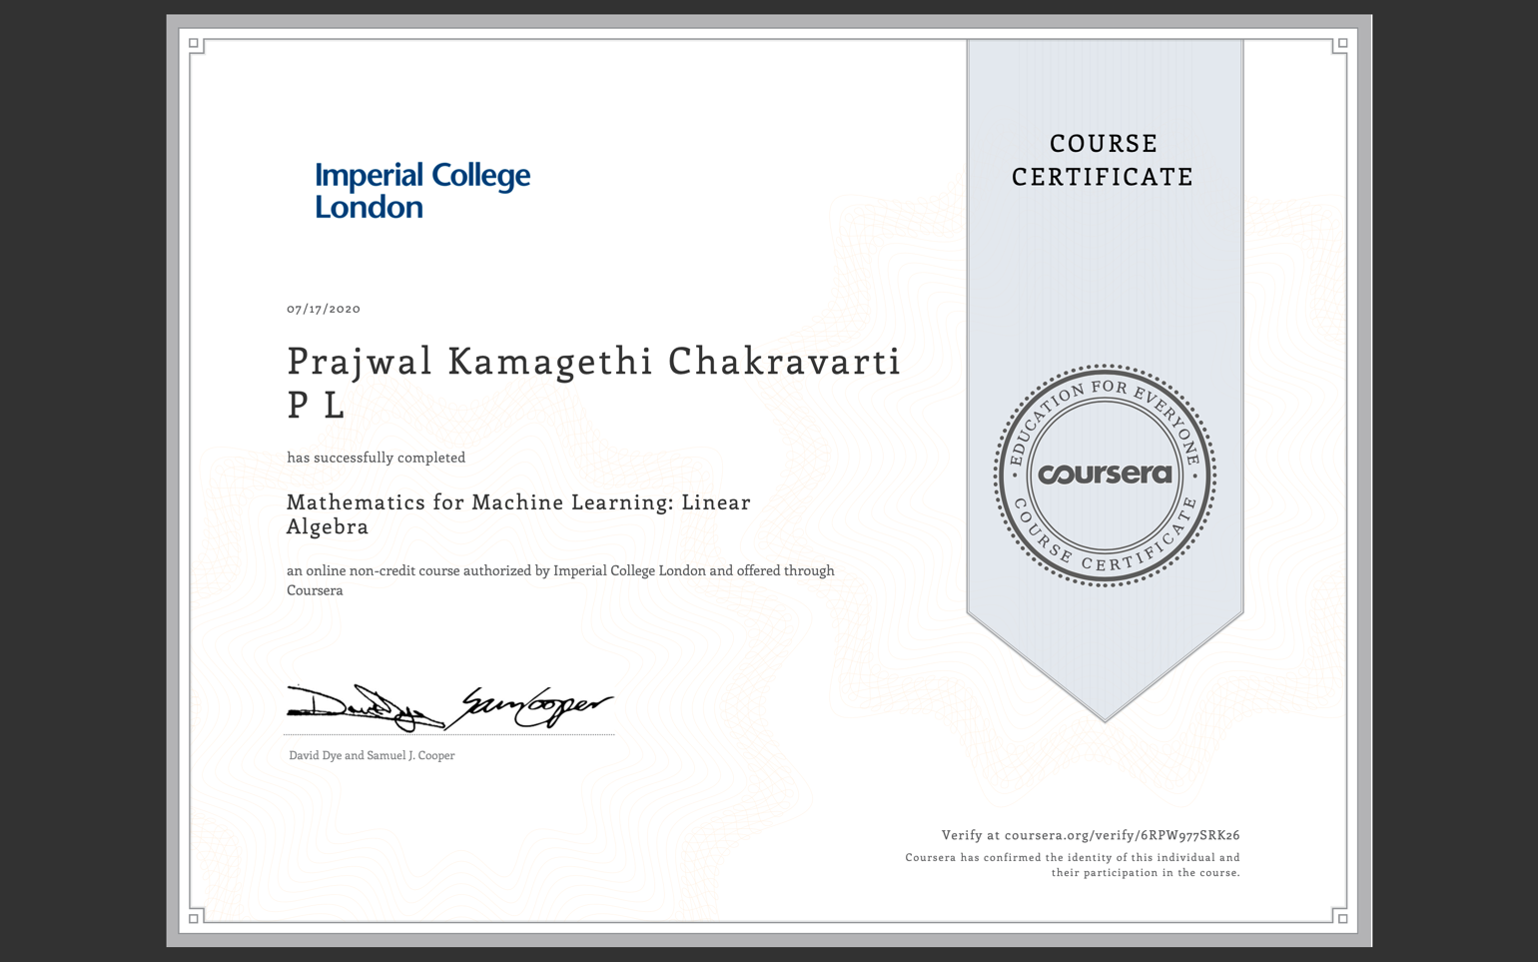

**DAILY ASSESSMENT FORMAT**

|  |  |  |  |
| --- | --- | --- | --- |
| **Date:** | **17/07/2020** | **Name:** | **Prajwal Kamagethi Chakravarti P L** |
| **Course:** | **Salesforce** | **USN:** | **4AL17EC107** |
| **Topic:** | * **Build-your-career-with-salesforce-skills** | **Semester & Section:** | **6 & B** |
| **Github Repository:** | **https://github.com/alvas-education-foundation/Prajwal-Kamagethi.git** |  |  |

|  |
| --- |
| **SESSION DETAILS**  **Session images**    **Report:**  **Secure Your Users' Identity** **Learning Objectives** **After completing this module, you’ll be able to:**  **Describe ways to identify your users in addition to a username and password.**  **Set up two-factor authentication.**  **Use the Salesforce Authenticator app to verify identity.**  **Get login information about users who log in to your org.** **Secure Identity with Two-Factor Authentication and Salesforce Authenticator:** **As an admin, you probably walk a fine line between making sure that your Salesforce org is secure and that your users can log in quickly and easily.**   * **The most effective way to protect your org and its data is to require that users provide more than just their username and password. Security experts call this two-factor authentication, or 2FA for short.**  **What Is Two-Factor Authentication?**  * **Sounds like a mathematical equation, right? Whether math thrills you or fills you with dread, just know that 2FA has nothing to do with high school algebra. But it has everything to do with making sure that your users are who they say they are.**   **What are the two factors?**   * **Something users know, like their password** * **Something users have, such as a mobile device with an authenticator app installed** * **That second factor of authentication provides an extra layer of security for your org.**   **As an admin, you can require it every time your users log in. Or you can require it only in some circumstances, such as when users log in from an unrecognized device or try to access a high-risk application.**   * **After users successfully verify their identity with both authentication factors, they can access Salesforce and start working.**  **How Two-Factor Authentication Works**  * **You might not have known what it’s called, but you’ve probably already used two-factor authentication.** * **Every time you get cash from the ATM, you use something you have (your bank card) plus something you know (your PIN). And maybe you already have an authenticator app on your phone. For instance, you enter a verification code that you get from the app when you log in to some of your online accounts.** * **This unique code is sometimes called a time-based one-time password (or TOTP for short) because it expires after a set amount of time.** * **Several vendors, including Salesforce and Google, provide apps that generate these time-sensitive codes.**  **Set Up Two-Factor Authentication for Every Login**  * **Now that you know the basics of two-factor authentication, let’s see how easy it is to set up.**   **Suppose you’re a Salesforce admin for Jedeye Technologies, a company *not* located in a galaxy far, far away.**   * **Your chief security officer has handed you a mission: Make all employees supply more than their username and password every time they try to access the company’s Salesforce org.**  **Step 1: Set the session security level for two-factor authentication****Step 2: Create a user****Step 3: Create a permission set for two-factor authentication****Step 4: Assign the permission set to Sia’s userx** |