**DAILY ONLINE ACTIVITIES SUMMARY**

|  |  |  |  |  |  |  |  |
| --- | --- | --- | --- | --- | --- | --- | --- |
| **Date:** | **20/05/2020** | | | | **Name:** | **Rakshith Rai** | |
| **Sem & Sec** | **8th- B** | | | | **USN:** | **4AL16CS075** | |
| **Online Test Summary** | | | | | | | |
| **Subject** | | **IOT** | | | | | |
| **Max. Marks** | | **30** | | **Score** | | **22** | |
| **Certification Course Summary** | | | | | | | |
| **Course** | **Ultimate java development and certification course** | | | | | | |
| **platform** | | | **Eduonix** | **Duration** | | | **1 hours** |
| **Coding Challenges** | | | | | | | |
| **Problem Statement:**  **1)Write a program to sort a arraylist using Collections.sort method.** | | | | | | | |
| **Status: Executed** | | | | | | | |
| **Uploaded the report in Github** | | | | **Yes** | | | |
| **If yes Repository name** | | | | <https://github.com/rakshithrai77/online-coding> | | | |
| **Uploaded the report in slack** | | | | **Yes** | | | |

Online Test Details: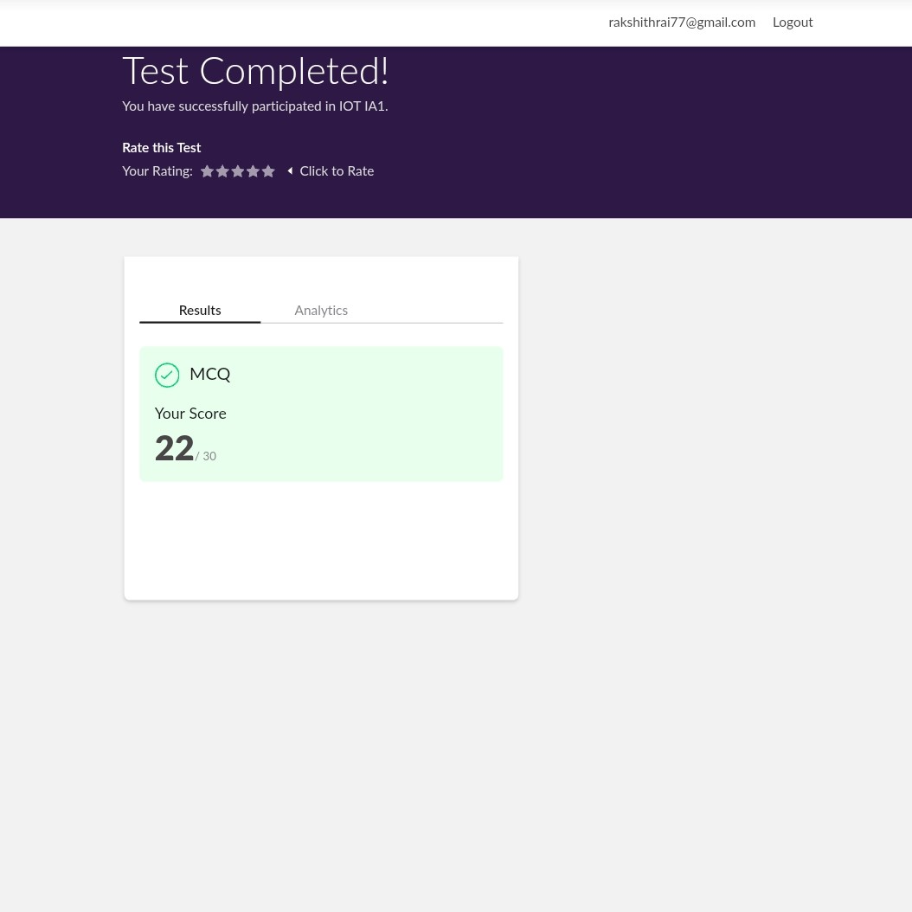

Certification:

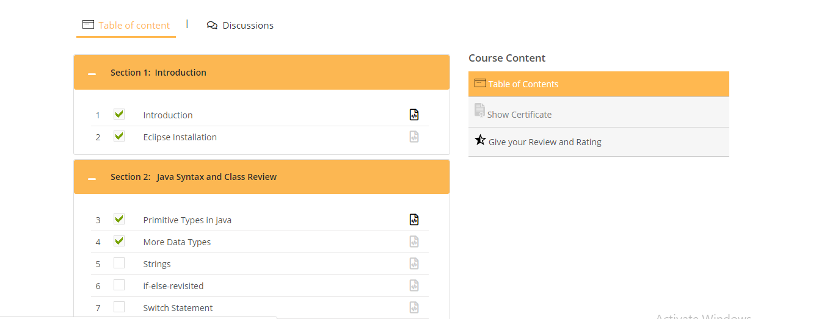

Coding Challenges Details: 