**DAILY ONLINE ACTIVITIES SUMMARY**

|  |  |  |  |  |  |  |
| --- | --- | --- | --- | --- | --- | --- |
| **Date:** | **2/07/2020** | | | **Name:** | **Ravi k r** | |
| **Sem & Sec** | **8th- B** | | | **USN:** | **4AL16CS076** | |
| **Certification Course Summary** | | | | | | |
| **Course** | **Building Scalable Java Microservices with Spring Boot and Spring Cloud** | | | | | |
| **platform** | | **coursera** | **Duration** | | | **10 hours** |
| **Coding Challenges** | | | | | | |
| **Problem Statement:**  **The java program without exception handling mechanism for some input** | | | | | | |
| **Status: Executed** | | | | | | |
| **Uploaded the report in Github** | | | **Yes** | | | |
| **If yes Repository name** | | | https://github.com/alvas-education-foundation/Ravi_kr | | | |
| **Uploaded the report in slack** | | | **Yes** | | | |

Certification:

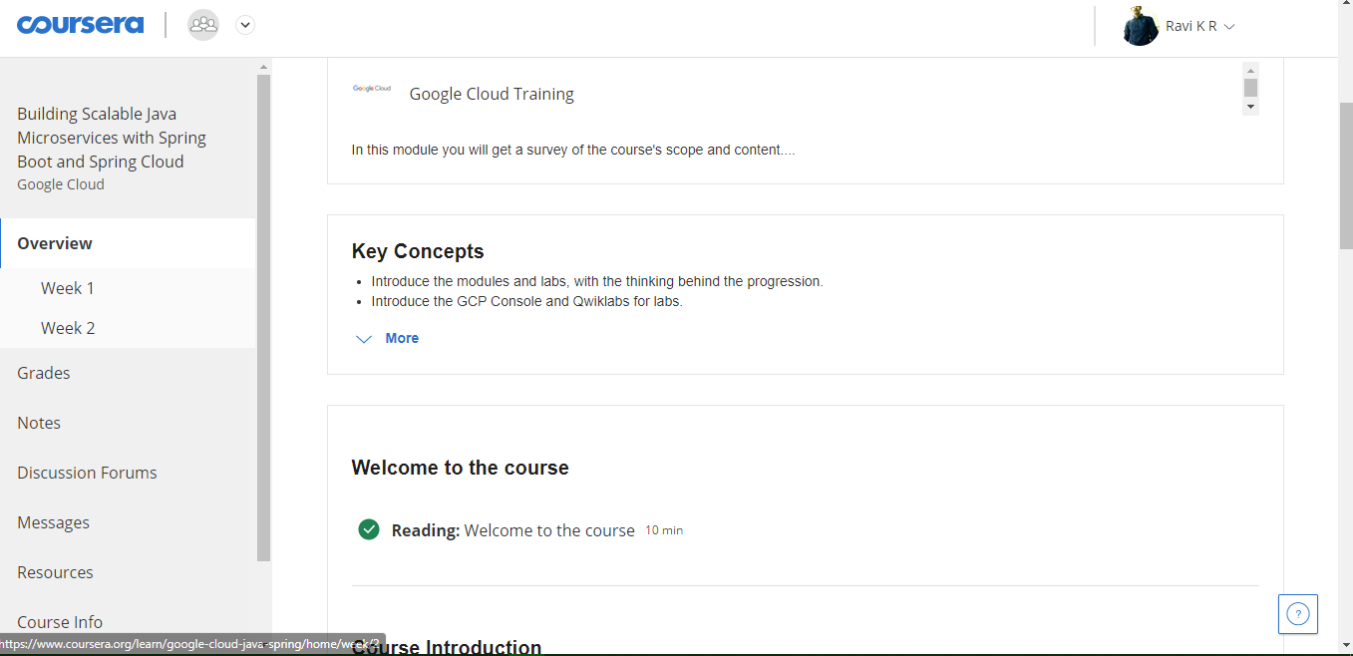

Coding Challenges Details:

public class Demonstration_106 {

public static void main (String args[ ])

{

int i = args.length; // No of arguments in the command line

String myString[] = new String[i];

myString[0]=args[0];

if(myString[0].equals("Java"))

{

System.out.println("First word is Java !");

}

System.out.println( " Number of arguments = " + i );

int x = 12/ i;

int y[ ] = {555, 999};

y[ i ] = x;

}

}