**DAILY ONLINE ACTIVITIES SUMMARY**

|  |  |  |  |  |  |  |
| --- | --- | --- | --- | --- | --- | --- |
| **Date:** | **18/07/2020** | | | **Name:** | **Ravi K R** | |
| **Sem & Sec** | **8th- B** | | | **USN:** | **4AL16CS076** | |
| **Online Test Summary** | | | | | | |
| **Certification Course Summary** | | | | | | |
| **Course** | **Object Oriented Programming in Java**  **by University of California San Diego** | | | | | |
| **platform** | | **coursera** | **Duration** | | | **250 hrs** |
| **Coding Challenges** | | | | | | |
| **Problem Statement:**  **1)** Java program to demonstrate working of Java beans | | | | | | |
| **Status: Executed** | | | | | | |
| **Uploaded the report in Github** | | | **Yes** | | | |
| **If yes Repository name** | | | <https://github.com/alvas-education-foundation/Ravi_kr> | | | |
| **Uploaded the report in slack** | | | **Yes** | | | |

Online Test Details:

Certification:

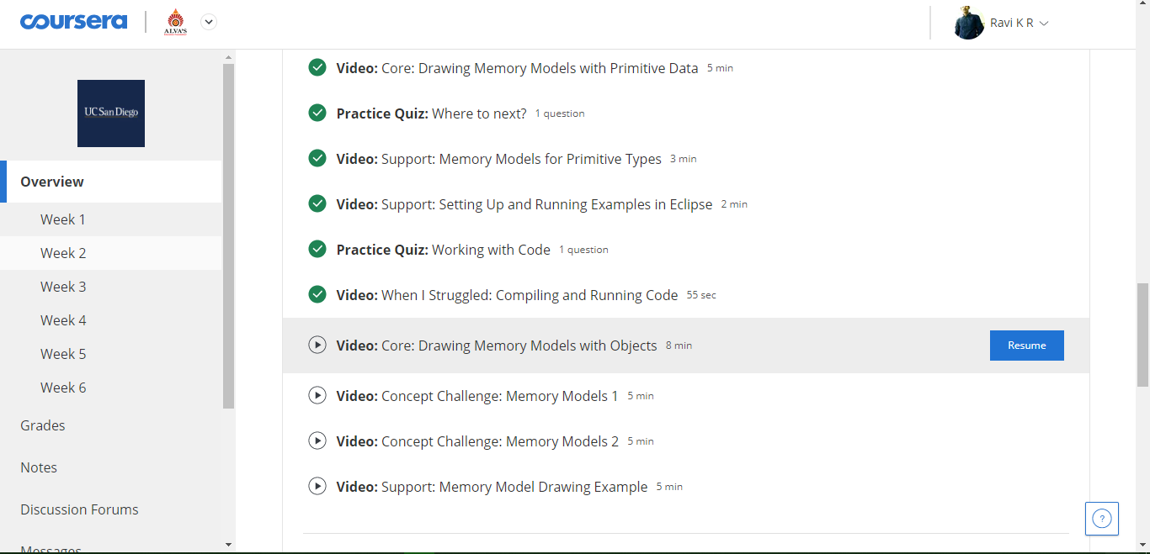

Coding Challenges Details:

According to Java white paper, it is a reusable software component. A bean encapsulates many objects into one object so that we can access this object from multiple places. Moreover, it provides easy maintenance.

**package** mypack;

**public** **class** Employee **implements** java.io.Serializable{

**private** **int** id;

**private** String name;

**public** Employee(){}

**public** **void** setId(**int** id){

**this**.id=id;

}

**public** **int** getId(){

**return** id;

}

**public** **void** setName(String name){

**this**.name=name;

}

**public** String getName(){

**return** name;

}

}

To access the JavaBean class, we should use getter and setter methods.

**package** mypack;

**public** **class** Test{

**public** **static** **void** main(String args[]){

Employee e=**new** Employee();//object is created

e.setName("Arjun");//setting value to the object

System.out.println(e.getName());

}

}